**Worksheet - THE ENGLISH MIX 3**

**Ordinal numbers, telling the time, Decimals and Fractions, the Present Perfect tense**

|  |  |  |  |
| --- | --- | --- | --- |
| ORDINAL NUMBERS | | | |
| 1st | first | 16th | sixteenth |
| 2nd | second | 17th | seventeenth |
| 3rd | third | 18th | eighteenth |
| 4th | fourth | 19th | nineteenth |
| 5th | fifth | 20th | twentieth |
| 6th | sixth | 21st | twenty-first |
| 7th | seventh | 22nd | twenty-second |
| 8th | eighth | 23rd | twenty-third |
| 9th | ninth | 24th | twenty-fourth |
| 10th | tenth | 25th | twenty-fifth |
| 11th | eleventh | 26th | twenty-sixth |
| 12th | twelfth | 27th | twenty-seventh |
| 13th | thirteenth | 28th | twenty-eighth |
| 14th | fourteenth | 29th | twenty-ninth |
| 15th | fifteen | 30th | thirtieth |

**FORMATION RULES:**

**Ordinal numbers**

• Usually you add –th to the cardinal (*standard*) number.

* *Ex: tenth, fourth, sixth…*

• If a number ends with –y, the ending changes to –ieth.

* Ex: twenty -> twentieth, thirty -> thirtieth, forty - fortieth…

• If a number ends with –t, add only –h.

* Ex: eight -> eighth

**EXCEPTIONS:**

• 1st, 2nd, 3rd, 21st, 22nd, 23rd and 31st are irregulars.

• 5th, 9th, 12th and 29th etc. suffer small irregularities.

1. **Fill in the gaps.  - **

a) 23rd – twenty-third h) 42nd - forty-second

b) 25th –twenty-fifth i) 66th - sixty- sixth

c) 31st –thirty-first j) 71st - seventy- first

d) 54th –fifty-fourth k) 93rd - ninety- third

e) 12th –twelfth l) 50th - fiftieth

f) 20th – twentieth m) 13th - thirteenth

g) 5th – fifth n) 29th - twenty- ninth

1. **Read the text. Fill in the gaps.  - **

Joe is faster than Billy. Billy is faster than Sarah and Jane.   
Jane is slower than Sarah, but Mary is faster than everybody.

1. Joe is__2nd________

2. Jane is _5th_________

3. Mary is _1st________

4. Sarah is __4th________  
5. Billy is __3rd_________

1. **Fill in the gaps.  - **

1. Beth’s birthday is the ___seventh________ of___April________ *7/4*

2. Tom’s birthday is the __thirty-first_________ of __July_________ *31/7*

3. My birthday is the ____________ of ___________  */ .*

4. My teacher’s birthday is the___ ______of _________  */ .*

5. My friend’s birthday is the__________ of __________  */ .*

6. My mum’s birthday is the __________ of __________  */ .*

7. My dad’s birthday is the __________ of __________  */ .*

8. __March_____________ is the third month of the year.

9. November is the ____11th_________ month of the year.

(the intro and the exercises [2, 3, 4] are adapted from: <https://busyteacher.org/13116-ordinal-numbers-and-telling-the-time.html>)

We can describe numbers smaller than one by using fractions or decimals. Today, the decimal system is more common than fractions.

To indicate a decimal number we use a point (.) and this includes money such as dollars and cents.

**We write: We say:**

0.3 nought point three / zero point three

3.45 three point four five (NOT three point forty-five)

98.4 ninety-eight point four

$1.55 one dollar, fifty-five cents, one dollar, fifty-five

$700.00 seven hundred dollars

€3,500.50 three thousand five hundred euro and fifty cents, three thousand five hundred euro, fifty cents

Remember that we use **commas** to separate thousands. Be careful with commas and points. Some languages use them in the opposite way!

**We write: We say:**

½ a half OR one half

¼ a quarter OR one quarter

¾ three quarters

⅓ a third OR one third

⅔ two thirds

**We write: We say:**

⅕ a fifth OR one fifth

⅗ three fifths

⅛ an eighth OR one eighth

⅝ five eighths

1½ one and a half

5¾ five and three quarters

Although the system of fractions is not used much these days, we commonly use a few simple fractions in everyday speech, for example:

*They phoned half an hour ago.*

*Hurry up! The bus leaves in a quarter of an hour.*

*The police station is about three quarters of a mile past the traffic lights.*

(adapted from: <https://www.englishclub.com/vocabulary/numbers-fractions.htm> &<https://www.englishclub.com/vocabulary/numbers-decimal.htm>)

1. **Become a statistician. Ask your groupmates the following questions. Calculate the statistics. **

|  |  |  |  |
| --- | --- | --- | --- |
| **QUESTION** | **YES, I HAVE.** | **NO, I HAVEN’T.** | **STATISTICS  (fractions, decimals)** |
| Have you ever ridden a horse? |  |  |  |
| Have you ever seen a shooting star? |  |  |  |
| Have you ever been bitten by a dog? |  |  |  |
| Have you ever seen something strange? |  |  |  |
| Have you ever gone to a concert? |  |  |  |
| Have you ever been late at work? |  |  |  |
| Have you ever quit your job? |  |  |  |
| Have you ever had a part-time job? |  |  |  |

There are a few basic math expressions which we can use:

**=** equals **+** plus **-** minus **:** divided by **x** times

for example:

5 x 4 = 20 -> five **times** four **equals** twenty 10 – 9 = 1 -> ten **minus** nine **equals** one

1. **Write how you would read each of the mathematical operations. Calculate the result.**  
2. $1/2+ 1/2$ = ____1_____

a half plus a half equals one

1. $2/3+ 2/3$ = $1 1/3$_________   
   two thirds plus two thirds equals one and one third (a third)
2. 1.5 + 1.5 – 1 = ___2______   
   one point five plus one point five minus one equals two / one and a half plus one and a half equals two
3. $1/2+ 1/4$ = $3/4$_________   
   a half plus a quarter equals three quarters
4. $4/5- 3/5$ = $1/5$_________   
   four fifths minus three fifths equals one fifth
5. 10.2 + 22.4 = __32.6_______   
   ten point two plus twenty two point four equals thirty two point six
6. $53/4+10 1/4$ = ___16______   
   five and three quarters plus ten and one quarter equals sixteen
7. ${10}/{50}+ {12}/{50}$ = ${22}/{50}$_________   
   ten fiftieths plus twelve fiftieths equals twenty two fiftieths
8. $5/8+ 5/8$ = $2/8$_________   
   five eights plus five eights equals one and two eights
9. $5/8 x 4$ = $2 4/8$_________   
   five eights times four equals (twenty eights) two and four eights
10. $1/2 :2$ = $1/4$_________   
    a half divided by two equals a quarter

$11 {12}/{23}-4 8/{23 }=$ $74/{23}$
11. _________   
    eleven and twelve twenty thirds minus four and eight twenty thirds equals seven and four twenty thirds
12. $21/4 :2$ = $1 1/8$_________   
    two and a quarter divided by two equals one and one eighth
13. $24{12}/{30} :2$ = $126/{30}$_________   
    twenty four and twelve thirtieths divided by two equals twelve and six thirtieths

$10{12}/{24} :2=$ $5 6/{24}$
14. _________   
    ten and twelve twenty fourths divided by two equals five and six twenty fourths

We often tell somebody the time - at work, at school, at a party...   
How to do it in English? It’s quite simple ☺

**What time is it?**

When we want to ask somebody about the time, we can use such questions as:

* What time is it?
* What time do you have?
* Do you know the time?
* Do you know what time it is?
* What time does ------- start/finish/?
* What time do you….. (do something - wake up, go to sleep, etc.)
* When is the movie/class/concert/etc.?

To talk about time, we use such expressions as PAST, TO, TILL, A QUARTER, HALF…

* past in Polish means “po” – five past two – *pięć po drugiej.*
* to & till mean “do”, e.g. five to ten – *pięć do dziesiątej / za pięć dziesiąta*.
* a quarter in Polish means “kwadrans”, e.g. a quarter to two – *kwadrans do drugiej.*
* half in Polish means “pół”, *e.g. half past four – ‘pół’ po drugiej – wpół do trzeciej*

The Americans ususally do not use the *a quarter* or *half*. They prefer to be more ‘direct’.

**American British**

**5:30** = five thirty half past five

**7:15** = seven fifteen a quarter past seven

**2:45** = two forty-five a quarter to three

Lastly, English speakers prefer to use the 12-hour system, so they use **A.M.** and **P.M.**

**A.M.** is before noon, so in Poland that would be 01:00-12:59

**P.M.** is after noon, so in Poland that would be 13:00 – 00:59 = 1 p.m = 12:59 p.m.

Or we simply mention the part of the day: in the morning / in the afternoon / in the evening.**Examples:**

It’s 3:45 p.m. now. / It’s 3:45 in the afternoon now.

I wake up at 6:30 in the morning. / I wake up at 6:30 a.m.

The movie starts at 8:00 p.m. / The movie starts at 8 o’clock in the evening.

**Remember!**

We can’t say “o’clock a.m./p.m.”. They never go together! There are two possibilities to tell time by the hour:

Example:

3:00 p.m.

- It’s three p.m.

- It’s three o’clock in the afternoon.

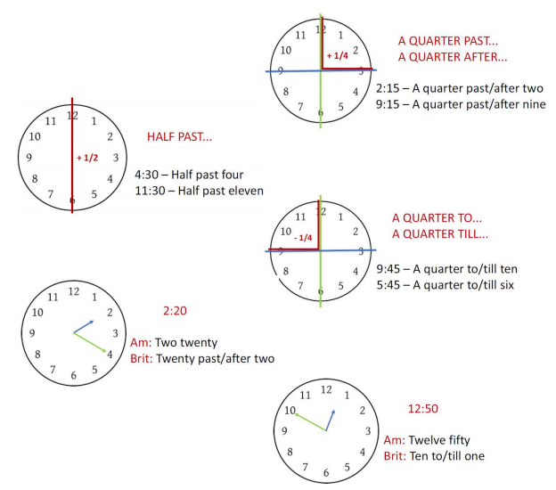

(the intro is adapted from: <https://busyteacher.org/24930-telling-time-general-rules.html>)

1. **Play the interactive game.**

 <https://learningapps.org/view2409911>

1. **Read the text and draw the hands of the clocks. Fill in the gap at the end of the text.  - **

Mark gets up at seven o’clock. It takes him five minutes to get dressed. Then he has a wash and cleans his teeth. That takes him five minutes. Next he eats his breakfast. That takes him fifteen minutes. He watches TV for ten minutes. Then he puts on his coat, but he can’t find his shoes. It takes him five minutes to find them. Finally, Mark leaves his house and walks slowly to school. It takes him twenty minutes. He arrives at school at___8_______

*He gets up. 7:00 He gets dressed 7:05 He cleans his teeth. 7:10*

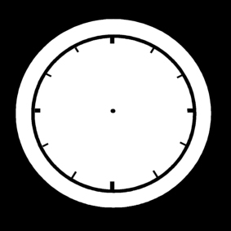  

*He has breakfast. 7:25 He watches TV for ten minutes. 7:35*

 

*He finds his shoes. 7:40 He leaves his house. 7:40*

 

(adapted from: <https://busyteacher.org/13116-ordinal-numbers-and-telling-the-time.html>)

1. **What did you do / What were you doing yesterday? Draw the activities.   
   Put the time below the pictures, but do not label them. Ask your partner to guess the activities. **



1. **What did you do / What were you doing yesterday? Prepare an answer key to your pictures.  
   Remember to mention the time of the action.**  

Example:   
*I woke up at 6 a.m. I brushed my teeth at 6:15, and then I ate a sandwich and drank coffee…*

…………………………………………………………………………………………………………………………………………………………………………………………………………………………………………………………………………………………………………………………………………………………………………………………………………………………………………………………………………………………………………………………………………………………………………………………………………………………………………………………………………………………………………………………………………………………………………………………………………………………………………………………………………………………………………………………………………………………………………………………………………………………………………………………………………………………………………………………………………………………………………………………………………………………………………………………………………………………………

Use the online dictionary if need be.  
[www.bab.la](http://www.bab.la)



The **present perfect** is used to indicate **a link between the present and the past.**   
The time of the action is before now but not specified, and we are often more interested in the result than in the action itself.

**Present Perfect**

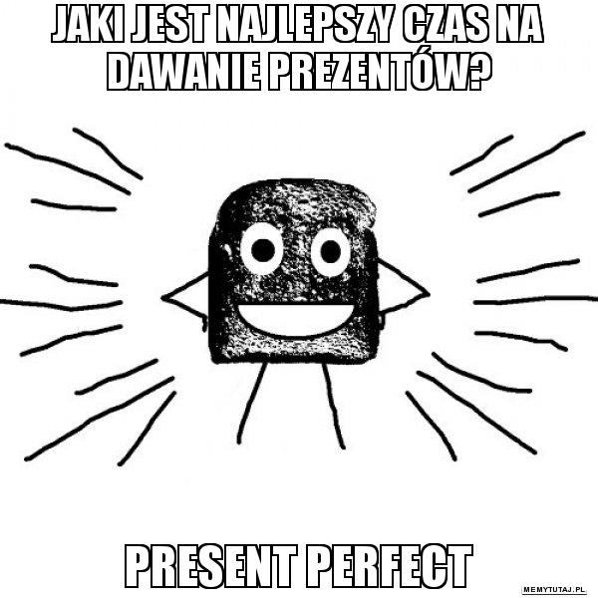**THE PRESENT PERFECT IS USED TO DESCRIBE**

* An action or situation that started in the past and continues in the present.   
  *I have lived in Bristol since 1984 (= and I still do.)*
* An action performed during a period that has not yet finished.   
  *She has been to the cinema twice this week (= and the week isn't over yet.)*
* A repeated action in an unspecified period between the past and now.   
  *We have visited Portugal several times.*
* An action that was completed in the very recent past, expressed by 'just'.   
  *I have just finished my work.*
* An action when the time is not important.   
  *He has read 'War and Peace'. (= the result of his reading is important)*

*Note: When we want to give or ask details about when, where, who, we use the Past Simple.*

**ACTIONS STARTED IN THE PAST AND CONTINUING IN THE PRESENT**

*They haven't lived here for years.*

*She has worked in the bank for five years.*

*We have had the same car for ten years.*

*Have you played the piano since you were a child?*

**WHEN THE TIME PERIOD REFERRED TO HAS NOT FINISHED**

*I have worked hard this week.*

*It has rained a lot this year.*

*We haven't seen her today.*

**ACTIONS REPEATED IN AN UNSPECIFIED PERIOD BETWEEN THE PAST AND NOW.**

*They have seen that film six times.*

*It has happened several times already.*

*She has visited them frequently.*

*We have eaten at that restaurant many times.*

**ACTIONS COMPLETED IN THE VERY RECENT PAST (+JUST)**

*Have you just finished work?*

*I have just eaten.*

*We have just seen her.*

*Has he just left?*

**WHEN THE PRECISE TIME OF THE ACTION IS NOT IMPORTANT OR NOT KNOWN**

*Someone has eaten my soup!*

*Have you seen 'Gone with the Wind'?*

*She's studied Japanese, Russian, and English.*

**FORMING THE PRESENT PERFECT**

The present perfect of any verb is composed of **two** elements : the appropriate form of the (…) verb to have (present tense), plus the past participle of the main verb.   
The past participle of a regular verb is base+ed, e.g. played, arrived, looked.

**Affirmative**

Subject to have past participle

*She has visited.*

**Negative**

Subject to have + not past participle

*She has not (hasn't) visited.*

**Questions**

to have subject past participle

*Has she visited?*

(…)

**TO WALK, PRESENT PERFECT**

**Affirmative Negative Questions**

*I have walked I haven't walked Have I walked?*

*You have walked You haven't walked. Have you walked?*

*He, she, it has walked He, she, hasn't walked Has he, she, it walked?*

*We have walked We haven't walked Have we walked?*

*You have walked You haven't walked Have you walked?*

*They have walked They haven't walked Have they walked?*

Some words are used with the Present Perfect tense more often than others. These words are:  
*ever, never, already, yet, since, for*

**EVER - kiedykolwiek**

The adverbs ever and never express the idea of an unidentified time before now (*Have you ever visited Berlin?*) 'Ever' and 'never' are always placed before the main verb (past participle).

Ever is used:

IN QUESTIONS

*Have you ever been to England?*

*Has she ever met the Prime Minister?*(…)

**NEVER - nigdy**

Never means at no time before now (…) (*I have never visited Berlin*)

BE CAREFUL!  
You must not use never and not together.

~~I haven't never been to Italy.~~ I have never been to Italy.

**ALREADY - już**

Already refers to an action that has happened at an unspecified time before now.   
It suggests that there is no need for repetition.

*I've already drunk three coffees this morning.* (= and you're offering me another one!)

*Don't write to John, I've already done it.*

It is also used in questions:

*Have you already written to John?*

*Has she finished her homework already?*

Already can be placed before the main verb (past participle) or at the end of the sentence:

*I have already been to Tokyo. | I have been to Tokyo already.*

**YET - już, jeszcze [nie]**

Yet is used in negative statements and questions, to mean (not) in the period of time between before now and now, (not) up to and including the present. Yet is usually placed at the end of the sentence.

*Have you met Judy yet?*

*I haven't visited the Tate Gallery yet.*

*Has he arrived yet?*

*They haven't eaten yet.* (Adapted from: [https://www.ef.com/english-resources/english-grammar/present-perfect](https://www.ef.com/english-resources/english-grammar/present-perfect/) &   
[https://www.ef.com/english-resources/english-grammar/present-perfect-ever-never-already-yet](https://www.ef.com/english-resources/english-grammar/present-perfect-ever-never-already-yet/) )

**SINCE & FOR – od i przez**

To talk about the time in the Present Perfect tense, we can use the words *since & for*.

*I’ve taught English since 1995. I’ve taught English for 23 years.*

*We’ve studied at this school since 2010. We’ve studied at this school for 8 years.*

*They’ve worked at that office since 2004. They’ve worked at that office for 14 years.*

Notice that we use ***since*** with dates (years, months, days) and ***for*** with periods of time.

1. **Do the interactive exercises. **

Verb forms - multiple choice: <https://www.ang.pl/cwiczenia/812> 

 Choose the correct forms: <https://www.ang.pl/cwiczenia/3259/present-perfect>

Put the verb in the correct form: <https://www.ang.pl/cwiczenia/806> 

 Insert FOR or SINCE: <https://www.ang.pl/cwiczenia/1757>

Complete the sentences using Present Perfect: <https://www.ang.pl/cwiczenia/813> 

 Make a negative: <https://www.ang.pl/cwiczenia/1771>

Make a question: <https://www.ang.pl/cwiczenia/1770> 

1. **Transform the words in brackets, so that they are in the 3rd form. Ask and answer the questions in pairs.** Have you ever…  ** **

* (throw away) ……thrown away……………………… rubbish on the floor?
* (be) ……been…………………… to *Gdańsk / Warsaw / Prague / Berlin / London*?
* (download) ……downloaded……………………… *music / games / an antivirus software*?
* (send) ………sent…………………… an e-mail to *a mayor / to a president / to a friend*?
* (present) ………presented…………………… the presentation in front of a large group of people?

 *Yes, I have.  No, I haven’t.*

1. **Draw three lies and three truths about your past experiences.  
   Ask your partner to guess what you mean and to tell if it’s a lie or a truth. **



1. **Write down an answer key to your pictures. **

………………………………………………………………………………………………………………………………………………………………………………………………………………………………………………………………………………………………………………………………………………………………………………………………………………………………………………………………………………………………………………………………………………………………………………………………………………………………………………………………………………………………………………………………………………………………………………………………………………………………………………………………………………………………………………………………………………………………………………………………………………………………………………………………………………………………………………………………………………………………………………………………………………………………………………………………………………………………………………………………………………………………………………

Use the online dictionary if need be.  
[www.bab.la](http://www.bab.la)



1. **Listen to the song and fill in the gaps.** <https://youtu.be/YQHsXMglC9A?t=1m14s>  

/ everything / everything / forgotten / between / done / anymore / secret / other / tried /   
/ tried / tried / younger / million / called / sorry / after / heart / when / well / tell / hear /   
/ free /

**Adele "Hello"**

Hello, it's me, I was wondering

If 1 _after______ all these years you'd like to meet   
to go over 2 __everything_____________

They say that time's supposed to heal, yeah

But I ain't done much healing

Hello, can you 3 __hear______ me?

I'm in California dreaming about who we used to be

When we were 4 _younger_____ and 5 _free____

I've 6 _forgotten_________ how it felt before the world fell at our feet

There's such a difference 7 ___between____ us

And a 8 _million______ miles

Hello from the other side

I must've 9 __called____ a thousand times

To tell you I'm 10 _sorry_____, for everything that  
 I've 11 _done_____

But when I call you never seem to be home

Hello from the outside

At least I can say that I've 12 _tried_______

To tell you I'm sorry, for breaking your 13 _heart__

But it don't matter, it clearly doesn't tear you apart 14 __anymore______

Hello, how are you?

It's so typical of me to talk about myself, I'm sorry

I hope that you're 15 __well____

Did you ever make it out of that town where nothing ever happened?

It's no 16 _secret______

That the both of us are running out of time

So hello from the 17 ___other_____ side

I must've called a thousand times

To tell you I'm sorry, for 18 __everything________ that I've done

But when I call you never seem to be home

Hello from the outside

At least I can say that I've 19 __tried_______

To tell you I'm sorry, for breaking your heart

But it don't matter, it clearly doesn't tear you apart anymore

Ooh, anymore

Ooh, anymore

Ooh, anymore

Anymore...

Hello from the other side

I must've called a thousand times

To 20 __tell____ you I'm sorry, for everything that I've done

But 21 __when__ I call you never seem to be home

Hello from the outside

At least I can say that I've 22 _tried________

To tell you I'm sorry, for breaking your heart

But it don't matter, it clearly doesn't tear you apart anymore