Worksheet - THE ENGLISH MIX 1
Free time activities
Free Time Activities, Adverbs of Frequency, Family Members, Personality Adjectives, Present Simple, Present Continuous
- Look at the pictures. Label them with the names provided below.
/ gardening / playing volleyball / playing football / playing basketball / windsurfing / jogging (running) /
/ ice skating / playing board games / playing video games / walking a dog / swimming / singing / fishing /
/ going to a cinema / listening to music / painting / knitting / going shopping / riding a horse / dancing /
/ cycling / sailing / watching TV / reading / playing tennis / cooking / going to a gym / meeting friends /
/ spending time with your family / ………………………….. (your idea)
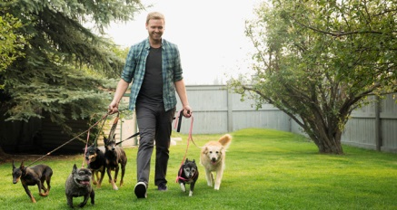
1. ……………………………………… 2. ……………………………………… 3. ………………………………………
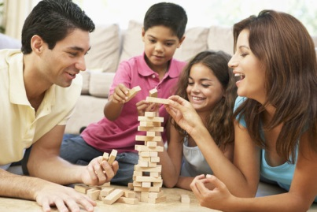
4. ……………………………………… 5. ……………………………………… 6. ………………………………………

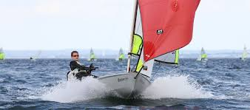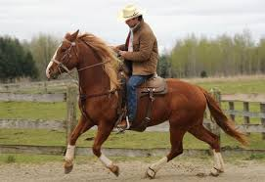
7. ……………………………………… 8. ……………………………………… 9. ………………………………………

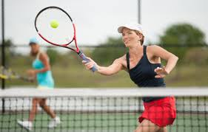
10. ……………………………………… 11. ……………………………………… 12. ………………………………………

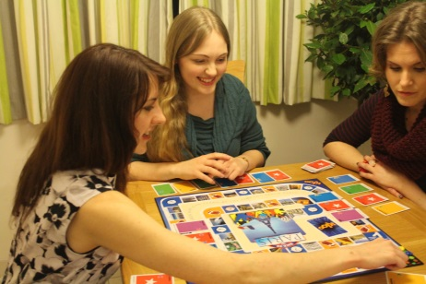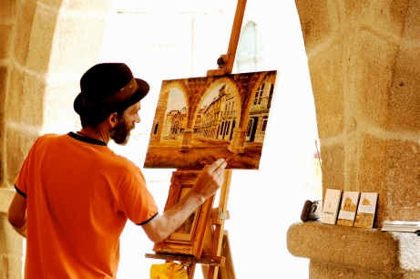
13. ……………………………………… 14. ……………………………………… 15. ………………………………………
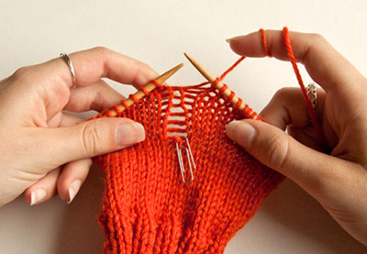
16. ……………………………………… 17. ……………………………………… 18. ………………………………………

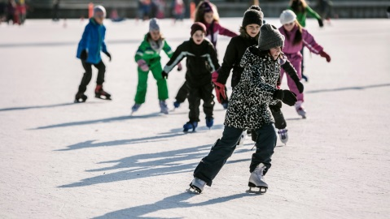
19. ……………………………………… 20. ……………………………………… 21. ………………………………………

22. ……………………………………… 23. ……………………………………… 24. ………………………………………

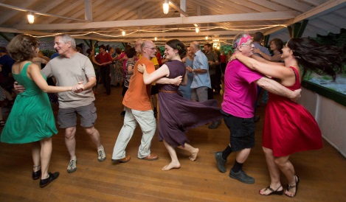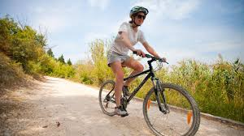
25. ……………………………………… 26. ……………………………………… 27. ………………………………………

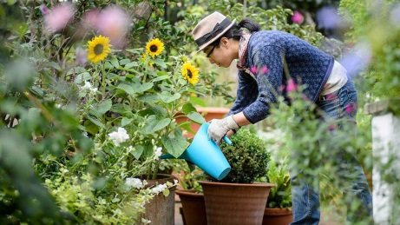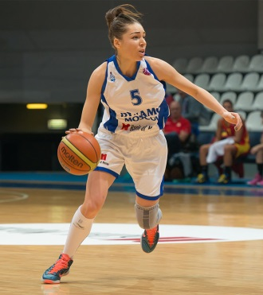
28. ……………………………………… 29. ……………………………………… 30. ………………………………………

- Discuss in pairs. Which of the things mentioned in the 1st task you love, hate etc.?
- I love…
- I like…
- I enjoy…
- I hate…
- I can’t stand…
- I don’t mind…
- Discuss in pairs. Ask questions, using the example – replace the underlined words with your own.
Example:
Do you like cycling?
Yes, I do!
No, I don’t!

To talk about habits – things you do often/regularly – you can use the Present Simple tense.
Present Simple
(theory)
I sometimes dance. We sometimes dance.
You sometimes dance. You sometimes dance.
He sometimes dances. They sometimes dance.
She sometimes dances.
It sometimes dances.

It’s very easy to form a Present Simple sentence. The general rule is:
+) + VERB (-s / -es)

-) + DO NOT / DOES NOT + VERB
(DON’T / DOESN’T)

?) DO / DOES + + VERB?

Apart from habits, we can use the Present Simple tense:
For habits: He drinks tea at breakfast.
For repeated actions or events: We catch the bus every morning.
For general truths: Water freezes at zero degrees.
For instructions or directions: Open the packet and pour the contents into hot water.
For fixed arrangements: His mother arrives tomorrow.
(adapted from: www.ef.com)

For further info (in Polish) you can visit: https://www.ang.pl/gramatyka/czas/present-simple

- Fill in the gaps with the proper form of a verb, using the Present Simple tense:
Present Simple (practice)
  - The shops in Poland usually ……………………………………..…………… (open) quite early.
  - I always ……………………………………..…………… (drink) coffee in the morning because it ……………………………………..…………… (wake) me up.
  - My mother ……………………………………..…………… (do) the shopping every afternoon and I sometimes ……………………………………..…………… (help) her.
  - They're keen on sport and they sometimes ……………………………………..…………… (play) basketball at weekend.
  - My friend ……………………………………..…………… (write) poems and she's really good at it.
  - Scientists ……………………………………..…………… (read) many books because their job ……………………………………..…………… (require) it.
  - Her brother rarely ……………………………………..…………… (leave) home because he's extremely shy.
  - It never ……………………………………..…………… (snow) in Africa so it's a good place for summer holidays.
  - I ……………………………………..…………… (hate) spiders! They're awful!
  - This car ……………………………………..…………… (cost) a lot of money but it is worth it.
(the exercise is adapted from: https://www.ang.pl/cwiczenia/878)
- In English we can talk about how often we do some things using adverbs of frequency and the Present Simple tense. Do you know what these adverbs mean? -
Adverbs of frequency
always – …………………………………………………………
She always studies English at this time of the day.
constantly – …………………………………………………………
He constantly brags about how strong he is.
continually – …………………………………………………………
They continually make progress.
frequently – …………………………………………………………
I frequently visit Paris.
normally – …………………………………………………………
Mary normally wears elegant clothes but today she chose to wear something sporty.
occasionally – …………………………………………………………
We occasionally eat pasta for dinner.
often – …………………………………………………………
She often reads books in the evening.
regularly – …………………………………………………………
They regularly play football on Saturdays.
periodically – …………………………………………………………
He periodically visits his grandmother.
sometimes – …………………………………………………………
You sometimes have this strange look on your face.

rarely – …………………………………………………………
We rarely go to school on Saturdays.
seldom – …………………………………………………………
They seldom have fun together.
hardly ever – …………………………………………………………
I hardly ever stay up late.
never – …………………………………………………………
We will never eat dinner at 10 a.m.
- Put the correct adverb of frequency:
1. Nancy and I (30%) ………………………………………………………… go out for coffee together.
2. Andrea (90%) ………………………………………………………… has ice-cream for dessert.
3. I (20%) ………………………………………………………… drive my car to work.
4. It (0%) ………………………………………………………… rains here in the summer.
5. Andy (10%) ………………………………………………………… gets to visit with his cousins.
6. Thomas and Peter are (50%) ………………………………………………………… nervous before an exam.
(the exercise is adapted from: https://www.thatquiz.org/es/previewtest?H/Q/J/V/3MYA1462624179)
- Draw the things you do in your free time and ask your partner to guess what they mean.
Write down the proper adverb below the picture.

- Write about the things you do in your free time, using the adverbs of frequency and the Present Simple tense.
In my free time…
always – …………………………………………………………………………………………………………
occasionally – ……………………………………………………………………………………….………
often – …………………………………………………………………………………………………………
periodically – …………………………………………………………………………………………………
sometimes – …………………………………………………….……………………………………………
rarely – ………………………………………………………………..…………………………………………
hardly ever – ………………………………………………….………………………………………………
never – …………………………………………………………………..………………………………………
To talk about things that you do NOW you can use the Present Continuous tense.
Present Continuous
(theory)
I’m dancing (now). We’re dancing (now).
You’re dancing (now). You’re dancing (now).
He’s dancing (now). They’re dancing (now).
She’s dancing (now).
It’s dancing (now).

It’s very easy to form a Present Continuous sentence. The general rule is:
+) + AM / ARE / IS + VERBING

-) + AM NOT / ARE NOT / IS NOT + VERBING
(AM NOT/ AREN’T / ISN’T)

?) AM / ARE / IS + + VERBING?

We can use the Present Continuous tense:
to describe an action that is going on at this moment:
You are using the Internet. You are studying English grammar.
to describe an action that is going on during this period of time or a trend:
Are you still working for the same company? More and more people are becoming vegetarian.
to describe an action or event in the future, which has already been planned or prepared:
We're going on holiday tomorrow. I'm meeting my boyfriend tonight. Are they visiting you next winter?
to describe a temporary event or situation:
He usually plays the drums, but he's playing bass guitar tonight.
The weather forecast was good, but it's raining at the moment.
with "always, forever, constantly", to describe and emphasise a continuing series of repeated actions:
Harry and Sally are always arguing! You're constantly complaining about your mother-in-law!
(adapted from: www.ef.com)

For further info (in Polish) you can visit: https://www.ang.pl/gramatyka/czas/present-continuous

- Fill in the gaps with the proper form of a verb, using the Present Continuous tense.
Present Continuous
(practice)
  - Jack ……………………………………..…………… (help) his brother with his homework.
  - I see that you ……………………………………..…………… (work) very hard today.
  - Hurry up! She ……………………………………..…………… (wait) for you.
  - Of course I ……………………………………..…………… (enjoy) the party!
  - My mother ……………………………………..…………… (do) the shopping at the moment.
  - Oh no! It ……………………………………..…………… (rain) again!
  - Bill and Mark ……………………………………..…………… (repair) their car.
  - Be quiet! I ……………………………………..…………… (try) to get to sleep.
  - My friends ……………………………………..…………… (swim) in the river.
  - Look! That tree ……………………………………..…………… (fall) down in the wind!
(the exercise is adapted from: https://www.ang.pl/cwiczenia/891/present-continuous-budowa)
- Play charades, using the words and phrases from ex. 1 and the Present Continuous tense.
[The person is miming an activity]
You’re running!
- How are these people related to JANE? Fill in the gaps with the provided words.
Family members
son / sister-in-law / sister / grandmother / uncle / mother / grandfather / nephew

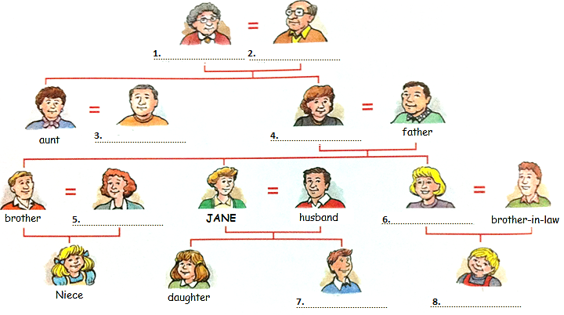
(the exercise is adapted from: https://busyteacher.org/19489-family-members.html)
- Fill in the gaps with the proper word.
  - Your mother's husband is your ……………………………………..……………
  - Your father's father is your ……………………………………..……………
  - Your brother's daughter is your ……………………………………..……………
  - Your cousin's mother is your ……………………………………..……………
  - Your mother's brother is your ……………………………………..……………
  - Your son’s brother is your ……………………………………..……………
  - Your husband’s mother is your ……………………………………..……………
(the exercise is adapted from: https://busyteacher.org/19489-family-members.html)

- Describe your family.
Example:
I have a son. His name is Tomek. He’s 15 years old. He likes playing video games and windsurfing.
I have a husband. His name is Włodek. He’s 40 years old. He likes reading and watching TV.

- Match the words to their definitions.
Personality adjectives
 | ADJECTIVE |  | THIS PERSON…
1. | confident | A. | is easy to like
2. | smart / intelligent / clever | B. | behaves in a way that shows care about other people
3. | silly | C. | believes in their own possibilities
4. | funny | D. | is not at all interesting
5. | boring | E. | gives money or big presents to others
6. | nice / kind | F. | makes you laugh a lot
7. | lovely / cute | G. | does not tell lies or cheat people
8. | generous | H. | is good at understanding difficult concepts
9. | honest | I. | smiles a lot
10. | happy | J. | is not intelligent
11. | friendly / easy-going | K. | always says “thank you” and “please”
12. | unfriendly | L. | never wants to work
13. | outgoing | M. | doesn’t like meeting people and sometimes doesn’t talk very much
14. | shy | N. | feels excited and worried
15. | polite | O. | enjoys meeting and talking to people
16. | impolite / rude | P. | never says “thank you” or “please”
17. | hardworking | Q. | is relaxed
18. | lazy | R. | always does their homework and studies a lot
19. | serious | S. | does not laugh much
20. | nervous | T. | not friendly
21. | heartless | U. | doesn’t like to be late
22. | patient | V. | takes care only for oneself
23. | punctual | W. | always breaks things
24. | selfish | X. | shows no sympathy or kindness
25. | clumsy | Y. | is able to deal with a difficult situation without becoming upset
(the exercise is adapted from: https://busyteacher.org/24640-personality-adjectives.html)
- Discuss in pairs. Ask questions, using the examples – replace the underlined words with your own.
2nd example:
Is your brother confident?
Yes, he is!
No, he isn’t!

1st example:
Are you confident?
Yes, I am!
No, I am not!

