Easter Worksheet History of the Holidays: Easter | History : https://youtu.be/eJYXMIJrhRI
Before the movie:
- When you think about Easter, what comes to your mind first?
Fill in the mind map alone or with your deskmate. Add more lines if necessary. -

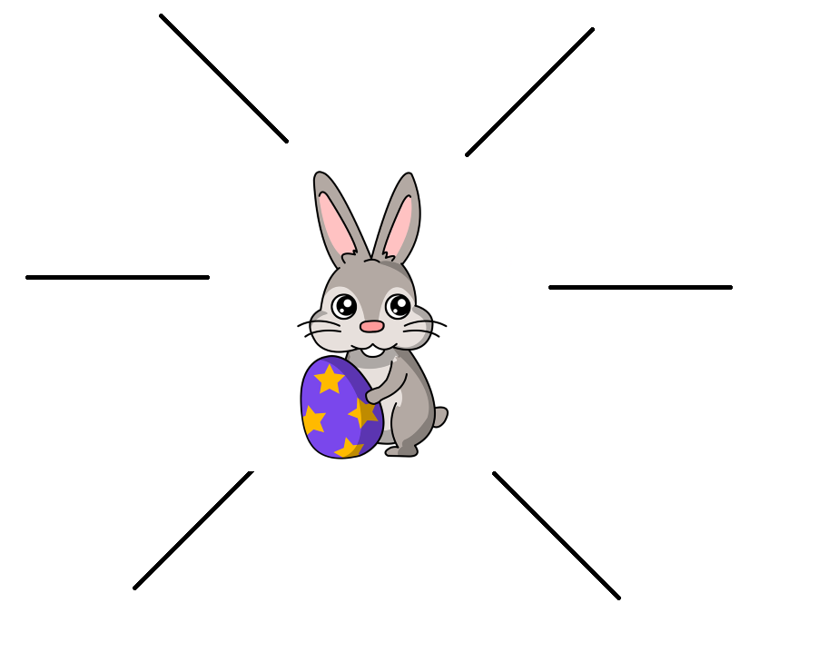
- Translate these words and phrases into your own language. Ask your friends or use a dictionary to help you.
-
holy – ………………………………………………………………………………………………………………………..………………………………………..…
a celebration – ………………………………………………………………………………………………………………………………………………………
a resurrection –.……………………………………………………………………………………………………………………………………………………..
an apostle – …………………………………………………………………………………………………………………………………………………………..
to crucify – ………………………………………………………………..…………………………………………………………………………………………
to derive something from something – ………………………….…………………………………………………………………..………………….
to feel right – ………………………………………………………….…………………………………………………………………………….……………….
to fall on – …………………..……………………………………………………………………………………………………………………………..………….
an equinox – ……………………………………………………………………………………………………………………………………….…………………
a candle – ………………………………….………………………………………………………………………………………………………….……………….
a custom – …..………………………..……………………………………………………………………………………………………….......................
a goddess – ……………………………………………………………………………………………………………………..…………………………………..
to hatch – ………………………………………………………………………………………………………………………..……………………….……………
to prohibit – …………………………………………………………………………………………………………………………………………………………..
a lawn – …………………………………………………………………………………………………………………………………………………………………
fertile – …………………………………………………………………………………………………………………………………………………………………
to entice – ……………………………………………………………………………………………………………………………………………………………..
to spread – ……………………………………………………………………………………………………………………………………………………………
During the movie:
- Is Easter the holiest day of the Christian calendar?
- Yes. b) No. c) I don’t know.
- When was Jesus crucified?
- on Good Sunday b) on Good Thursday c) on Good Friday
- The Easter celebration was called…
- Pesach. b) Pascha. c) Easter Eve.
- When was Easter originally celebrated?
- 2 days before the Passover b) 2 days after the Passover c) On Sunday after the Passover
- In which century did Roman Emperor Constantine decide that Easter must fall only on a Sunday?
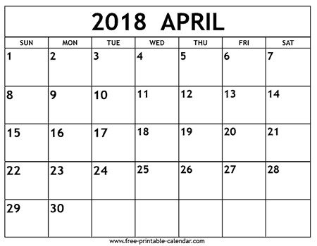
- When could Easter occur after the Emperor’s decision? Mark the span of dates on the 2018 calendars.
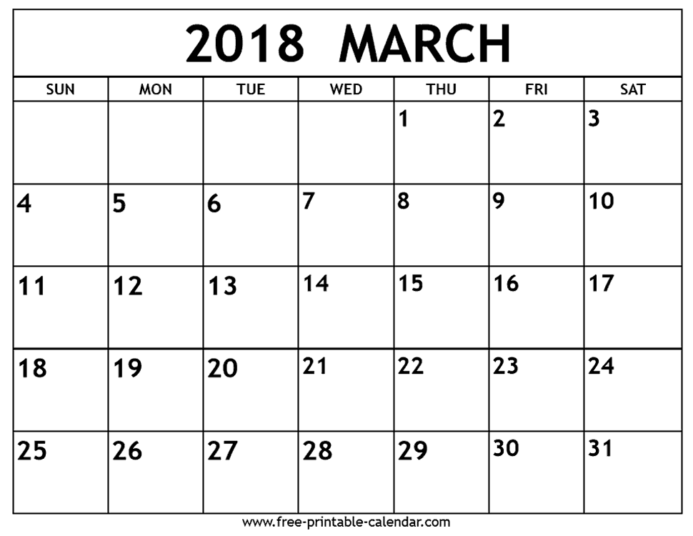

- The flame of the paschal candle is a reminder of...
a) the Easter bunny. b) Christ’s resurrection. c) light.
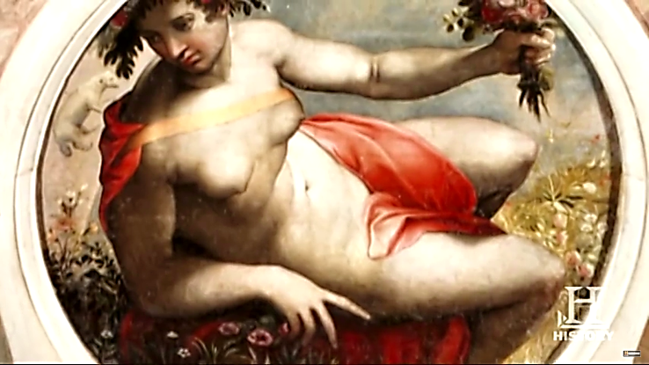
- What’s the name of this goddess of spring and fertility?
- Easter b) Ēostre c) Passover
- In which century did Christians adopt the egg as an Easter custom?
- Eggs were painted red to represent…
- roses. b) Christ’s blood. c) Christ’s clothes.
- Rabbit had long been the symbol of…
a) low fertility rate b) new life c) Easter
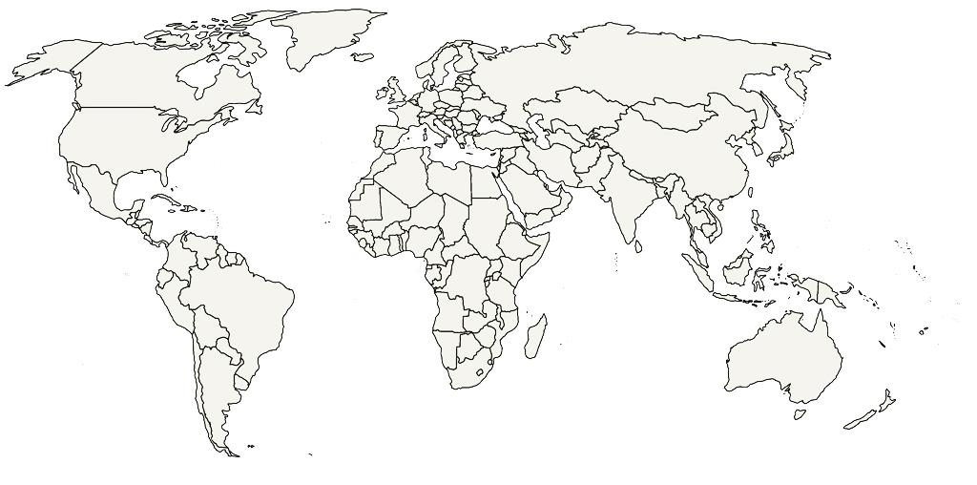
- Where did chocolatiers start the production of egg-shaped chocolates?
Write the name of the continent. Afterwards, find and mark it on the map.
………………………………………………………………………………………………………………………………
After the movie:
- Work in groups. How do people in your country celebrate Easter? Describe the traditions and customs. -
………………………………………………………………………………………………………………………………………………………………………………………………………………………………………………………………………………………………………………………………………………………………………………………………………………………………………………………………………………………………………………………………………………………………………………………………………………………………………………………………………………………………………………………………………………………………………………………………………………………………………………………………………………………………………………………………………………………………………………………………………………………………………………………………………………………………………………………………………………………………………………………………………………………………………………………………………………………………………………………………………………………………………………………………………………………………………………………………………………………………………………………………………………………………………………………………………………………………………………………………………………………………………………………………………………………………………………………………………………………………………………………………………………………………………………………………………………………………………………………………………………………………………………………………………………………………………………………………………………………………………………………………
………………………………………………………………………………………………………………………………………………………………………………………………………………………………………………………………………………………………………………………………………………………………

