Easter Worksheet History of the Holidays: Easter | History : https://youtu.be/eJYXMIJrhRI
Before the movie:
- When you think about Easter, what comes to your mind first?
Fill in the mind map alone or with your deskmate. Add more lines if necessary. -

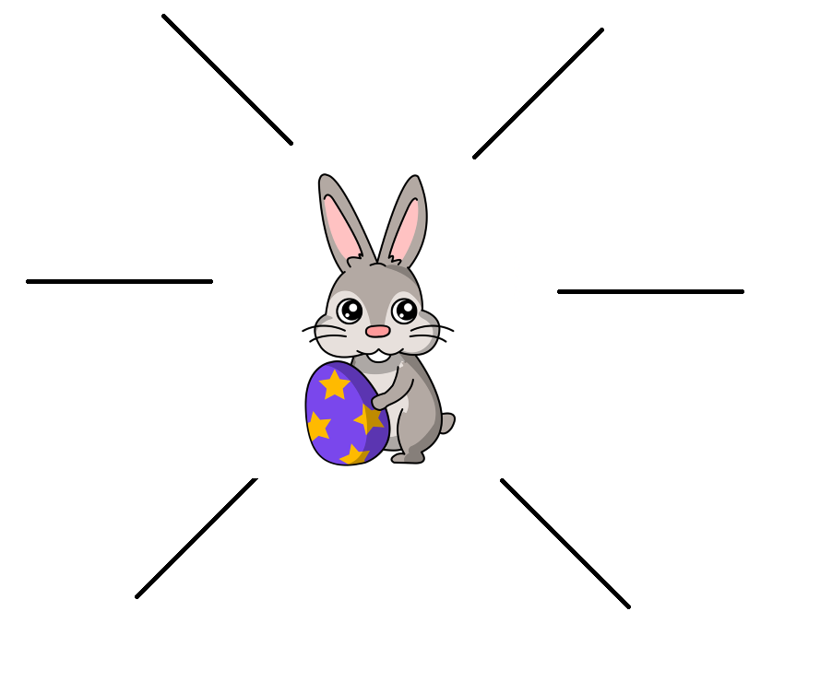
- Translate these words and phrases into your own language. Ask your friends or use a dictionary to help you.
-
holy – …święty…………………………………………………………………………………………………………………………………………………….…
a celebration – …świętowanie, obchody…………………………………………………………………………….…………………………………
a resurrection –.…zmartwychwstanie……………………………………………………………………………..……………………………………..
an apostle – …apostoł…………………………………………………………………………………………………………………………………………….
to crucify – …ukrzyżować……………………………………………………………..……………………………………………………………………….
to derive something from something – …wywodzić się od/z czegoś, pochodzić z……….…………………………………………
to feel right – …brzmieć dobrze, czuć się (z czymś) dobrze…………………………………………….…………………………………….
to fall on – …przypadać na (dzień, datę)………………..……………………………………………………………..……………………………….
an equinox – …równonoc, zrównanie…………………………………………………………………………….………………………………………
a candle – …świeca……………………………….………………………………………………………….…………………………………………………….
a custom – zwyczaj…..………………………..…………………………………………………...................................................................
a goddess – bogini……………………………………………………………………..…………………………………………………………………………..
to hatch – …wykluwać się, powstać…………………………………………………………………………..……………………….………………….
to prohibit – …zabronić…………………………………………………………………………………………………………………………………………..
a lawn – …trawnik………………………………………………………………………………………………………………………………………………….
fertile – …żyzny………………………………………………………………………………………………………………………………………………………
to entice – …kusić, wabić………………………………………………………………………………………………………………………………………
to spread – …rozprzestrzeniać (się)………………………………………………………………………………………………………………………..
During the movie:
- Is Easter the holiest day of the Christian calendar?
- Yes. b) No. c) I don’t know.
- When was Jesus crucified?
- on Good Sunday b) on Good Thursday c) on Good Friday
- The Easter celebration was called…
- Pesach. b) Pascha. c) Easter Eve.
- When was Easter originally celebrated?
- 2 days before the Passover b) 2 days after the Passover c) On Sunday after the Passover
- In which century did Roman Emperor Constantine decide that Easter must fall only on a Sunday?
325 AD (4th century)
- When could Easter occur after the Emperor’s decision? Mark the span of dates on the 2018 calendars.
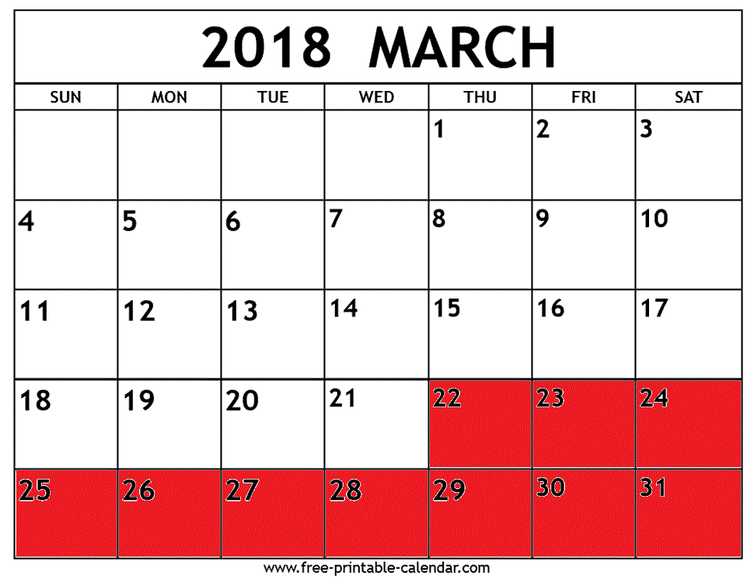
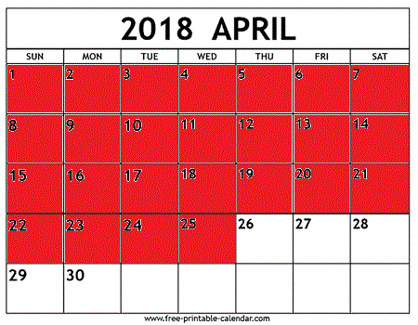
22nd March – 25th April

- The flame of the paschal candle is a reminder of...
a) the Easter bunny. b) Christ’s resurrection. c) light.
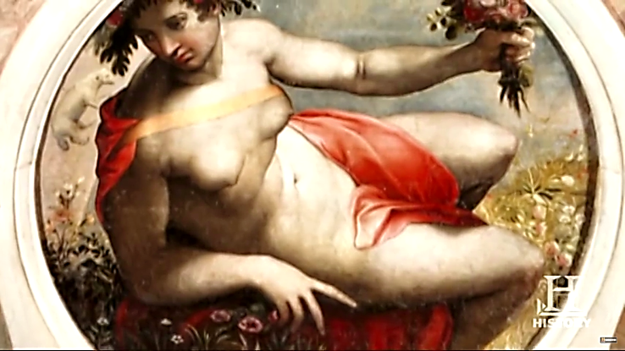
- What’s the name of this goddess of spring and fertility?
- Easter b) Ēostre c) Passover
- In which century did Christians adopt the egg as an Easter custom?
13th century
- Eggs were painted red to represent…
- roses. b) Christ’s blood. c) Christ’s clothes.
- Rabbit had long been the symbol of…
a) low fertility rate b) new life c) Easter
- Where did chocolatiers start the production of egg-shaped chocolates?
Write the name of the continent. Afterwards, find and mark it on the map.
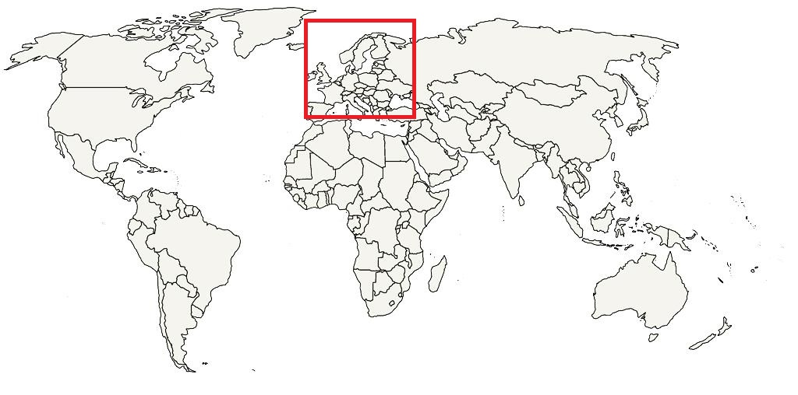
…………Europe……………………………………………………………………………………………………………………
After the movie:
- Work in groups. How do people in your country celebrate Easter? Describe the traditions and customs. -
………………………………………………………………………………………………………………………………………………………………………………………………………………………………………………………………………………………………………………………………………………………………………………………………………………………………………………………………………………………………………………………………………………………………………………………………………………………………………………………………………………………………………………………………………………………………………………………………………………………………………………………………………………………………………………………………………………………………………………………………………………………………………………………………………………………………………………………………………………………………………………………………………………………………………………………………………………………………………………………………………………………………………………………………………………………………………………………………………………………………………………………………………………………………………………………………………………………………………………………………………………………………………………………………………………………………………………………………………………………………………………………………………………………………………………………………………………………………………………………………………………………………………………………………………………………………………………………………………………………………………………………………
………………………………………………………………………………………………………………………………………………………………………………………………………………………………………………………………………………………………………………………………………………………………

