Halloween Worksheet History of the Holidays: Halloween | History (youtube): https://youtu.be/Xt8KqQOyk7k
Before the movie:
- What do you and (your friend) know about Halloween? Fill in the mind map alone or with your deskmate.
Add more lines if necessary. -

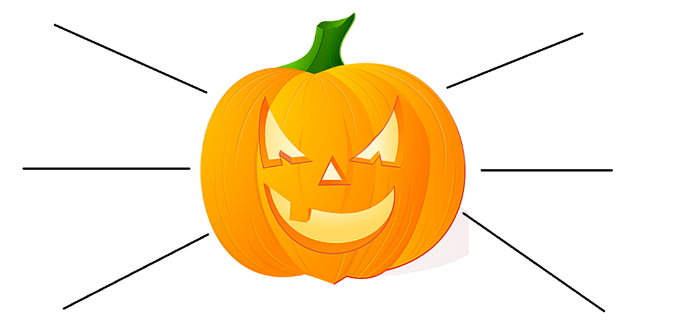

- Translate these words into your own language. Ask your friends or use the dictionary to help you.
-
a graveyard - ………………………………………………………………………………………………………………………………………………………….
a monster - …………………………………………………………………………………………………………………………………………………………….
a tribe - ………………………………………………………………………………………………………………………………………………………………….
a spirit - ………………………………………………………………………………………………………………………………………………………………….
a priest - ………………………………………………………………………………………………………………………………………………………………..
a villager - ……………………………………………………………………………………………………………………………………………………………..
to lurk - ………………………………………………………………………………………………………………………………………………………………….
to repel - ………………………………………………………………………………………………………………………………………………………………..
to confuse - ……………………………………………………………………………………………………………………………………………………………
a heathen - …………………………………………………………………………………………………………………………………………………………….
a bonfire - ……………………………………………………………………………………………………………………………………………………………...
to carve - ……………………………………………………………………………………………………………………………………………………………….
the poor - ………………………………………………………………………………………………………………………………………………………………
sinister - …………………………………………………………………………………………………………………………………………………………………
profitable - …………………………………………………………………………………………………………………………………………………………….
a retailer - ………………………………………………………………………………………………………………………………………………………………
to transcend -…………………………………………………………………………………………………………………………………………………………
spooky - ………………………………………………………………………………………………………………………………………………………………..

During the movie:
- Where did the Halloween tradition begin?
- Celtic Ireland b) the USA c) Poland
- What is the date of the Halloween?
…………………………………
- Did the tradition begin BC (Before Christ) or AD (Anno Domini, After Christ)?
- AD b) BC
- Why did the people light great bonfires and disguise themselves?
………………………………………………………………………………………………………………………………………………………………………………………………………………………………………………………………………………………………………………………………………………………………
- In which century did the Pope establish All Hallow’s Day?
…………………………………
- Which pope established All Hallow’s Day?
- John Paul II b) Gregory IV c) Gregory III
- What was the purpose of All Hallow’s Day?
- to honour all dead b) to honour all saints c) to honour all living

- What was the name that the Samhain changed into?
a) All Halloween b) All Hallow’s Day c) All Hallow’s Eve

- When did the Potato Famine drive millions of Irish into America? Mark it on the timeline provided below.
- What is a jack-o’-lantern? Draw it.

- What is the origin of trick or treating?
………………………………………………………………………………………………………………………………………………………………………………………………………………………………………………………………………………………………………………………………………………………………………………………………………………………………………………………………………………………………………………………………………………
- Is Halloween profitable nowadays? a) Yes b) No. c) I don’t know.

- Adults also celebrate Halloween.
- True b) False c) I have no idea.

- How do some people celebrate Halloween now?
………………………………………………………………………………………………………………………………………………………………………………………………………………………………………………………………………………………………………………………………………………………………………………………………………………………………………………………………………………………………………………………………………………………………………………………………………………………………………………………………………………………………………………………………………………………………………………………………………………………………………………………………………………………………………………………………………………………………………………………………………………………………………………………………………………………………………………………………………………………………………………………………………………………………………………………………………………

After the movie:
- Work in pairs or in groups. Write a spooky story you could tell someone else to scare them. -
………………………………………………………………………………………………………………………………………………………………………………………………………………………………………………………………………………………………………………………………………………………………………………………………………………………………………………………………………………………………………………………………………………………………………………………………………………………………………………………………………………………………………………………………………………………………………………………………………………………………………………………………………………………………………………………………………………………………………………………………………………………………………………………………………………………………………………………………………………………………………………………………………………………………………………………………………………………………………………………………………………………………………………………………………………………………………………………………………………………………………………………………………………………………………………………………………………………………………………………………………………………………………………………………………………………………………………………………………………………………………………………………………………………………………………………………………………………………………………………………………………………………………………………………………………………………………………………………………………………………………………………………………………………………………………………………………………………………………………………………………………………………………………………………………………………………………………………………………………………………………………………………………………………………

