Halloween Worksheet History of the Holidays: Halloween | History (youtube): https://youtu.be/Xt8KqQOyk7k
Before the movie:
- What do you and (your friend) know about Halloween? Fill in the mind map alone or with your deskmate.
Add more lines if necessary. -

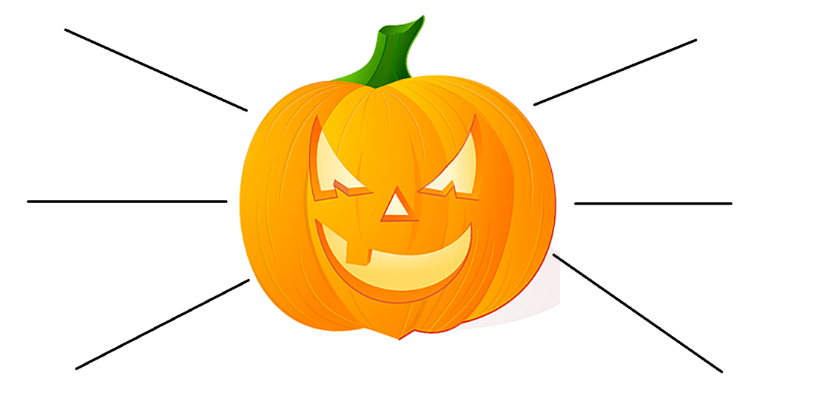

- Translate these words into your own language. Ask your friends or use the dictionary to help you.
-
a graveyard - …cmentarz………………………………………………………………………………………………………………………………………..
a monster - …potwór………………………………………………………………………………………………………………………………………………
a tribe - …plemię…………………………………………………………………………………………………………………………………………………….
a spirit - …dusza, duch…………………………………………………………………………………………………………………………………………….
a priest - …kapłan…………………………………………………………………………………………………………………………………………………..
a villager - …osoba mieszkająca na wsi…………………………………………………………………………………………………………………..
to lurk - …czaić się…………………………………………………………………………………………………………………………………………………..
to repel - …odpierać, odrzucać……………………………………………………………………………………………………………………………….
to confuse - …mieszać komuś w głowie, mylić, wikłać, gmatwać, komplikować……………………………………………………
a heathen - …poganin, poganka……………………………………………………………………………………………………………………………..
a bonfire - …ognisko…………………………………………………………………………………………………………………………………..............
to carve - …rzeźbić, wycinać…………………………………………………………………………………………………………………………………..
the poor - …biedni………………………………………………………………………………………………………………………………………………….
sinister - …złowrogi………………………………………………………………………………………………………………………………………………..
profitable - …zyskowny, rentowny…………………………………………………………………………………………………………………………
a retailer - …sprzedawca (detaliczny)…………………………………………………………………………………………………………………..…
to transcend -…przekraczać (granice) ……………………………………………………………………………………………………………………
spooky - …straszny………………………………………………………………………………………………………………………………………..………

During the movie:
- Where did the Halloween tradition begin?
- Celtic Ireland b) the USA c) Poland
- What is the date of the Halloween?
…………31st October………………………
- Did the tradition begin BC (Before Christ) or AD (Anno Domini, After Christ)?
- AD b) BC
- Why did the people light great bonfires and disguise themselves?
to repel and confuse the spirits ………………………………………………………………………………………………………………………………………………………………………………
- In which century did the Pope establish All Hallow’s Day?
………8th …………………………
- Which pope established All Hallow’s Day?
- John Paul II b) Gregory IV c) Gregory III
- What was the purpose of All Hallow’s Day?
- to honour all dead b) to honour all saints c) to honour all living

- What was the name that the Samhain changed into?
a) All Halloween b) All Hallow’s Day c) All Hallow’s Eve

- When did the Potato Famine drive millions of Irish into America? Mark it on the timeline provided below.
mid 19th century
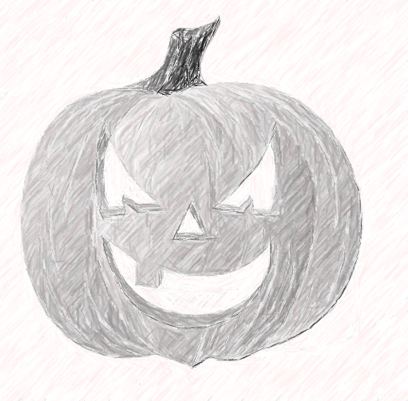
- What is a jack-o’-lantern? Draw it.

- What is the origin of trick or treating?
it is believed to have stemmed from the custom in which the poor went from home to home and prayed for the souls of each families’ dead in exchange for some cakes to eat ………………………………………………………………………………………………………………………………………………………………………………………………………………………………………………………………………………………………………………………………………………………………
- Is Halloween profitable nowadays? a) Yes b) No. c) I don’t know.

- Adults also celebrate Halloween.
- True b) False c) I have no idea.

- How do some people celebrate Halloween now?
People wear costumes, scare other people etc. ………………………………………………………………………………………………………………………………………………………………………………………………………………………………………………………………………………………………………………………………………………………………………………………………………………………………………………………………………………………………………………………………………………………………………………………………………………………………………………………………………………………………………………………………………………………………………………………………………………………………………………………………………………………………………………

After the movie:
- Work in pairs or in groups. Write a spooky story you could tell someone else to scare them. -
………………………………………………………………………………………………………………………………………………………………………………………………………………………………………………………………………………………………………………………………………………………………………………………………………………………………………………………………………………………………………………………………………………………………………………………………………………………………………………………………………………………………………………………………………………………………………………………………………………………………………………………………………………………………………………………………………………………………………………………………………………………………………………………………………………………………………………………………………………………………………………………………………………………………………………………………………………………………………………………………………………………………………………………………………………………………………………………………………………………………………………………………………………………………………………………………………………………………………………………………………………………………………………………………………………………………………………………………………………………………………………………………………………………………………………………………………………………………………………………………………………………………………………………………………………………………………………………………………………………………………………………………………………………………………………………………………………………………………………………………………………………………………………………………………………………………………………………………………………………………………………………………………………………………

