Johnny English – Movie Worksheet
- Watch the movie and answer the questions provided below.

1. At the start of the movie, Johnny English has sneaked in to a building and has met an attractive lady. What is the truth about this scene?
A. It happened but the lady was really Agent 1
B. It is a videogame
C. It is a dream
D. It is a movie
2. What color is the pen which Johnny English uses to make the secretary collapse?
_____________________________________________
3. Johnny English blames an assault on a man with orange hair and a scar on his cheeks. What was his scar shaped like?
A. a frog
B. a banana
C. a pear
D. an elephant
4. When Johnny English is speaking to Lorna in Japanese, what is he saying?
A. "May all your pets have three bottoms"
B. "May All Your Sons be born with three bottoms."
C. "May All Your Daughters be born with three bottoms."
D. "Nice Sushi, though I'd rather have pork pies"
5. What is the name of Johnny English's right-hand man?
A. Bradshaw
B. Bradford
C. Bough
D. Boughen
6. Complete this line which features on a character's bottom:
"Jesus is coming! Look _________________________!"
7. The people who stole the Crown Jewels hid them in what?
- doll houses
- shoe boxes
- briefcases
- coffins

8. What country does the character Pascal Sauvage come from?
_______________________________ (One Word)
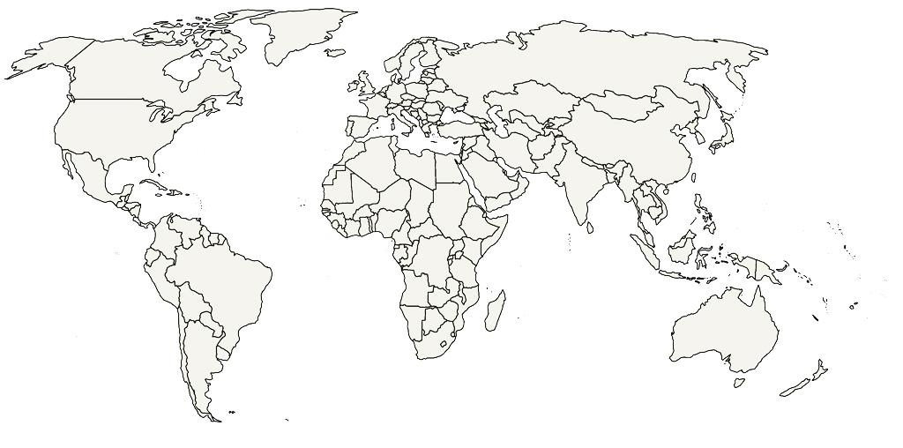
9. Find and mark the country from which Pascal Savauge comes from.

10. At the end of the movie, who becomes King of England?
A. Agent One B. Johnny English C. Pascal Sauvage D. Pegasus

- Did you like the movie? Why / Why not?
………………………………………………………………………………………………………………………………………………………………………………………………………………………………………………………………………………………………………………………………………………………………………………………………………………………………………………………………………………………………………………………………………………………………………………………………………………………………………………………………………………………………………………………………………………………………………………………………………………………………………………………………………………………………………………………………………………………………………………………………………………………………………………………………………………………………………………………………………………………………………………………………………………………………………………………………………………………………………………………………………………………………………………………………………………………………………………………………………………………………………………………………………………………………………………………………………………………………………………………………………………………………………………………………………………………………………………………………………………………………

- What words or phrases have you learnt from this movie? Make a list.
………………………………………………………………………………………………………………………………………………………………………………………………………………………………………………………………………………………………………………………………………………………………………………………………………………………………………………………………………………………………………………………………………………………………………………………………………………………………………………………………………………………………………………………………………………………………………………………………………………………………………………………………………………………………………………………………………………………………………………………………………………………………………………………………………………………………
………………………………………………………………………………………………………………………………………………………………………………………………………………………………………………………………………………………………………………………………………………………………………………………………………………………………………………………………………………………………………………………………………………………………………………………………………………………………………………………………………………………………………………………………………………………………………………………………………………………………………………………………………………………………………………………………………………………………………………………………………………………………………………………………………………………………
- Have you learnt something else by watching this movie? What was it? Fill in the mind map.

What have I learnt?

