Goosebumps – Movie Worksheet
- Watch the movie and answer the questions provided below.

  - What town does the movie take place in?
    - Madison, Ohio
    - Madison, New Yersey
    - Madison, Delaware
    - Madison, Wisconsin

  - What is Champ's unfortunate nickname?
    - Chump
    - Lump
    - Chomp
    - Bump

  - Which is the first Goosebumps manuscript to be unlocked?
    - Night of the Living Dummy
    - The Abominable Snowman of Pasadena
    - Revenge of the Lawn Gnomes
    - The Haunted Car

  - What is this dummy's name?
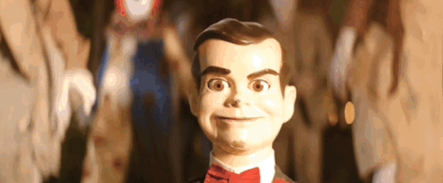
    - Zeebo
    - Champ
    - Slappy
    - Dummy

  - What happens to Hannah at the end of the movie?
    - Hannah and Champ start dating.
    - She and her dad move away.
    - Hannah goes to a new school.
    - She gets sucked into a book.
  - What class does R.L. Stine end up teaching at school?
    - English
    - Creative Writing
    - History of Horror
    - Film Theory

  - What is Brent Green also known as?
    - The Werewolf
    - The Masked Mutant
    - The Invisible Boy
    - The Blob Who Ate Everything

- Did you like the movie? Why / Why not?
………………………………………………………………………………………………………………………………………………………………………………………………………………………………………………………………………………………………………………………………………………………………………………………………………………………………………………………………………………………………………………………………………………………………………………………………………………………………………………………………………………………………………………………………………………………………………………………………………………………………………………………………………………………………………………………………………………………………………………………………………………………………………………………………………………………………
- What words or phrases have you learnt from this movie? Make a list.
………………………………………………………………………………………………………………………………………………………………………………………………………………………………………………………………………………………………………………………………………………………………………………………………………………………………………………………………………………………………………………………………………………………………………………………………………………………………………………………………………………………………………………………………………………………………………………………………………………………………………………………………………………………………………………………………………………………………………………………………………………………………………………………………………………………………
………………………………………………………………………………………………………………………………………………………………………………………………………………………………………………………………………………………………………………………………………………………………………………………………………………………………………………………………………………………………………………………………………………………………………………………………………………………………………………………………………………………………………………………………………………………………………………………………………………………………………………………………………………………………………………………………………………………………………………………………………………………………………………………………………………………………
- Have you learnt something else by watching this movie? What was it? Fill in the mind map.

What have I learnt?

