Before reading:
- Work in pairs. In turns, answer the questions.
- Have you ever been to Ukraine?
If your answer is “yes”, then what places have you visited?
If “no”, then would you like to go there in the future? Why / Why not?
- Do your friends or family live in Ukraine? Do you keep contact with them?
- Do you keep up-to-date with the current events regarding the war in Ukraine? Why / Why not?
- What do you think is the general public’s reaction to the war in…
Ukraine?
Russia?
Your country?
- What do you think the government of your country should do regarding the war in Ukraine?
- Look at the map of Europe. Where exactly is Ukraine? Mark the country on the map. -
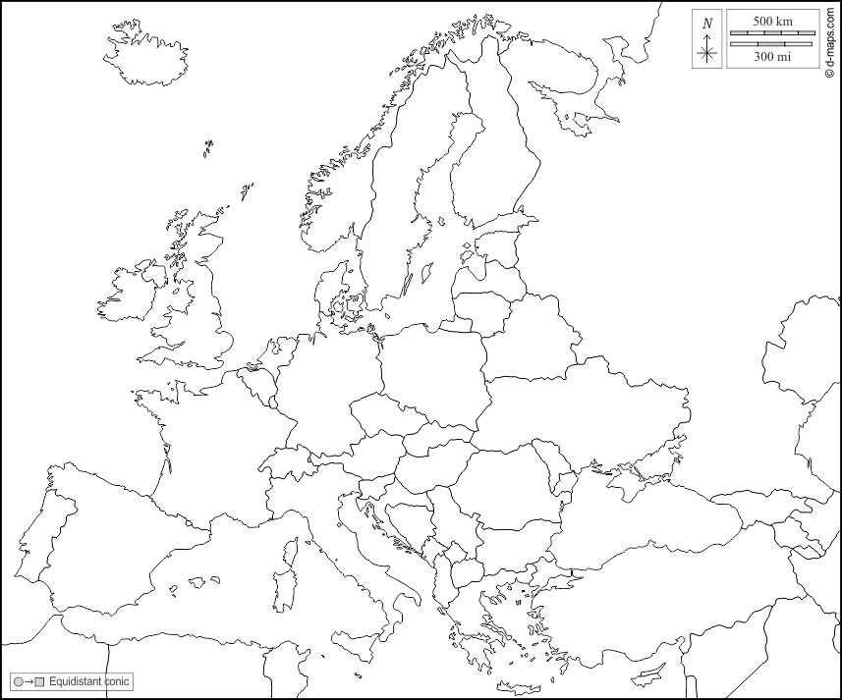
(map adapted from https://d-maps.com)
- Translate these words and phrases into your own language. Ask your friends or use a dictionary to help you.
-
despair –
independence –
to stammer –
to deteriorate –
to rattle –
irrevocable –
a defence –
a coffin –
apparent –
If you need English definitions you can look them up in OALD 😊 www.oxfordlearnersdictionaries.com
Don’t forget to mark the words you didn’t know before with a star
- Complete the text with the correct form of some of the words from the previous task.
The military invasion of Russia on the A. country of Ukraine started on 24th Feb 2022.
Many people expected this conflict to escalate for quite some time, as the situation in the region was
B. for many years. However, even though the invading forces believed to be entering a C. state, Ukrainian soldiers proved their mettle, fighting without D. . According to many, the aggression of one country over the other will E. change the diplomatic relations between Russia and the rest of the world.
to prove one’s mettle – to prove that a person is strong or skilful enough to succeed in a difficult situation

During reading:
https://www.theguardian.com/commentisfree/2022/feb/25/family-russia-ukraine-fear-both-sides-of-border
- Read the article quickly and answer the question.

How does the author feel about the war in Ukraine?

- Read the article once again (if need be). Decide if the sentences are TRUE, FALSE or NOT GIVEN.

  - The author of the article is Ukrainian.
TRUE / FALSE / NOT GIVEN
  - The author’s family liked talking with Ukrainians.
TRUE / FALSE / NOT GIVEN
  - The author of the article has started stammering because of the war in Ukraine.
TRUE / FALSE / NOT GIVEN
  - The Russian media were presenting their victory in the war.
TRUE / FALSE / NOT GIVEN
  - The author’s father had his car destroyed in Ukraine in 2014.
TRUE / FALSE / NOT GIVEN
  - The author feels compassion to both Russians and Ukrainians.
TRUE / FALSE / NOT GIVEN
  - The author has a neutral opinion on Vladimir Putin.
TRUE / FALSE / NOT GIVEN

After reading:
- Work in pairs. Describe the picture and answer the questions.
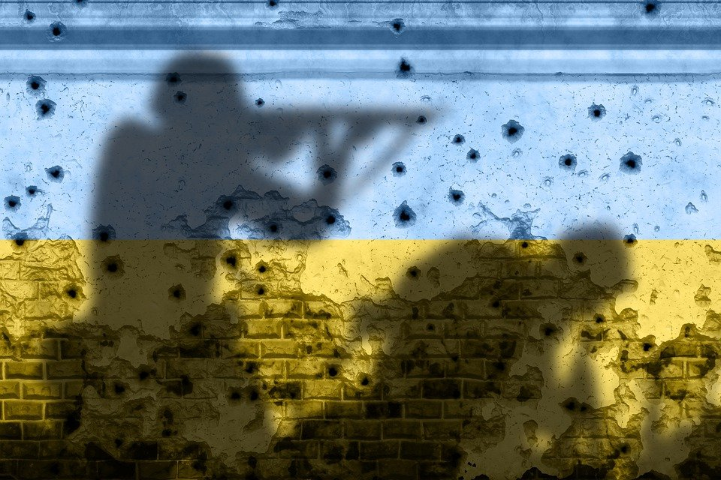
Source: https://pixabay.com/images/id-7031831/

  - What may be the metaphorical meaning of the photo?
  - How can a person from your country help Ukrainian refugees?
  - How is the current conflict different from the wars you’ve learnt about before?
  - Do you think that the Russian invasion on Ukraine will have long-lasting effects on the world politics?
Why / Why not?

