Warsaw: the Spirit of Hope Warsaw Vacation Travel Guide | Expedia: https://youtu.be/esJ_l1b_Ni0
Before the movie: TEACHER’S ANSWER KEY
- When you think about Warsaw, what comes to your mind first?
Fill in the mind map alone or with your deskmate. Add more lines if necessary. -

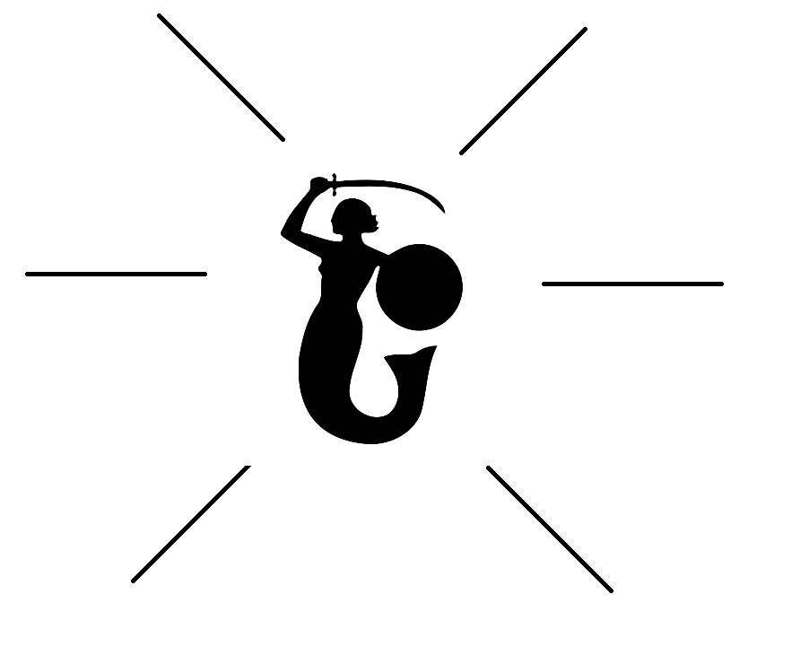
(clipart adapted from https://openclipart.org)
- Look at the map of Poland. Where exactly is Warsaw?
Try to find the dot which represents the city. Work alone or with your deskmate. -

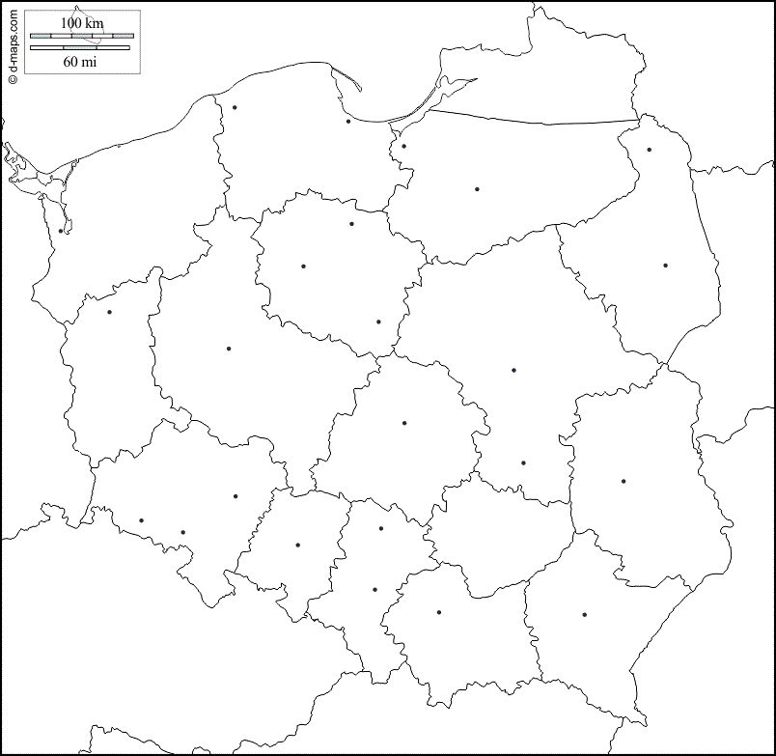
(map adapted from https://d-maps.com/carte.php?num_car=18745&lang=en)
- Translate these words and phrases into your own language. Ask your friends or use a dictionary to help you.
-
a stronghold – twierdza
refinement – udoskonalenie, wytworność
to resonate – rozbrzmiewać
shackles – kajdany
burgeoning – rozkwitający, kiełkujący
an uprising – powstanie
a retaliation – odwet, zemsta
opulent – bogaty, obfity
painstakingly – skrupulatnie, drobiazgowo
a coat of arms – herb
to outlaw – zakazać
to pay the ultimate price – umrzeć
infamous – niesławny
to incarcerate – uwięzić
a remnant – pozostałość, ślad
to stud – usiać
a deathbed – łoże śmierci
a reminder – przypomnienie, wspomnienie
luxurious – luksusowy, komfortowy
cutting edge – przełomowy, nowatorski, innowacyjny
a beacon – sygnał świetlny. latarnia

If you need English definitions you can look them up in OALD 😊
www.oxfordlearnersdictionaries.com

- Which of the words presented in exercise 3 were new to you?
Mark the new words with a star

- Work with a partner. Describe what you see in the picture provided below.
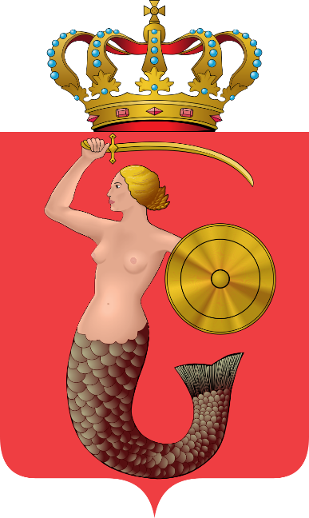
During the movie:
- What two events shaped the Warsaw of today?
Mark them on the timeline, using the information from the film and your own knowledge.

1939 – 1945 World War II
1900
2000
1989 the closing of the Iron Curtain
1944 Warsaw Uprising (exercise 7)

- In what part of the city brave locals started the Warsaw Uprising?
They started the Uprising in the Old Town.
Using your own knowledge mark the date of the Uprising on the timeline provided above (in exercise 6).

- What was the role of the Royal Castle in Castle Square?
- It served as the seat for Polish prime ministers.
- It served as the seat for Polish kings.
- It was always a museum.

- Were most of the castle’s treasures saved from being destroyed during the war?
a) Yes. b) No. c) I don’t know.

- Where is the Warsaw Museum?
On the northern side of the Old Town Square.

- Was education prohibited during the occupation?
a) Yes. b) No. c) I don’t know.

- How many people continued their lessons throughout the occupation?
Mark the appropriate number on the “digital screen”.
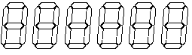
- Where is the POLIN Museum of the History of Polish Jews?
It’s on the site that was once the Warsaw Ghetto.

- What was the size of the Warsaw Ghetto?

A: 1 square mile.

B: 1,5 square miles.
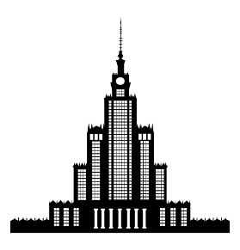

C: 2,5 square miles.

- The Palace of Culture and Science… (clipart adapted from https://www.kisspng.com/png-palace-of-culture-and-science-information-1812271)

was a gift to the Polish people from Stalin at the heights of the Cold War.
- What was the greatest achievement of Nicolaus Copernicus? Describe.

He revolutionized science with his theory that the earth orbits the sun.

- What can you find in the Holy Cross Church?
- 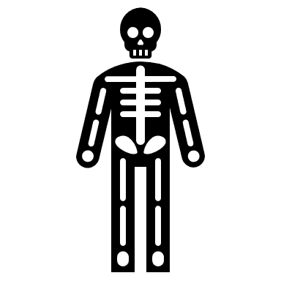The body of Fryderyk Chopin.
- 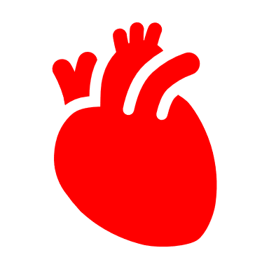The heart of Fryderyk Chopin.
- The original musical notation made by Fryderyk Chopin.

- How is the economic success of Poland reflected in the city? Describe.

The success is reflected in the luxury malls that have sprung up (e.g. Złote Tarasy) and in a number of former industrial areas that have transformed.
- What’s the reason for the Neon Museum to operate?
- It lets people see the neons of the XXI century.
- It preserves the neons from Warsaw’s Soviet era.
- It shows how neons were used around the world.

After the movie: -
- Work in groups. Imagine that you are travelling to Warsaw for 5 days.
Prepare a sightseeing plan, describing what attractions you would like to see (and why), where you would eat, as well as providing information about the accommodation (e.g. hotels) you would choose.
Don’t forget to talk about the costs!

To help you with the task you can use the internet, especially:
https://www.expedia.com/Warsaw.d178317.Destination-Travel-Guides
https://www.tripadvisor.com/Tourism-g274856-Warsaw_Mazovia_Province_Central_Poland-Vacations.html

………………………………………………………………………………………………………………………………………………………………………………………………………………………………………………………………………………………………………………………………………………………………
………………………………………………………………………………………………………………………………………………………………………………………………………………………………………………………………………………………………………………………………………………………………
………………………………………………………………………………………………………………………………………………………………………………………………………………………………………………………………………………………………………………………………………………………………
………………………………………………………………………………………………………………………………………………………………………………………………………………………………………………………………………………………………………………………………………………………………
………………………………………………………………………………………………………………………………………………………………………………………………………………………………………………………………………………………………………………………………………………………………
………………………………………………………………………………………………………………………………………………………………………………………………………………………………………………………………………………………………………………………………………………………………
………………………………………………………………………………………………………………………………………………………………………………………………………………………………………………………………………………………………………………………………………………………………
………………………………………………………………………………………………………………………………………………………………………………………………………………………………………………………………………………………………………………………………………………………………
………………………………………………………………………………………………………………………………………………………………………………………………………………………………………………………………………………………………………………………………………………………………
………………………………………………………………………………………………………………………………………………………………………………………………………………………………………………………………………………………………………………………………………………………………
………………………………………………………………………………………………………………………………………………………………………………………………………………………………………………………………………………………………………………………………………………………………
………………………………………………………………………………………………………………………………………………………………………………………………………………………………………………………………………………………………………………………………………………………………
………………………………………………………………………………………………………………………………………………………………………………………………………………………………………………………………………………………………………………………………………………………………
………………………………………………………………………………………………………………………………………………………………………………………………………………………………………………………………………………………………………………………………………………………………

