The Origins of Christmas Worksheet Origins of Christmas | History: o-rozewicz.pl/christmas-origins
Before the movie:
- When you think about Christmas, what comes to your mind first?
Fill in the mind map alone or with your deskmate. Add more lines if necessary. -

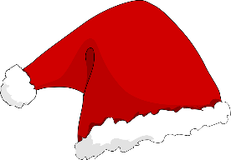

Picture adapted from https://pixabay.com/pl/vectors/święty-mikołaj-kapelusz-43847/
- Translate these words into your own language. Ask your friends or use the dictionary to help you.
-
origins – geneza, początki
norse - nordycki
evergreens – wiecznie zielone
logs – kłody, bale
solstice - przesilenie
to celebrate – celebrować, świętować
holy - święty
pagan - pogański
a mystery – zagadka
to theorise - teoretyzować
to outlaw - zakazać
to reimagine – wyobrazić sobie na nowo
a reindeer - renifer
a cheer - radość
jolly – radosny, wesoły
If you need English definitions you can look them up in OALD 😊 www.oxfordlearnersdictionaries.com
Don’t forget to mark the words you didn’t know before with a star
During the movie:
- What were people doing during Yule and Saturnalia? Describe the activities… or draw them.
- Yule
no drawing, sorry 😊
Around 21st Dec. (the Winter Solstice) fathers and sons dragged evergreens indoors as reminders of life and set logs on fire as a promise of good fortune.

- Saturnalia
no drawing, sorry 😊
One week before the Winter Solstice, Romans celebrated an orgy of food and drink (called Saturnalia).

- Does the Bible mention exactly when Christ was born?
- Yes. b) No. c) I don’t know.
- In which century was 25th XII adopted as the feast day of the nativity - later known as Christmas?
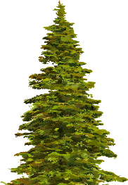
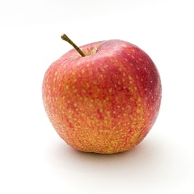
- What was the symbolic meaning of evergreens decorated with apples?
They symbolized the garden of Eden.

Pictures adapted from
https://pixabay.com/pl/photos/apple-żywności-owoców-1834639 and https://pixabay.com/pl/vectors/kolorowy-evergreen-iglastych-natura-1297806/
- Which century marks the beginning of the Santa Claus story?
- What’s the story described in a poem “The Night before Christmas”, published in 1822?
“Good natured saint called Santa Claus (…) was pulled by a group of reindeer and came down the chimney on Christmas Eve. Like Saint Nicolas, Santa Claus spread good cheer and gave gifts to children.”
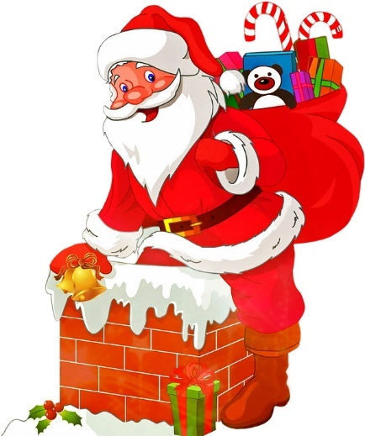
- Who’s responsible for the current-day look of Santa Claus?

In 1863, Thomas Nast
a cartoonist for Harper’s Weekly, created his version of the Christian saint.

Picture adapted from https://pixabay.com/pl/illustrations/santa-claus-boże-narodzenie-nicholas-1614994

After the movie:
- Work in pairs or in groups. Create a short Christmas story. -
………………………………………………………………………………………………………………………………………………………………………………………………………………………………………………………………………………………………………………………………………………………………………………………………………………………………………………………………………………………………………………………………………………………………………………………………………………………………………………………………………………………………………………………………………………………………………………………………………………………………………………………………………………………………………………………………………………………………………………………………………………………………………………………………………………………………………………………………………………………………………………………………………………………………………………………………………………………………………………………………………………………………………………………………………………………………………………………………………………………………………………………………………………………………………………………………………………………………………………………………………………………………………………………………………………………………………………………………………………………………………………………………………………………………………………………………………………………………………………………………………………………………………………………………………………………………………………………………………………………………………………………………………………………………………………………………………………………………………………………………………………………………………………………………………………………………………………………………………………………………………………………………………………………………

A Christmas song & carol:
Jingle Bells original with lyrics: o-rozewicz.pl/jingle-bells

- Listen to the Christmas songs and try to fill in the gaps in it, using the words provided below.
song / song / snow / ride / fun / fun / back / sleigh / sleigh / ring / laughed / story / horse / bank / white
chorus

A day or two ago
The ¹⁰ story I must tell
I went out on the snow
And on my ¹¹ back I fell;
A gent was riding by
In a one-horse open sleigh
He ¹² laughed as there I sprawling lie
But quickly drove away.

chorus

Now the ground is ¹³ white
Go it while you're young,
Take the girls tonight
And sing this sleighing ¹⁴ song
Just get a bob-tailed bay,
Two-forty for his speed,
Then hitch him to an open ¹⁵ sleigh
And crack! You'll take the lead.

Dashing through the ¹ snow
In a one-horse open ² sleigh
O'er the fields we go
Laughing all the way.
Bells on bob-tail ³ ring
Making spirits bright
What fun it is to ride and sing
A sleighing ⁴ song tonight.

chorus:
Jingle bells, jingle bells
Jingle all the way,
Oh what ⁵ fun it is to ride
In a one-horse open sleigh,
Jingle bells, jingle bells
Jingle all the way,
Oh what ⁶ fun it is to ride
In a one-horse open sleigh.

A day or two ago
I thought I'd take a ⁷ ride
And soon Miss Fanny Bright
Was seated by my side;
The ⁸ horse was lean and lank
Misfortune seemed his lot,
We got into a drifted ⁹ bank
And there we got upsot.
Lyrics: public domain – https://en.wikisource.org/wiki/Jingle_Bells
- Sing the Christmas song together with your groupmates! +
Michael Bublé - Silent Night: o-rozewicz.pl/silent-night-buble

- Listen to the Christmas carol and try to fill in the gaps in it, using some of the words provided below.

child / heavenly / Saviour / holy / holy / bright / birth / heavenly / heaven / Saviour / God / birth / holy / grace

Silent night, ¹ holy night,
All is calm, all is ² bright
Round yon Virgin Mother and ³ Child
Holy infant so tender and mild,
Sleep in ⁴ heavenly peace.
Sleep in ⁵ heavenly peace.

Silent night, ⁶ holy night,
Son of ⁷ God love's pure light
Radiant beams from Thy Holy face,
With the dawn of redeeming ⁸ grace,
Jesus, Lord, at Thy ⁹ birth
Jesus, Lord, at Thy ¹⁰ birth

Lyrics: public domain – https://en.wikisource.org/wiki/Silent_Night_(unsourced)

- Sing the Christmas carol together with your groupmates! +

