The Origins of Christmas Worksheet Origins of Christmas | History: o-rozewicz.pl/christmas-origins
Before the movie:
- When you think about Christmas, what comes to your mind first?
Fill in the mind map alone or with your deskmate. Add more lines if necessary. -

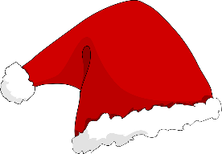

Picture adapted from https://pixabay.com/pl/vectors/święty-mikołaj-kapelusz-43847/
- Translate these words into your own language. Ask your friends or use the dictionary to help you.
-
origins - ………………………………………………………………………………………………………………………..……..……..……..………………….
norse - ………………………………………………………………………………………………………………………………………………………..………….
evergreens -..………………………………………………………………………………………………………………………………………………………….
logs - ………………………………………………………………………………………………………………………………………..………..………………….
solstice - ……………………………………………………………..………………………………………………………………..……………………………….
to celebrate - ……………………………………………………………..………………………………………………………………..………………………..
holy - ………………………….…………………………………………………………………………………………………..……………………………………..
pagan - ………………………………………………………….……………………………………………………………………………………………………….
a mystery - …………………..………………………………………………………………………………………………………………………………………..
to theorise - ……………………………………………………………………………………………………………………………………………………………
to outlaw - ………………………………….…………………………………………………………………………………………………..……….……..…….
to reimagine - ……..………………………..……………………………………………………………………………………………………….……………...
a reindeer - ……..………………………..………………………………………………………………………………………………………………..………...
a cheer - ……..………………………..……………………………………………………………………………………………………………….……………...
jolly - ……..………………………..…………………………………………………………………………………………………….……………………………...
If you need English definitions you can look them up in OALD 😊 www.oxfordlearnersdictionaries.com
Don’t forget to mark the words you didn’t know before with a star
During the movie:
- What were people doing during Yule and Saturnalia? Describe the activities… or draw them.
- Yule

- Saturnalia

- Does the Bible mention exactly when Christ was born?
- Yes. b) No. c) I don’t know.
- In which century was 25th XII adopted as the feast day of the nativity - later known as Christmas?
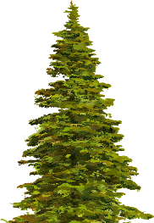
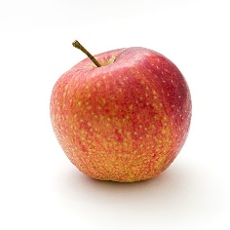
- What was the symbolic meaning of evergreens decorated with apples?
…………………………………………………………………………………………………………………………………………………………………………………………………………………………………………………………………………………………………………………………………………………………………………………………………………………………………………………………………………………………………………
Pictures adapted from
https://pixabay.com/pl/photos/apple-żywności-owoców-1834639 and https://pixabay.com/pl/vectors/kolorowy-evergreen-iglastych-natura-1297806/
- Which century marks the beginning of the Santa Claus story?
- What’s the story described in a poem “The Night before Christmas”, published in 1822?
……………………………………………………………………………………………………………………………………………………………………………………………………………………………………………………………………………………………………………………………………………………………………………………………………………………………………………………………………………………………………………………………………………………………………………………………………………………………………………………………………………………………………………………………..
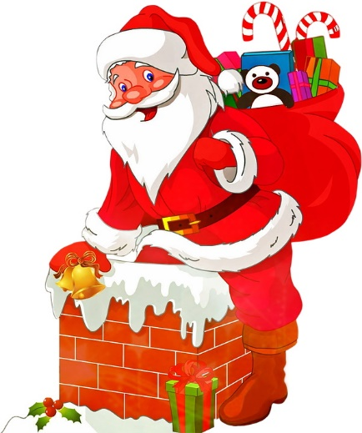
- Who’s responsible for the current-day look of Santa Claus?

In 1863, …………………………………………………………………………………….……………………, a cartoonist for Harper’s Weekly, created his version of the Christian saint.

Picture adapted from https://pixabay.com/pl/illustrations/santa-claus-boże-narodzenie-nicholas-1614994

After the movie:
- Work in pairs or in groups. Create a short Christmas story. -
………………………………………………………………………………………………………………………………………………………………………………………………………………………………………………………………………………………………………………………………………………………………………………………………………………………………………………………………………………………………………………………………………………………………………………………………………………………………………………………………………………………………………………………………………………………………………………………………………………………………………………………………………………………………………………………………………………………………………………………………………………………………………………………………………………………………………………………………………………………………………………………………………………………………………………………………………………………………………………………………………………………………………………………………………………………………………………………………………………………………………………………………………………………………………………………………………………………………………………………………………………………………………………………………………………………………………………………………………………………………………………………………………………………………………………………………………………………………………………………………………………………………………………………………………………………………………………………………………………………………………………………………………………………………………………………………………………………………………………………………………………………………………………………………………………………………………………………………………………………………………………………………………………………………
A Christmas song & carol:
Jingle Bells original with lyrics: o-rozewicz.pl/jingle-bells

- Listen to the Christmas songs and try to fill in the gaps in it, using the words provided below.
song / song / snow / ride / fun / fun / back / sleigh / sleigh / ring / laughed / story / horse / bank / white
chorus

A day or two ago
The ¹⁰ ____________________I must tell
I went out on the snow
And on my ¹¹ ____________________ I fell;
A gent was riding by
In a one-horse open sleigh
He ¹² ____________________as there I sprawling lie
But quickly drove away.

chorus

Now the ground is ¹³ ____________________,
Go it while you're young,
Take the girls tonight
And sing this sleighing ¹⁴ ____________________.
Just get a bob-tailed bay,
Two-forty for his speed,
Then hitch him to an open ¹⁵ ____________________
And crack! You'll take the lead.

Dashing through the ¹ ____________________
In a one-horse open ² ____________________
O'er the fields we go
Laughing all the way.
Bells on bob-tail ³ ____________________
Making spirits bright
What fun it is to ride and sing
A sleighing ⁴ ____________________tonight.

chorus:
Jingle bells, jingle bells
Jingle all the way,
Oh what ⁵ ____________________it is to ride
In a one-horse open sleigh,
Jingle bells, jingle bells
Jingle all the way,
Oh what ⁶ ____________________it is to ride
In a one-horse open sleigh.

A day or two ago
I thought I'd take a ⁷ ____________________
And soon Miss Fanny Bright
Was seated by my side;
The ⁸ ____________________was lean and lank
Misfortune seemed his lot,
We got into a drifted ⁹ ____________________
And there we got upsot.
Lyrics: public domain – https://en.wikisource.org/wiki/Jingle_Bells
- Sing the Christmas song together with your groupmates! +
Michael Bublé - Silent Night: o-rozewicz.pl/silent-night-buble

- Listen to the Christmas carol and try to fill in the gaps in it, using some of the words provided below.

child / heavenly / Saviour / holy / holy / bright / birth / heavenly / heaven / Saviour / God / birth / holy / grace

Silent night, ¹ ____________________ night,
All is calm, all is ² ____________________
Round yon Virgin Mother and ³ ____________________.
Holy infant so tender and mild,
Sleep in ⁴ ____________________ peace.
Sleep in ⁵ ____________________ peace.

Silent night, ⁶ ____________________ night,
Son of ⁷ ____________________, love's pure light
Radiant beams from Thy Holy face,
With the dawn of redeeming ⁸ ____________________,
Jesus, Lord, at Thy ⁹ ____________________.
Jesus, Lord, at Thy ¹⁰ ____________________.

Lyrics: public domain – https://en.wikisource.org/wiki/Silent_Night_(unsourced)

- Sing the Christmas carol together with your groupmates! +

