The Nobel Prize Worksheet
Before the movie:
- When you think about Nobel Prize, what comes to your mind first? -
Fill in the mind map alone or with your deskmate. Add more lines if necessary.

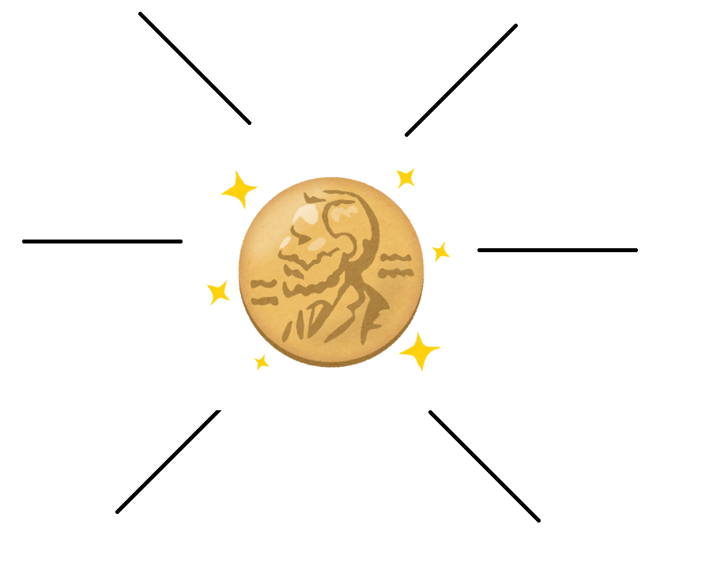
(clipart adapted from https://www.kisspng.com/png-nobel-prize-in-physiology-or-medicine-nobel-prize-3441682 )
- Where is Nobel Prize awarded? Find the countries on the map, as well as provide their names. -
There are two countries awarding Nobel Prizes – depending on the category.

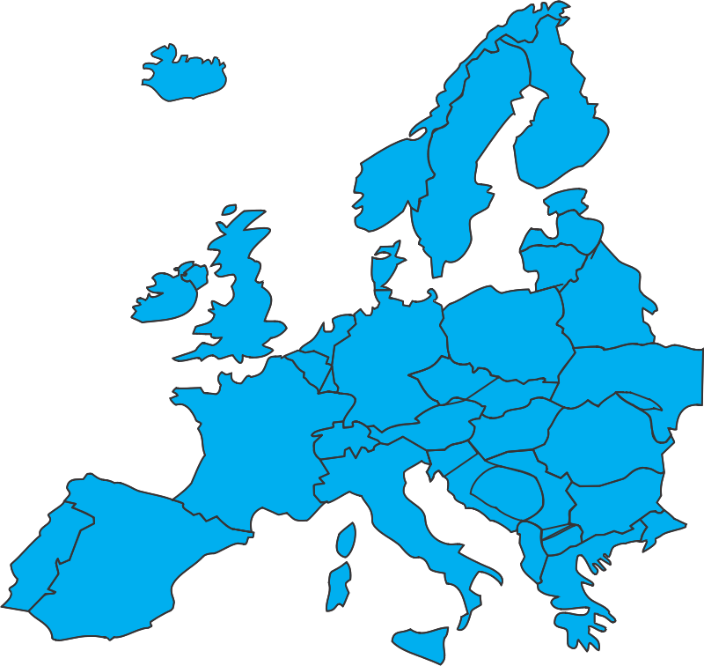 (map adapted from https://openclipart.org/detail/88159/european-map)

………………………………………………………………………………………………………..……………………………………………………………………

- Translate these words and phrases into your own language. Ask your friends or use a dictionary to help you.
You are provided with English definitions of the words to help you with the task.
-
- to covet – ………………………………………………………………………………………………………………………………………………………………
- innovative – ……………………………………………………………………………………………………………………………………………………………
- to establish – …………………………………………………………………………………………………………………………………………………………
- obituary – …………………………………………..………………………………………………………………………………………………………………….
- lavish – ………………………………………………………………………..…………………………………………………………………………………………
- nebulous – …………………………………………………………………………………………………………………………………………………………….
- fraternity – …………………………………………………………………………………………………………………………………………………………….
- contentious – …………………………………………………………………………………………………………………………………………………………
- to appoint – …………………………………………………………………………………………………………………………………………………………..
- to despair – ………………………………………………………………………………………………………..………………………………………………….
- to kick the bucket – ……………………………………………………………………………………………………………………………………………….
- a ceasefire – …………………………………………………………………………………………………...…………………………………………………….
- dubious – ……………………………………………………………………………………………………………………………………………………………….
- a stardom – ……………………………………………………………………………………………………………………………………………………………
- infallible – ………………………………………………………………………………………………………………………………………………………………
- a sage – …………………………………………………………………………………….……………………………………………………………………………
- a deification – ………………………………………………………………………………………………………………………………………………………..
- a cronyism – ..……………………………………………………………………………………………………………………………………………………….
- to skew – ……………………………………………………………………………………………………………………………………………………………….
- to plump –………………………………………………………………………………………………………………………………………………………………
- appalling – ……………………………………………………………………………………………………………………………………………………………..
- to circumvent – ………………………………………………………………..……………………………………………………………………………………

If you need English definitions you can look them up in OALD 😊
www.oxfordlearnersdictionaries.com

- Which of the words presented in exercise 3 were new to you?
Mark the new words with a star

During the movie: How to Win A Nobel Prize - EPIC HOW TO: https://youtu.be/iMsjHexEXWw
- Who established the Nobel Prize?
- Alfred Hitchcock. b) Alfonse Nobel. c) Alfred Nobel.

- How many times was the Nobel Prize given (as of 2014)?
Draw the number on the ‘digital screen’
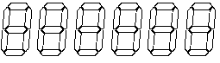
- Pick the correct graph showing the distribution of Nobel Prize laureates (as of 2014).

- Write down the names of some controversial nominees / laureates of the Nobel Peace Prize.
Why are they contentious?
………………………………………………………………………………………………………………………………………………………………………………………………………………………………………………………………………………………………………………………………………………………………………………………………………………………………………………………………………………………………………………………………………………………………………………………………………………………………………………………………………………………………………………………………………………………………………………………………………………………………………………………………………………………………………………………………………………………………………………………………………………………………………………………………………………………………`

- How many nominations were there in 2009 and 2004?
Mark the years and the exact numbers of nominations on the graph.
………………………………………………………………
………………………………………………………………

- How much time did Albert Einstein have to wait to win his Nobel Prize after the first nomination?
- 111 years. b) 91 years. c) 11 years.

- What do Dalai Lama, Al Gore and Barack Obama have in common?
- They got a Nobel Prize because they did only good things.
- They got a Nobel Prize for their scientific achievements.
- They got a Nobel Prize even though they didn’t primarily work for the world peace.

- Is it possible for an organization to get a Nobel Prize?
- Yes. b) No. c) I don’t know.

After the movie:
- What’s the article hidden behind the QR code about? -
Provide a brief summary or draw a mind map.
………………………………………………………………………………………………………………………………………………………………………………………………………………………………………………………………………………………………………………………………………………………………………………………………………………………………………………………………………………………………………………………………………………………………………………………………………………………………………………………………………………………………………………………………………………
https://bit.ly/2It6XFx

- Read the article again. Choose whether the following statements are true or false. -
- Nobel Prizes reward an outdated version of science. TRUE / FALSE
- People know who was nominated for a prize and who did the nominating. TRUE / FALSE
- Dmitri Mendeleev, creator of the periodic table of elements, didn’t get a Noble Prize. TRUE / FALSE
- No more than three people can win an individual science Nobel Prize. TRUE / FALSE
- There is no possibility for the organisations to win the Nobel Prize. TRUE / FALSE

- Answer the questions, using the article you’ve read. -
- What sciences are ignored and do not get the Nobel Prizes?
……………………………………………………………………………………………………………………………………………………………………………………………………………………………………………………………………………………………………………………………………………………
- How many women won Nobel Prizes in physics?
……………………………………………………………………………………………………………………………………………………………………………………………………………………………………………………………………………………………………………………………………………………
- How did William Shockley exploit his status as a Nobel Prize winner?
……………………………………………………………………………………………………………………………………………………………………………………………………………………………………………………………………………………………………………………………………………………
- According to Keating, how should awarding the Nobel Prizes change?
……………………………………………………………………………………………………………………………………………………………………………………………………………………………………………………………………………………………………………………………………………………

