The Nobel Prize Worksheet Teacher’s Answer Key
Before the movie:
- When you think about Nobel Prize, what comes to your mind first? -
Fill in the mind map alone or with your deskmate. Add more lines if necessary.

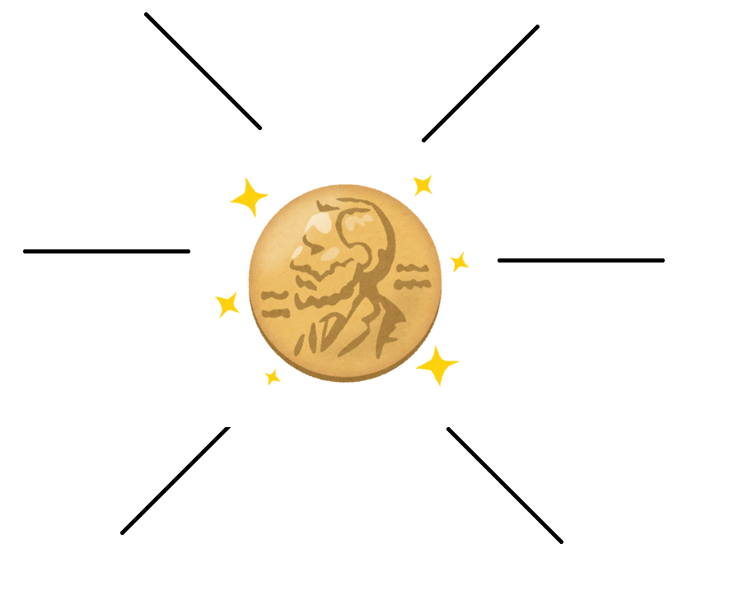
(clipart adapted from https://www.kisspng.com/png-nobel-prize-in-physiology-or-medicine-nobel-prize-3441682/)
- Where is Nobel Prize awarded? Find the countries on the map, as well as provide their names. -
There are two countries awarding Nobel Prizes – depending on the category.

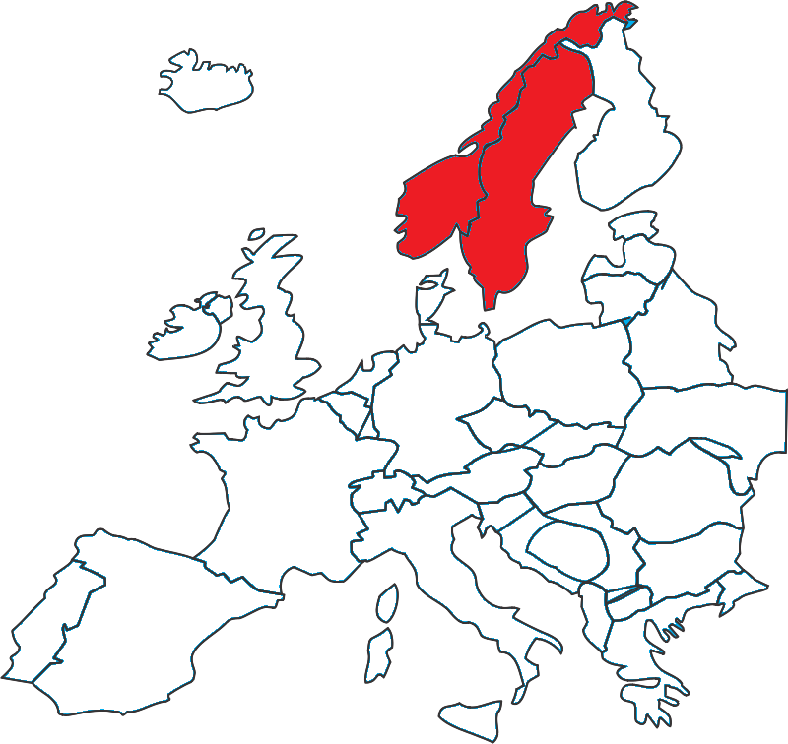 (map adapted from https://openclipart.org/detail/88159/european-map)

Sweden (all prizes except the Peace Prize), Norway (Peace Prize)

- Translate these words and phrases into your own language. Ask your friends or use a dictionary to help you.
You are provided with English definitions of the words to help you with the task.
-
- to covet – pragnąć, patrzeć z zazdrością
- innovative –innowacyjny
- to establish – założyć, rozpocząć
- obituary – nekrolog
- lavish – sowity, obfity, pełen przepychu
- nebulous – mglisty, zamglony
- fraternity – braterstwo, bractwo
- contentious – kontrowersyjny
- to appoint – mianować
- to despair – rozpacz, beznadzieja
- to kick the bucket – umrzeć, “kopnąć w kalendarz”
- a ceasefire – zawieszenie broni
- dubious – wątpliwy
- a stardom – status gwiazdy
- infallible – nieomylna/nieomylny
- a sage – mędrzec
- a deification – ubóstwianie
- a cronyism – kumoterstwo
- to skew – naciągać, wypaczać
- to plump – tu: poprzeć
- appalling – przerażające
- to circumvent – omijać, ominąć

- Which of the words presented in exercise 3 were new to you?
Mark the new words with a star

During the movie: How to Win A Nobel Prize - EPIC HOW TO: https://youtu.be/iMsjHexEXWw
- Who established the Nobel Prize?
- Alfred Hitchcock. b) Alfonse Nobel. c) Alfred Nobel.

- How many times was the Nobel Prize given (as of 2014)?
Draw the number on the ‘digital screen’
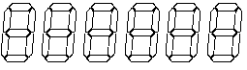
- Pick the correct graph showing the distribution of Nobel Prize laureates (as of 2014).

- Write down the names of some controversial nominees / laureates of the Nobel Peace Prize.
Why are they contentious?
e.g. Joseph Stalin, Adolf Hitler – they were mass murderers and tyrants, responsible for the deaths of millions during the World War II.

- How many nominations were there in 2009 and 2004?
Mark the years and the exact numbers of nominations on the graph.
2009
205
2014
278

- How much time did Albert Einstein have to wait to win his Nobel Prize after the first nomination?
- 111 years. b) 91 years. c) 11 years.

- What do Dalai Lama, Al Gore and Barack Obama have in common?
- They got a Nobel Prize because they did only good things.
- They got a Nobel Prize for their scientific achievements.
- They got a Nobel Prize even though they didn’t primarily work for the world peace.

- Is it possible for an organization to get a Nobel Prize?
- Yes. b) No. c) I don’t know.

After the movie:
- What’s the article hidden behind the QR code about? -
Provide a brief summary or draw a mind map.
The article primarily focuses on the problem of rewarding not every achievement related to science by the Nobel Prize Committee. The author points out that some fields are omitted and some scientists are not acknowledged due to the rule of three (which lets maximum 3 people to get the award). What’s more, in the article emerges the problem of
racial / gender injustice in terms of the Nobel Prize winners.
https://bit.ly/2It6XFx

- Read the article once again. Choose whether the following statements are true or false. -
- Nobel Prizes reward an outdated version of science. True / False
- People know who was nominated for a prize and who did the nominating. True / False
- Dmitri Mendeleev, creator of the periodic table of elements, didn’t get a Noble Prize. True / False
- No more than three people can win an individual science Nobel Prize. True / False
- There is no possibility for the organisations to win the Nobel Prize. True / False
- Answer the questions, using the article you’ve read. -
- What sciences are ignored and do not get the Nobel Prizes?
Mathematics, Computing, Robotics, Artificial Intelligence, Environmental Sciences.
- How many women won Nobel Prizes in physics?
Two.
- How did William Shockley exploit his status as a Nobel Prize winner?
He promoted racist ideas of intelligence.
- According to Keating, how should awarding the Nobel Prizes change?
It should circumvent the cult of the lone genius and award the Prizes to the teams, not just 1-3 people.

