The human body (Body Worlds Exhibition)
Before the movie:
- What do you think of scientists using the bodies of the dead for scientific purposes? Fill in the mind map. -

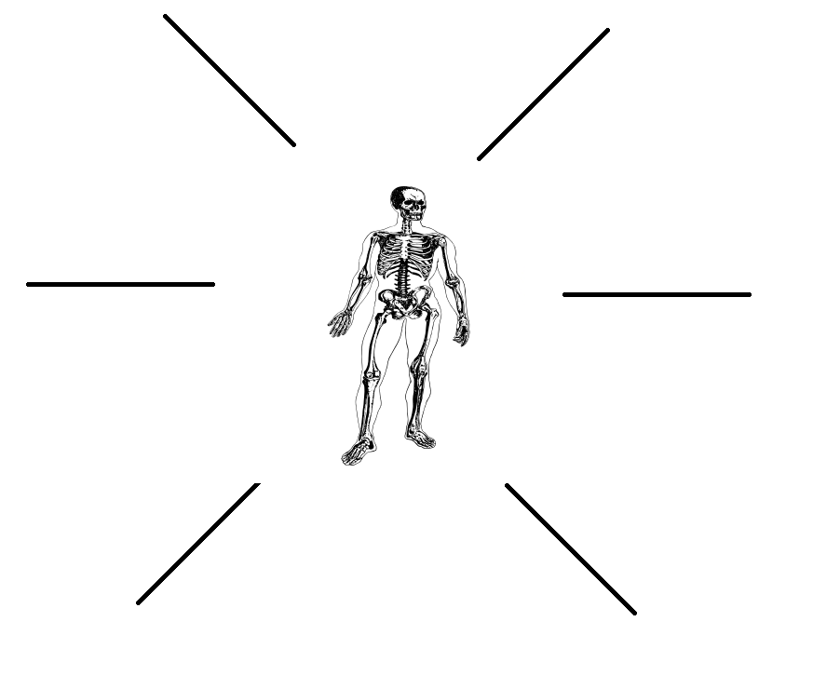
(clipart adapted from https://openclipart.org/detail/286972/skeleton-in-a-body)
- What could be the pros and cons of using the bodies of the dead for scientific purposes? Fill in the table.
-

PROS | CONS

- Translate these words and phrases into your own language. Ask your friends or use a dictionary to help you.
-
odorless – …………………………………………………………….…………………..………………………………………..………………………….……..
invaluable – …………………………….…………………………………………………………………………………………………………………….……..
a layman – ……………………………………………………………………………………………………………………………………………………………
to highlight– …………………………………………………………………………………………………………………………………………………………..
craftsmanship – ………………………………….………………………………………………………..………………………………………………………..
complexity – ………………………………………………………………………………………………......…………………..……………………………….
to halt – ………………………………………………………………..……………………………………………………………………………………………….
to decay – …………………………………………….………………..………………………………………………………………..……………………………
formaldehyde – ….……………………………………………………………………………………………………………………………………………….
arterial system – ..……………………………………………………………….…………………………………………………………………………………
a sinew –.…………..……...................................................................................................................................................
to dilute – …………………………………………………….…………………………………………………………..…………………………………………..
a tissue (in a body) – …….…………….………………………………………………………………………………………………………………………….
impregnation – ……..…………………………………………………………………………………………………………………………………………….
a cell – …………………………………………..……………………………………………………………………………………………………………………….
saleable – ………………………………………………………………………………………………………………………………………………………………
a workshop – ………………………………………………………………………………………………………………………………………………………..

If you need English definitions you can look them up in OALD 😊
www.oxfordlearnersdictionaries.com

If you prefer to search for Polish equivalents, use:
pl.bab.la/slownik/angielski-polski

or

www.diki.pl

- Mark the new words with a star

- Match the words from the list to the human organs they represent. Use a dictionary if necessary. -
a brain / a heart / lungs / kidneys / a pancreas / a small intestine / a large intestine / a bladder / a stomach / a liver / a spleen
1 ……………………………………………
11 ……………………………………………
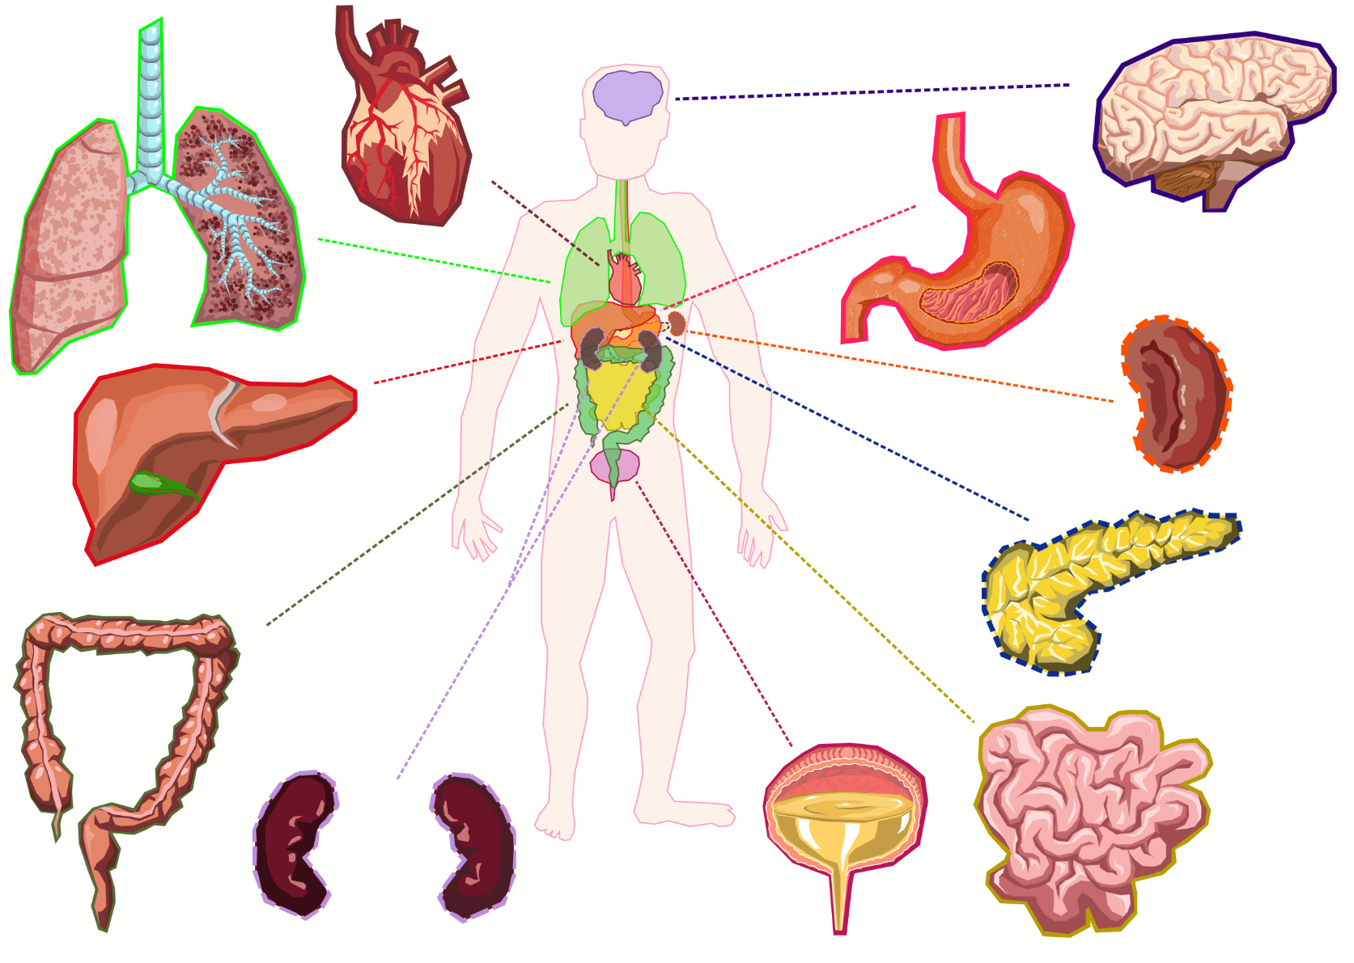
2 ……………………………………………
10 ……………………………………………
9 ……………………………………………
8 ……………………………………………
7 ……………………………………………
6 ……………………………………………
5 ……………………………………………
4 ……………………………………………
3 ……………………………………………

(clipart adapted from https://openclipart.org/detail/280284/human-body)

BODY WORLDS & The Art of Plastination: https://youtu.be/4UjDDp8Mpcg
During the movie:
- Are the bodies shown in the exhibition real?
a) Yes. b) No. c) I don’t know.

- How much time is required to prepare a full body for plastination?
hours

- Order the stages of plastination, using the provided timeline.
- The specimen is hardened with a special gas.
- The body is placed in a desired pose.
- The skin and fat are removed.
- A solution of formaldehyde is introduced into the body’s arterial system.
- The process of forced vacuum impregnation is performed.
- Water and fat in the body is replaced by a solvent, using a cold acetone bath.

- What’s a sheet plastination? Describe.
………………………………………………………………………………………………………………………………………………………………………………
………………………………………………………………………………………………………………………………………………………………………………
………………………………………………………………………………………………………………………………………………………………………………
………………………………………………………………………………………………………………………………………………………………………………
………………………………………………………………………………………………………………………………………………………………………………
………………………………………………………………………………………………………………………………………………………………………………

- Are animals also plastinated?
a) Yes. b) No. c) I don’t know.

- Who invented the plastination technique?
- Gunther von Haga
- Gunther von Hagens
- Gunther von Plasti

- Where was the plastination technique invented? Mark the country on the map.

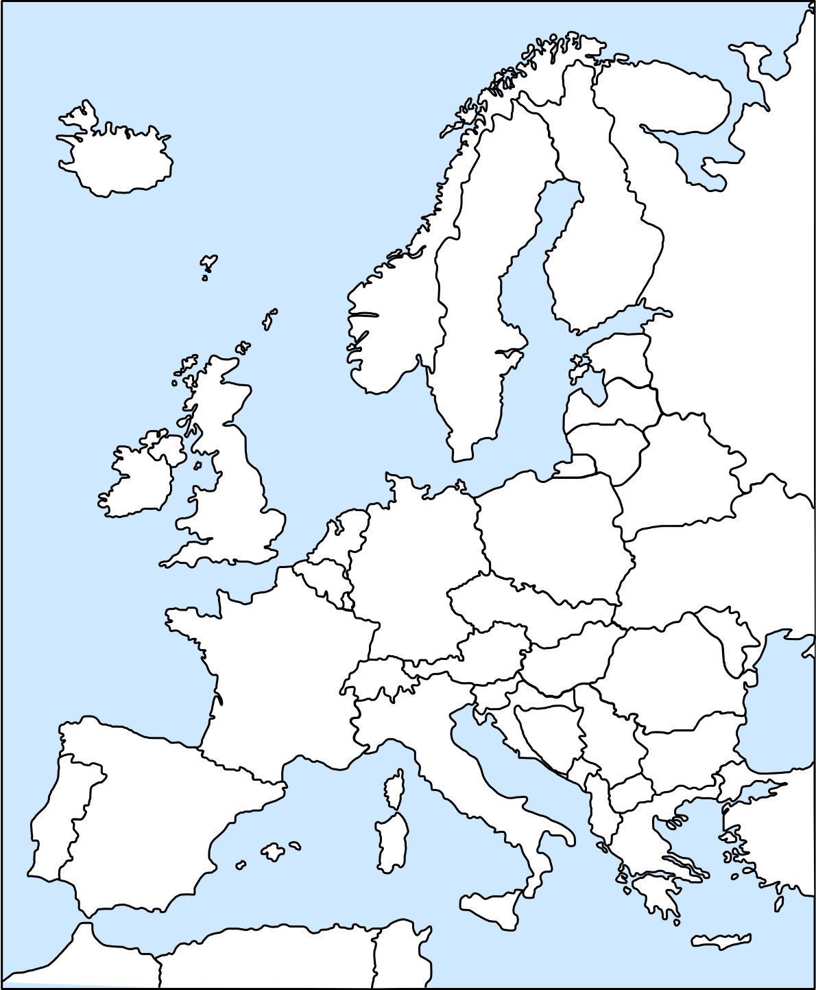
(map adapted from https://openclipart.org/detail/6734/europe-outline)

After the movie:
- Answer the following questions. Use the Notes section (provided at the bottom of the page) if necessary. -
  - How did you feel when you saw the bodies?
  - Do you think that it is ethical to show plastinated human bodies on an exhibition? Why / Why not?
  - Would you be willing to donate your body for plastination after your death? Why / Why not?

- What have you learnt during the lesson? Fill in the mind map. -

What have I learnt?

NOTES
………………………………………………………………………………………………………………………………………………………………………………
………………………………………………………………………………………………………………………………………………………………………………
………………………………………………………………………………………………………………………………………………………………………………
………………………………………………………………………………………………………………………………………………………………………………
………………………………………………………………………………………………………………………………………………………………………………
………………………………………………………………………………………………………………………………………………………………………………

