The human body (Body Worlds Exhibition)
Before the movie:
- What do you think of scientists using the bodies of the dead for scientific purposes? Fill in the mind map. -

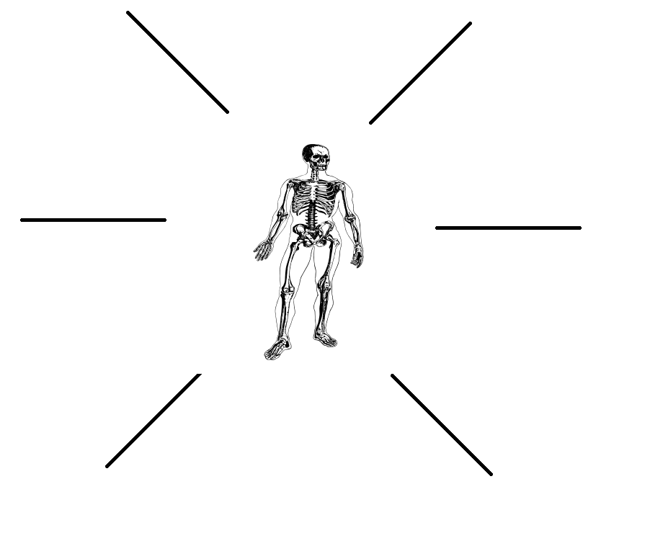
(clipart adapted from https://openclipart.org/detail/286972/skeleton-in-a-body)
- What could be the pros and cons of using the bodies of the dead for scientific purposes? Fill in the table.
-

PROS | CONS

- Translate these words and phrases into your own language. Ask your friends or use a dictionary to help you.
-
odorless – bez zapachu
invaluable – nieoceniony
a layman – laik
to highlight – uwydatnić, wyróżnić
craftsmanship – rzemieślnictwo
complexity – złożoność
to halt – zatrzymać, zahamować
to decay – rozkładać się
formaldehyde – formaldehyd
arterial system – układ krążenia
a sinew – ścięgno
to dilute – rozcieńczać
a tissue (in a body) – tkanka
impregnation – impregnacja
a cell – komórka
saleable – chodliwy (łatwy do sprzedaży)
a workshop – warsztat

If you need English definitions you can look them up in OALD 😊
www.oxfordlearnersdictionaries.com

If you prefer to search for Polish equivalents, use:
pl.bab.la/slownik/angielski-polski

or

www.diki.pl

- Mark the new words with a star

- Match the words from the list to the human organs they represent. Use a dictionary if necessary. -
a brain / a heart / lungs / kidneys / a pancreas / a small intestine / a large intestine / a bladder / a stomach / a liver / a spleen
1 a heart
11 a brain
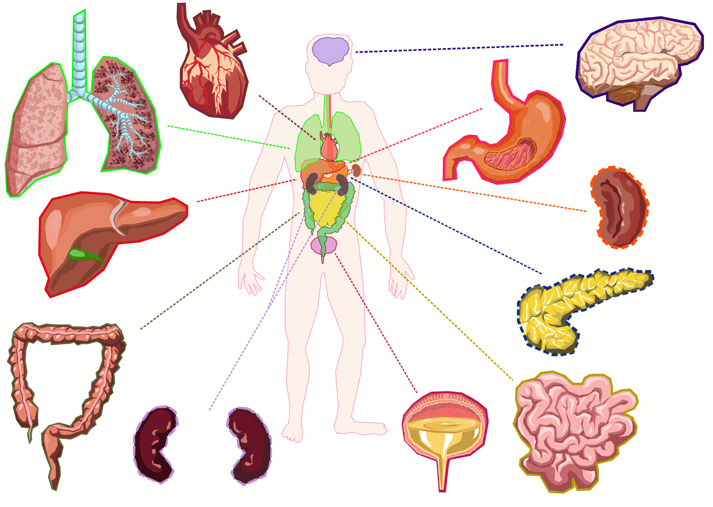
2 lungs
10 a stomach
9 a spleen
8 a pancreas
7 a small intestine
6 a bladder
5 kidneys
4 a large intestine
3 a liver

(clipart adapted from https://openclipart.org/detail/280284/human-body)

BODY WORLDS & The Art of Plastination: https://youtu.be/4UjDDp8Mpcg
During the movie:
- Are the bodies shown in the exhibition real?
a) Yes. b) No. c) I don’t know.

- How much time is required to prepare a full body for plastination?
800
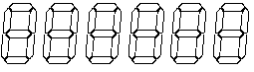hours

- Order the stages of plastination, using the provided timeline.
- The specimen is hardened with a special gas.
- The body is placed in a desired pose.
- The skin and fat are removed.
- A solution of formaldehyde is introduced into the body’s arterial system.
- The process of forced vacuum impregnation is performed.
- Water and fat in the body is replaced by a solvent, using a cold acetone bath.
D + C + F + E + B + A

- What’s a sheet plastination? Describe.
It’s cutting thin transparent slices either through or along the body, to show how the various positions of anatomical structures relate to each other and to view the individual deviations.

- Are animals also plastinated?
a) Yes. b) No. c) I don’t know.

- Who invented the plastination technique?
- Gunther von Haga
- Gunther von Hagens
- Gunther von Plasti

- Where was the plastination technique invented? Mark the country on the map.

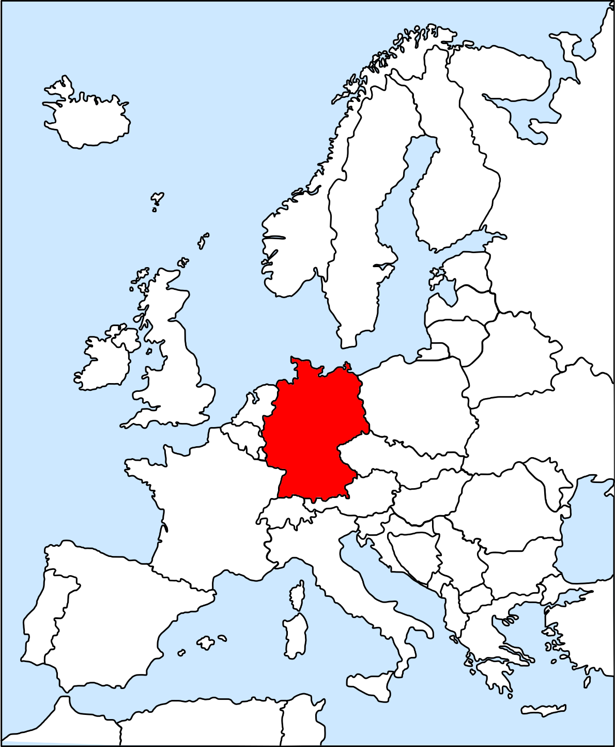
(map adapted from https://openclipart.org/detail/6734/europe-outline)

After the movie:
- Answer the following questions. Use the Notes section (provided at the bottom of the page) if necessary. -
  - How did you feel when you saw the bodies?
  - Do you think that it is ethical to show plastinated human bodies on an exhibition? Why / Why not?
  - Would you be willing to donate your body for plastination after your death? Why / Why not?

- What have you learnt during the lesson? Fill in the mind map. -

What have I learnt?

NOTES
………………………………………………………………………………………………………………………………………………………………………………
………………………………………………………………………………………………………………………………………………………………………………
………………………………………………………………………………………………………………………………………………………………………………
………………………………………………………………………………………………………………………………………………………………………………
………………………………………………………………………………………………………………………………………………………………………………
………………………………………………………………………………………………………………………………………………………………………………

