The English-speaking world: New York City Vacation Travel Guide | Expedia: https://youtu.be/MtCMtC50gwY
Before the movie:
- When you think about New York, what comes to your mind first?
Fill in the mind map alone or with your deskmate. Add more lines if necessary. -

(clipart adapted from https://openclipart.org)
- Look at the map of the USA. Where exactly is New York?
Try to find the dot which represents New York. Work alone or with your deskmate. -

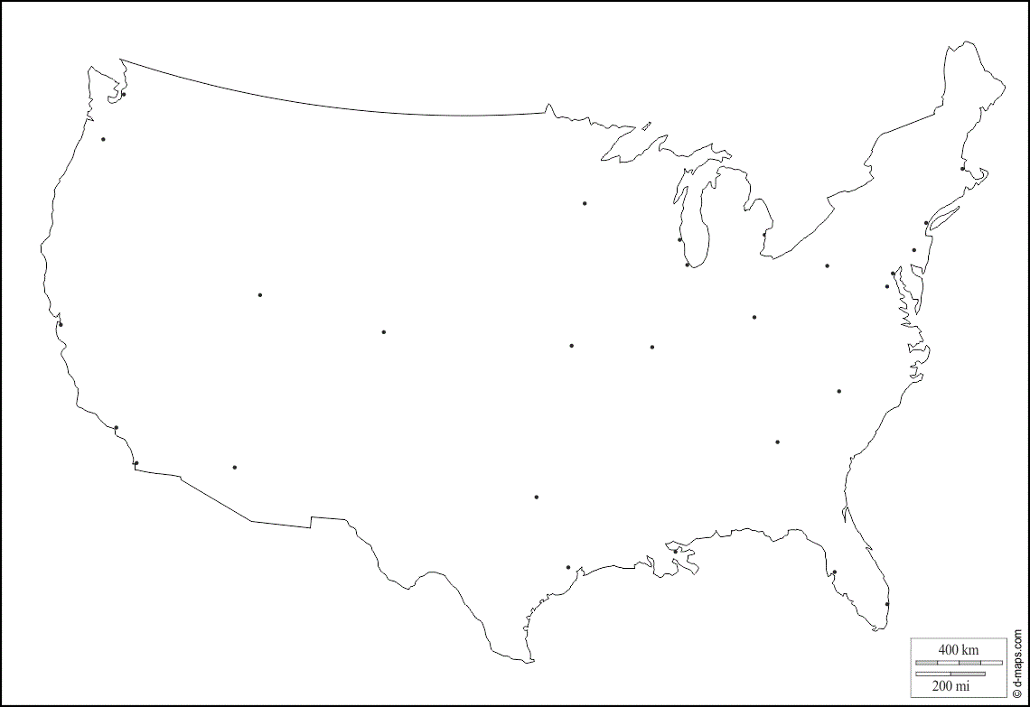
(map adapted from https://d-maps.com)
- Translate these words and phrases into your own language. Ask your friends or use a dictionary to help you.
-
to attract – …………………………………………………………….…………………..………………………………………..………………………………..
continuously – …………………………….………………………………………………………………………………………………………………………..
a newcomer –…………………………………………………………………………………………………………………………………………………………
a skyline – ………………………………………………………………………………………………………………………………………………………………
to radiate – ……………………………………….………………………………………………………..………………………………………………………..
straightforward – ………………………………………………………………………………………………......…………………..…………………………
iconic – ………………………………………………………………..………………………………………………………………………………………………..
endearing – …………………………………………….………………..………………………………………………………………..………………………….
breathtaking –…….………………………………………………………………………………………………………………………………………………….
concourse – ..……………………………………………………………………….………………………………………………………………………………..
joyous –.………………..……...............................................................................................................................................
shopping spree – …………………………………………………….…………………………………………………………..………………………………..
eye-popping – …….……………………….………………………………………………………………………………………………………………………..
retail –………..………………………………………………………………………………………………………………………………………………………….
civic spaces – …………………………………………..…………………………………………………………………………………………………………….
a meadow – ……………………………………………………………………………………………………………………………………………………………
fabulous – ………………………………………………………………………………………………………………………………………………………………
dizzying –.……………………………………………………………………………………………………………………………………………………………….
to bow – …………………………………………………………………………………………….………………………………………………………………….
to epitomize – …………………………………………………………………………………………………………………………………….………………….
to retain – ………………………………………………………………………………………..……………………………………………………………………
boroughs – ………………………………………………………………………………….…… …………………………………………………………………..
moniker – ………………………………………………………………………………………. ……………………..…………………………………………….
a venue –………………………………………………………………………………………………………………………………………………………………..
to revive – ………………………………………………………………………….…………………………………………………………………………………
a woe – …………………………………………………………….…………………..………………………………………..……………………………………..
a sobriquet – …………………………………………………………….…………………..………………………………………..…………………………….
to proliferate – …………………………………………………………….…………………..………………………………………..………………………….

If you need English definitions you can look them up in OALD 😊
www.oxfordlearnersdictionaries.com
- Which of the words presented in exercise 3 were new to you?
Mark the new words with a star
- Why is New York called “The Big Apple”?
Read the short article and find the answer. (clipart adapted from https://openclipart.org)

https://www.history.com/news/why-is-new-york-city-nicknamed-the-big-apple
…………………………………………………………………………………….………………………………………………………………………………………………………………………………….………………………………………………………………………………………………………………………………….……………………………………………………………………………………………………

During the movie:
- How many people live in New York?
Colour the appropriate number of people – each person represents 1 million.
1 2 3 4 5 6 7 8 9 10 11 12
million people

- When did the story of New York begin? Mark the correct date on the timeline.
1400
1800

- Is New York easy to explore?
- Yes. b) No. c) I don’t know.
Why?
………………………………………………………………………………………………………………………………………………………………………………
………………………………………………………………………………………………………………………………………………………………………………
- Which architecture style does the Empire State Building represent?
- Neo-gothic.
- Art Nouveau.
- Art Deco.
- When was the Empire State Building first opened?
a) 1933. b) 1921. c) 1931.
- Which part of the NYC is most known for its shopping opportunities?
- The Central Park.
- The Fifth Avenue.
- The Times Square.
- What’s the size of the Central Park? Choose the appropriate rectangle.

A: 500 acres.

B: 850 acres.

C: 1,850 acres.
- When you visit the Metropolitan Museum of Art…
you walk through ………………… years of humankind’s greatest creative moments.
- How are the 2001 attacks on the World Trade Center honored? Describe.

………………………………………………………………………………………………………………………………………………………………………………
………………………………………………………………………………………………………………………………………………………………………………
………………………………………………………………………………………………………………………………………………………………………………
………………………………………………………………………………………………………………………………………………………………………………

- How many language groups are spoken in NYC? Mark the appropriate number on the “digital screen”.

After the movie: -
- Work in groups. Imagine that you are travelling to New York City for 5 days.
Prepare a sightseeing plan, describing what attractions you would like to see (and why), where you would eat, as well as providing information about the accommodation (e.g. hotels) you would choose.
Don’t forget to talk about the costs!

To help you with the task you can use the internet, especially:
https://www.expedia.com/New-York.dx178293
https://www.tripadvisor.com/Tourism-g60763-New_York_City_New_York-Vacations.html

………………………………………………………………………………………………………………………………………………………………………………………………………………………………………………………………………………………………………………………………………………………………
………………………………………………………………………………………………………………………………………………………………………………………………………………………………………………………………………………………………………………………………………………………………
………………………………………………………………………………………………………………………………………………………………………………………………………………………………………………………………………………………………………………………………………………………………
………………………………………………………………………………………………………………………………………………………………………………………………………………………………………………………………………………………………………………………………………………………………
………………………………………………………………………………………………………………………………………………………………………………………………………………………………………………………………………………………………………………………………………………………………
………………………………………………………………………………………………………………………………………………………………………………………………………………………………………………………………………………………………………………………………………………………………
………………………………………………………………………………………………………………………………………………………………………………………………………………………………………………………………………………………………………………………………………………………………
………………………………………………………………………………………………………………………………………………………………………………………………………………………………………………………………………………………………………………………………………………………………
………………………………………………………………………………………………………………………………………………………………………………………………………………………………………………………………………………………………………………………………………………………………
………………………………………………………………………………………………………………………………………………………………………………………………………………………………………………………………………………………………………………………………………………………………
………………………………………………………………………………………………………………………………………………………………………………………………………………………………………………………………………………………………………………………………………………………………
………………………………………………………………………………………………………………………………………………………………………………………………………………………………………………………………………………………………………………………………………………………………
………………………………………………………………………………………………………………………………………………………………………………………………………………………………………………………………………………………………………………………………………………………………
………………………………………………………………………………………………………………………………………………………………………………………………………………………………………………………………………………………………………………………………………………………………

