The English-speaking world: New York City Vacation Travel Guide | Expedia: https://youtu.be/MtCMtC50gwY
Before the movie:
- When you think about New York, what comes to your mind first?
Fill in the mind map alone or with your deskmate. Add more lines if necessary. -

(clipart adapted from https://openclipart.org)
- Look at the map of the USA. Where exactly is New York?
Try to find the dot which represents New York. Work alone or with your deskmate. -

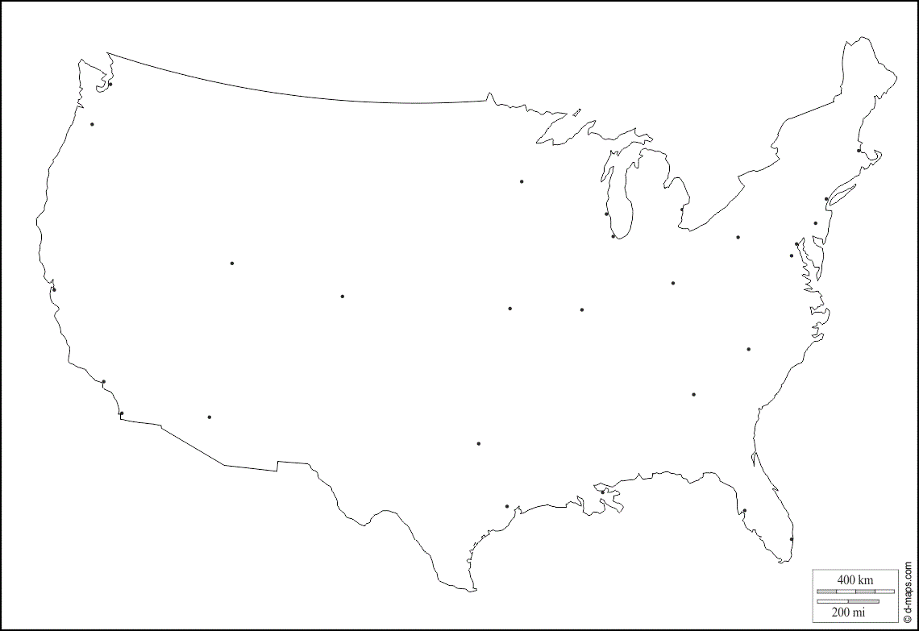
(map adapted from https://d-maps.com)
- Translate these words and phrases into your own language. Ask your friends or use a dictionary to help you.
-
to attract – przyciągać
continuously – ciągle
a newcomer – przybysz, nowo przybyły
a skyline – linia horyzontu, linia dachów
to radiate – promieniować
straightforward – prosty, prostolinijny
iconic – kultowy, ikoniczny, znany
endearing – ujmujący
breathtaking – zapierający dech w piersiach
concourse – hala, zgromadzenie
joyous – radosny, pełny radości
shopping spree – szał zakupów
eye-popping – zaskakujący, zadziwiający, szokujący
retail – sprzedaż detaliczna, handel detaliczny
civic spaces – przestrzenie miejskie
a meadow – łąka
fabulous – bajeczny, fantastyczny, piękny
dizzying – oszałamiający, zawrotny
to bow – kłaniać się
to epitomize – być uosobieniem, być przykładem
to retain – zachowywać, zatrzymywać
boroughs – gmina; tu: dzielnica
moniker – przydomek, przezwisko
a venue – miejsce
to revive – ożywić, wskrzesić
a woe – cierpienie, żałość, rozpacz
a sobriquet – przydomek, przezwisko
to proliferate – rozrastać się, mnożyć się

If you need English definitions you can look them up in OALD 😊
www.oxfordlearnersdictionaries.com
- Which of the words presented in exercise 3 were new to you?
Mark the new words with a star
- Why is New York called “The Big Apple”?
Read the short article and find the answer. (clipart adapted from https://openclipart.org)

https://www.history.com/news/why-is-new-york-city-nicknamed-the-big-apple
“The Big Apple” is a term used first around 1920 by African-American stable hands in New Orleans when talking about New York City, as its race tracks were considered important. It was later used (in 1930s) by jazz musicians to indicate that in NYC there were important music clubs. The nickname was revived in 1970s during a tourism campaign created by Charles Gillett.
During the movie:
- How many people live in New York?
Colour the appropriate number of people – each person represents 1 million.
1 2 3 4 5 6 7 8 9 10 11 12
million people

- When did the story of New York begin? Mark the correct date on the timeline.
1624
1400
1800

- Is New York easy to explore?
- Yes. b) No. c) I don’t know.
Why?
NYC has a straightforward grid system.

- Which architecture style does the Empire State Building represent?
- Neo-gothic.
- Art Nouveau.
- Art Deco.
- When was the Empire State Building first opened?
a) 1933. b) 1921. c) 1931.
- Which part of the NYC is most known for its shopping opportunities?
- The Central Park.
- The Fifth Avenue.
- The Times Square.
- What’s the size of the Central Park? Choose the appropriate rectangle.

B: 850 acres.
A: 500 acres.

B: 850 acres.

C: 1,850 acres.
- When you visit the Metropolitan Museum of Art…
you walk through 5000 years of humankind’s greatest creative moments.
- How are the 2001 attacks on the World Trade Center honored? Describe.

At the place of the towers there is the Reflecting Absence memorial. It honours 3000 people who lost their lives in the September 11 attacks.

- How many language groups are spoken in NYC? Mark the appropriate number on the “digital screen”.
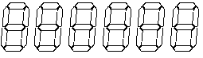

After the movie: -
- Work in groups. Imagine that you are travelling to New York City for 5 days.
Prepare a sightseeing plan, describing what attractions you would like to see (and why), where you would eat, as well as providing information about the accommodation (e.g. hotels) you would choose.
Don’t forget to talk about the costs!

To help you with the task you can use the internet, especially:
https://www.expedia.com/New-York.dx178293
https://www.tripadvisor.com/Tourism-g60763-New_York_City_New_York-Vacations.html

………………………………………………………………………………………………………………………………………………………………………………………………………………………………………………………………………………………………………………………………………………………………
………………………………………………………………………………………………………………………………………………………………………………………………………………………………………………………………………………………………………………………………………………………………
………………………………………………………………………………………………………………………………………………………………………………………………………………………………………………………………………………………………………………………………………………………………
………………………………………………………………………………………………………………………………………………………………………………………………………………………………………………………………………………………………………………………………………………………………
………………………………………………………………………………………………………………………………………………………………………………………………………………………………………………………………………………………………………………………………………………………………
………………………………………………………………………………………………………………………………………………………………………………………………………………………………………………………………………………………………………………………………………………………………
………………………………………………………………………………………………………………………………………………………………………………………………………………………………………………………………………………………………………………………………………………………………
………………………………………………………………………………………………………………………………………………………………………………………………………………………………………………………………………………………………………………………………………………………………
………………………………………………………………………………………………………………………………………………………………………………………………………………………………………………………………………………………………………………………………………………………………
………………………………………………………………………………………………………………………………………………………………………………………………………………………………………………………………………………………………………………………………………………………………
………………………………………………………………………………………………………………………………………………………………………………………………………………………………………………………………………………………………………………………………………………………………
………………………………………………………………………………………………………………………………………………………………………………………………………………………………………………………………………………………………………………………………………………………………
………………………………………………………………………………………………………………………………………………………………………………………………………………………………………………………………………………………………………………………………………………………………
………………………………………………………………………………………………………………………………………………………………………………………………………………………………………………………………………………………………………………………………………………………………

