The English-speaking world: Edinburgh Edinburgh Vacation Travel Guide | Expedia: https://youtu.be/zhtg9XgVwuM
Before the movie:
- When you think about Edinburgh, what comes to your mind first?
Fill in the mind map alone or with your deskmate. Add more lines if necessary. -

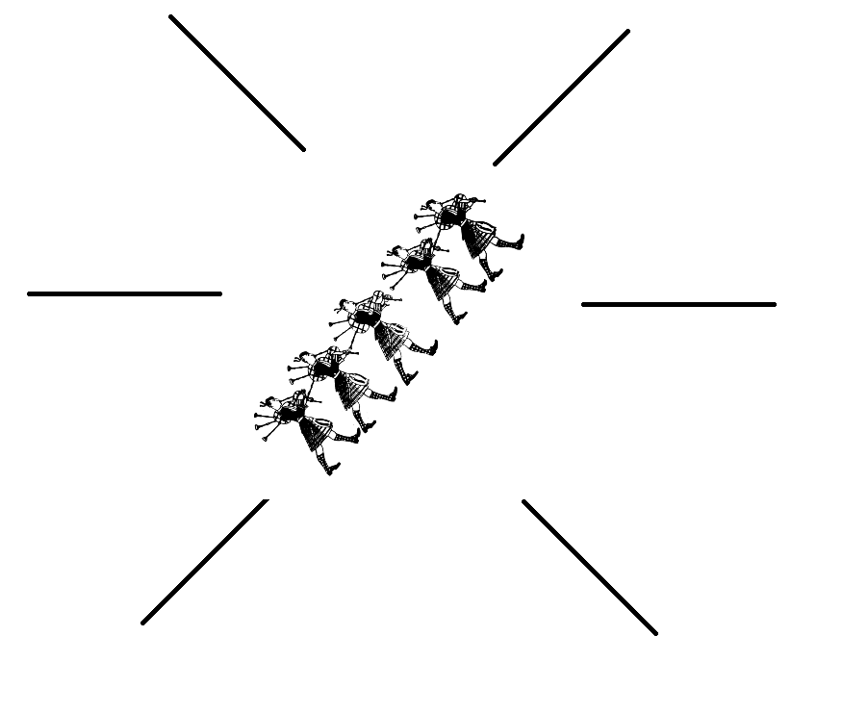
(clipart adapted from https://openclipart.org)
- Look at the map of the UK. Where exactly is Edinburgh?
Try to find the dot which represents Edinburgh. Work alone or with your deskmate. -

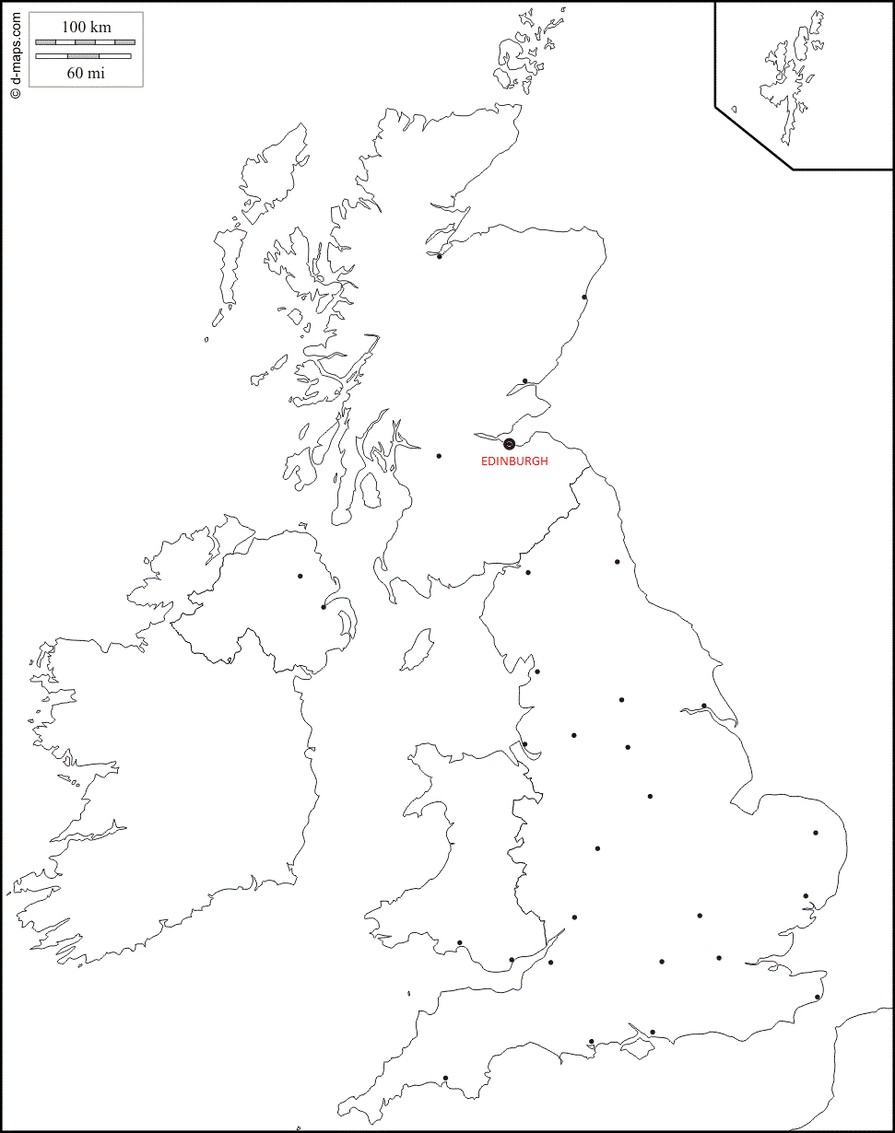 (map adapted from https://d-maps.com)
- Translate these words and phrases into your own language. Ask your friends or use a dictionary to help you.
You are provided with English definitions of the words to help you with the task.
-
- bricks and mortar – nieruchomości (inwestycje)
- to grace something – ozdobić coś
- a heritage – dziedzictwo, spuścizna
- medieval – średniowieczne
- the Enlightenment – Oświecenie
- to stud something - usiać
- lofty – wzniosły, wysoki
- a crag – urwisko, turnia, skała
- a peak – szczyt
- to clash (with something) – kolidować, ścierać się
- battlements – blanki (na murach)
- a testimony – świadectwo, zeznanie
- indomitable – nieposkromiony, nieugięty, niezłomny
- to decommission something – zamykać, likwidować, wycofać z użytku
- to moor – cumować
- a chieftain – wódz
- a chivalry – rycerskość
- a spire – strzeliste zakończenie wieży, szpic
- to cherish somebody / something – miłować, cenić
- contemporary – współczesny
- a nook – zakątek, kącik
- a marvel – cud, fenomen
- to take somebody's breath away – zapierać dech w piersiach
- to swoon – omdleć
- to harry somebody – dręczyć, zadręczać, nękać
- to adorn – zdobić, ozdabiać, stroić

If you need English definitions you can look them up in OALD 😊
www.oxfordlearnersdictionaries.com

- Which of the words presented in exercise 3 were new to you?
Mark the new words with a star

During the movie:
- How many heritage-listed buildings are there in Edinburgh?
Draw the number on the ‘digital screen’
- What can you see in the Royal Mile (Old Town)?
- a lot of animals. b) sculptures of people. c) scary ghosts.
- When are parties and festivals in Edinburgh organised?
- In the summer. b) throughout the winter. c) throughout the whole year.
- What’s the name of the highest peak of Edinburgh?
…Arthur’s Seat……………………………………………………………………………………………………………………………………………………
- How many times was the Edinburgh Castle under siege over the last 11 centuries?
Circle the appropriate number of catapults – each catapult represents one siege.
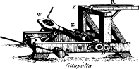 x 26

- How many miles did Her Majesty’s Yacht Britannia sail? Mark the number on the graph.

over 1,000,000 mi.
0 mi.
5,000,000 mi.

- When was the yacht decommissioned? Circle the appropriate year.
- To whom is dedicated the world’s largest monument to a writer, located in Princes Street Gardens?
- Sir William Poe.
- Sir Walter Scott.
- William Shakespeare.
- How many Harry Potter books did JK Rowling write in Edinburgh?
- All books.
- 5 books.
- 2 books.
- Why Edinburgh was called “the Athens of the North”?
- It has given people a lot of inventions.
- Great scientists studied there.
- The buildings were similar to the ones you can see in Athens.

- What is the greatest gift given by Edinburgh to the world, according to the speaker? Describe.
“She shows us that all parts of the human experience, sciences and the arts, the past and the present, the sacred and the light hearted, all have equal value. And that when brought together these things can create a beauty, a state of mind, a city like no other.”
After the movie:
- Work in groups. Find information about one of these people: -
- Sir Walter Scott,
- Robert Burns,
- Robert Louis Stevenson.
Present the information you find on a mind map.

