The English-speaking world: London Vacation Travel Guide | Expedia: https://youtu.be/45ETZ1xvHS0
Before the movie:
- When you think about London, what comes to your mind first?
Fill in the mind map alone or with your deskmate. Add more lines if necessary. -

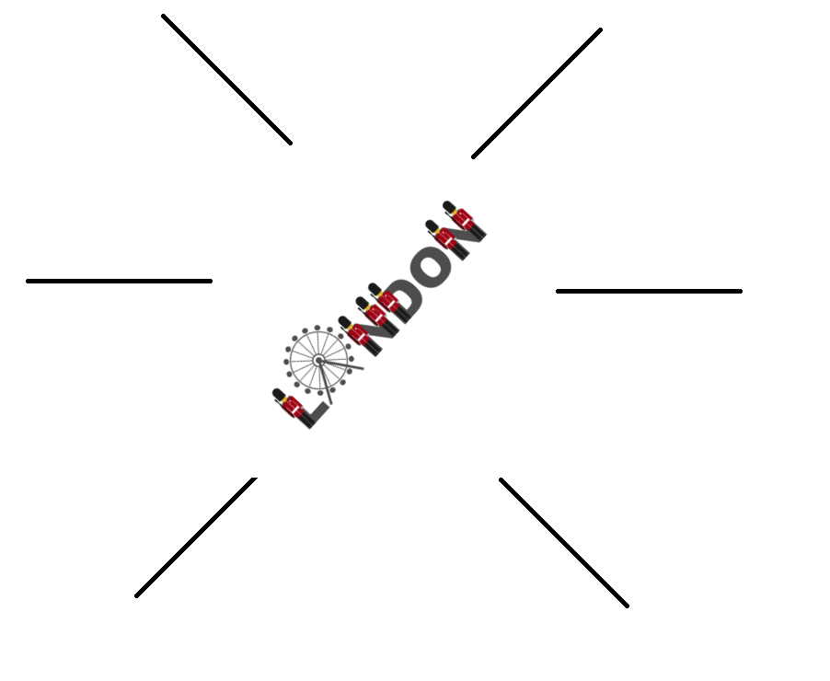
(clipart adapted from https://openclipart.org)
- Look at the map of the UK. Where exactly is London?
Try to find the dot which represents London. Work alone or with your deskmate. -

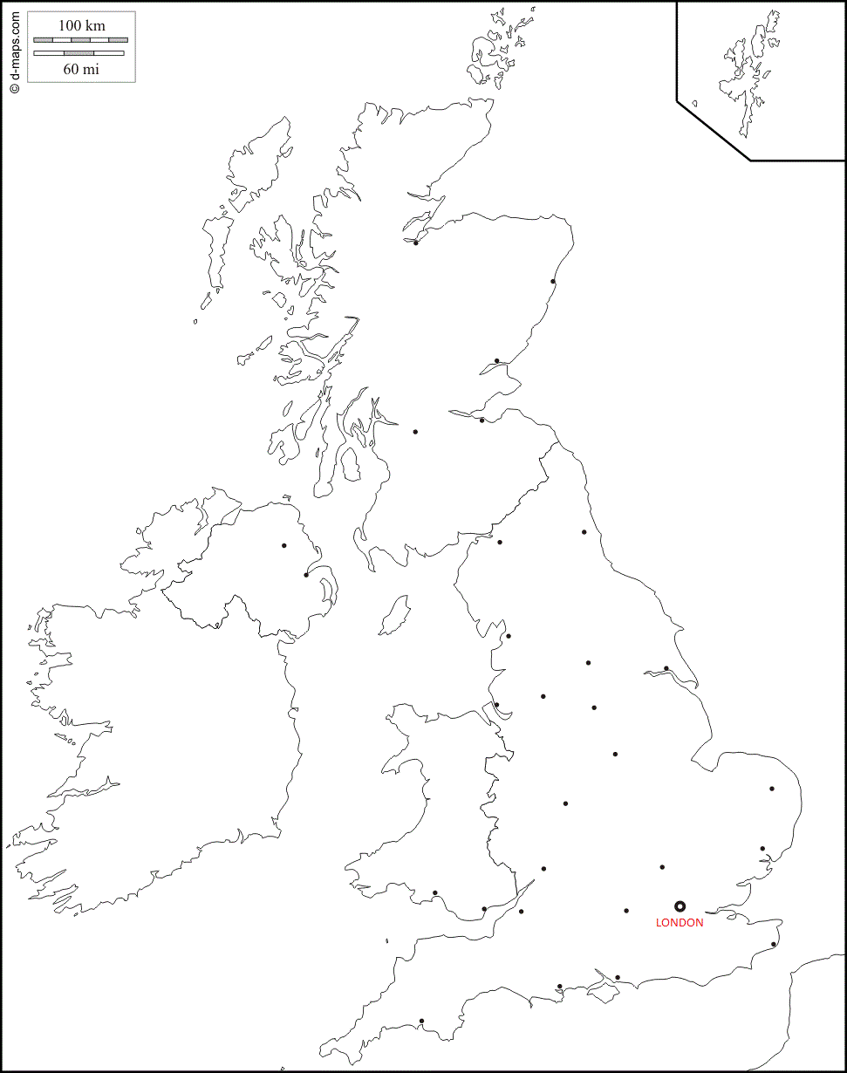 (map adapted from https://d-maps.com)
- Translate these words and phrases into your own language. Ask your friends or use a dictionary to help you.
-
Thames –…Tamiza………..……………………………………………………………………………………………………...…………………..……………
a capital – …stolica………………………………………………………………………………………………………………………………………………..
the Bronze Age –…Epoka Brązu……………………………………………………………………………………..…………………………………..….
to withdraw –……wycofać się……………………………………………………………………………………………………………………………..….
to become – ………stać się…………………………………………………………………………………..……………………………………………..…..
to explore –……odkrywać………………..………………………………………………………………………………………………………………..……
iconic –…kultowy, ikoniczny, znany …………….……………….……………………………………………………………………………………….
rapid –…szybki, błyskawiczny………………..…………………………………….………………………………………………………………………..
an expansion –……ekspansja, rozbudowa, rozrost……….…………………………………………………………………………………..……
to chime –……dzwonić, bić, wybijać godzinę……………………………………………………………………………………………………….…
a refurbishment –…..remont, renowacja, odnowa.………………….................................................................................
royal –…królewski.……….………………………………………………………………………………………………………………………………….…….
to hunt –….polować………………….…………………………………………………………………………………………………………………………...
a worship –…cześć, uwielbienie, kult ……………………………………………………………………………………………………………….……
to bury – ………pochować (kogoś)…………..…………………… ………………………………………………………………………………………..
to rebuild – …odbudować…………………………………………………………………………………………………………………………………….…
strength – ………siła…………………………………………………………………………………………………………………………………………………
resilience – odporność……………….……………………………………………………………………………………………………………………….….
a boutique – …………..butik………..………………………………………………………………………………………………………………………..….
a district –……dzielnica………………………..………………………………………………………………………………………………………………….
trendy –……modne……………………………….………………………………………………………………………………………………………………..
a treasure –……skarb………………………………….……………………………………………………………………………………………………….….
a pace –……tempo……..…………………………………………………………………………………………………………………………………………..
air-conditioned –……klimatyzowany………………………………….…………………………………………………………………………………..
a skyline –……linia horyzontu…………...…………………………………………………………………………………………………………………...

If you need English definitions you can look them up in OALD 😊
www.oxfordlearnersdictionaries.com

- Which of the words presented in exercise 3 were new to you?
Mark the new words with a star

During the movie:
- How many people live in London?
Colour the appropriate number of people – each person represents 1 million.
1 2 3 4 5 6 7 8 9 10 11 12
million people
- When did the story of London begin?
- When the Romans withdrew. b) In the Iron Age. c) In the Bronze Age.
- When was the Tower of London built?
- In the 12th century. b) in the 11th century. c) in the 1st century.
- Tower Bridge is a reminder of…
- The Queen’s victories.
- London’s rapid expansion in the Bronze Age.
- London’s rapid expansion during the Industrial Revolution.
- Is the Buckingham Palace the official residence of Queen Elisabeth?
a) No. b) Yes. c) I don’t know.
- What was the purpose of the Royal Parks in the past?
- They were a place of worship.
- They were private hunting grounds for the royal family.
- People could relax there.
- The Royal Albert Hall is a reminder of…
- Queen Victoria’s hate for Prince Albert.
- Queen Victoria’s love for Prince Albert.
- Queen Victoria’s power over Prince Albert.
- Why is Westminster Abbey so significant?
- Common people have been buried there.
- Kings and Queens have been crowned, married and buried there.
- It’s a very modern building.
- What caused London’s destruction and the need to rebuild the city?

………the Great fire of London…………………………………………………………………………………………………………………………………

In which century did this event occur?
- Where is the West End?
a) in the Western part of London. b) in Central London. c) in the Wild West.

- What makes the speaker say that at times you can feel on West End like you’re on a Monopoly board? Describe.
………Coventry Street, Trafalgar Swuare and Piccadily Circus are close by………………...…………………………………………
- What’s the name of the free museum having treasures covering thousands of years of history?
a) The London’s museum. b) The Brit’s museum. c) The British Museum.
- What landscape can you see from the London Eye? Choose a picture.
- 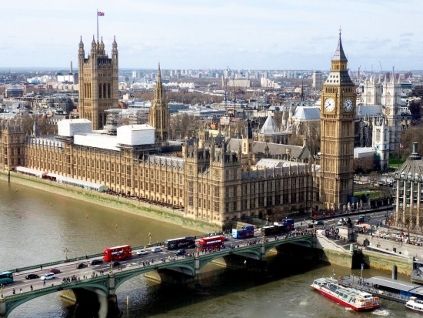
- 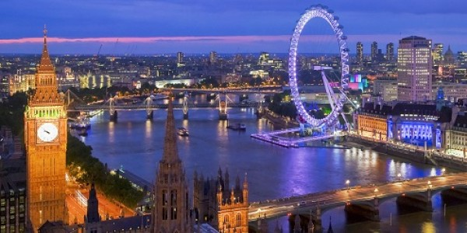
- 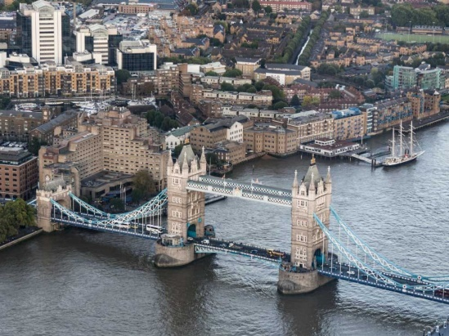

After the movie:
- Work in groups. Describe the capital city of your country. Don’t forget to talk about:
- Number of people living in the capital, -
- The capital’s famous attractions and monuments.
………………………………………………………………………………………………………………………………………………………………………………………………………………………………………………………………………………………………………………………………………………………………………………………………………………………………………………………………………………………………………………………………………………………………………………………………………………………………………………………………………………………………………………………………………………………………………………………………………………………………………………………………………………………………………………………………………………………………………………………………………………………………………………………………………………………………………………………………………………………………………………………………………………………………………………………………………………………………………………………………………………………………………………………………………………………………………………………………………………………………………………………………………………………………………………………………………………………………………………………………………………………………………………………………………………………………………………………………………………………………………………………………………………………………………………………………………………………………………………………………………………………………………………………………………………………………………………………………………………………………………………………………
………………………………………………………………………………………………………………………………………………………………………………………………………………………………………………………………………………………………………………………………………………………………
………………………………………………………………………………………………………………………………………………………………………………………………………………………………………………………………………………………………………………………………………………………………
………………………………………………………………………………………………………………………………………………………………………………………………………………………………………………………………………………………………………………………………………………………………
………………………………………………………………………………………………………………………………………………………………………………………………………………………………………………………………………………………………………………………………………………………………
………………………………………………………………………………………………………………………………………………………………………………………………………………………………………………………………………………………………………………………………………………………………
………………………………………………………………………………………………………………………………………………………………………………………………………………………………………………………………………………………………………………………………………………………………
………………………………………………………………………………………………………………………………………………………………………………………………………………………………………………………………………………………………………………………………………………………………
………………………………………………………………………………………………………………………………………………………………………………………………………………………………………………………………………………………………………………………………………………………………
………………………………………………………………………………………………………………………………………………………………………………………………………………………………………………………………………………………………………………………………………………………………
………………………………………………………………………………………………………………………………………………………………………………………………………………………………………………………………………………………………………………………………………………………………

