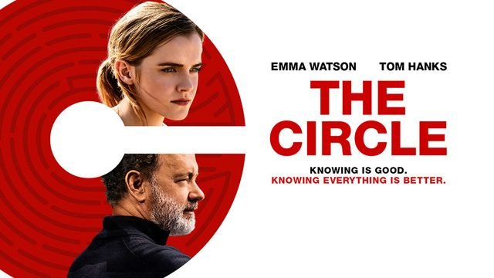
The Circle – Movie Worksheet
- Watch the movie and answer the questions provided below.

  - What was Mae’s job at the beginning of the movie? Draw it.

She was working at a call center.

  - What is TruYou? Define.
TruYou is the ultimate social networking site. It enables you to contact other people, send photos, present your opinion etc. It also allows one to use their payment systems, store their passwords and store other private info.

  - What is the reason of using ultra-small cameras “SeeChange”, according to Bailey?
    - You can spy on your friends and neighbours
    - You can see & hear everything, even the terrorists.
    - You can record vlogs.

  - In The Circle, what action is the near equivalent of "liking" something on Facebook?
    - “Smiling”
    - “Chirping”
    - “Circling”

  - What has influence on your participation rank (“PartiRank”)? Tick. More than one answer is possible.
- comments on your profile and zings
- comments you write on other profiles and zings
- the number of text messages you send to people
- attendance at Circle events
- the time you spend online
- comments and photos related to the Circle events
- the number of SeeChange cameras you put in the world

  - What are the top Circlers in the PartiRank called?
    - PartiLovers.
    - T2K.
    - Wise Men.

  - What does it mean to go “fully transparent”?
    - To start walking naked around the city.
    - To give your money to the people in need.
    - To wear a camera showing what you are doing live.

  - What happens at the end of the movie? Describe.
Mae Holland discredits the people behind the Circle, but instead of rejecting the idea of ‘full transparency’ she embraces it even further. It can be seen when she goes kayaking and is not bothered by the drones surrounding her.
- Did you like the movie? Why / Why not?
………………………………………………………………………………………………………………………………………………………………………………………………………………………………………………………………………………………………………………………………………………………………………………………………………………………………………………………………………………………………………………………………………………………………………………………………………………………………………………………………………………………………………………………………………………………………………………………………………………………………………………………………………………………………………………………………………………………………………………………………………………………………………………………………………………………………………………………………………………………………………………………………………………………………………………………………………………
- What words or phrases have you learnt from this movie? Make a list.
………………………………………………………………………………………………………………………………………………………………………………………………………………………………………………………………………………………………………………………………………………………………………………………………………………………………………………………………………………………………………………………………………………………………………………………………………………………………………………………………………………………………………………………………………………………………………………………………………………………………………………………………………………………………………………………………………………………………………………………………………………………………………………………………………………………………………………………………………………………………………………………………………………………………………………………………………………
………………………………………………………………………………………………………………………………………………………………………………
- Have you learnt something else by watching this movie? What was it? Fill in the mind map.

What have I learnt?

