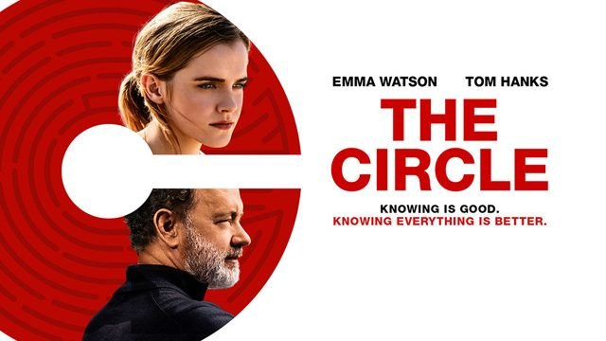
The Circle – Movie Worksheet
- Watch the movie and answer the questions provided below.

  - What was Mae’s job at the beginning of the movie? Draw it.

  - What is TruYou? Define.
……………………………………………………………………………………………………………………………………………………………………………………………………………………………………………………………………………………………………………………………………………………………….……………………………………………………………………………………………………………………………………………………………………………………………………………………………………………………………………………………………………………………………………………………………….
………………………………………………………………………………………………………………………………………………………………………………

  - What is the reason of using ultra-small cameras “SeeChange”, according to Bailey?
    - You can spy on your friends and neighbours
    - You can see & hear everything, even the terrorists.
    - You can record vlogs.

  - In The Circle, what action is the near equivalent of "liking" something on Facebook?
    - “Smiling”
    - “Chirping”
    - “Circling”

  - What has influence on your participation rank (“PartiRank”)? Tick. More than one answer is possible.
- comments on your profile and zings
- comments you write on other profiles and zings
- the number of text messages you send to people
- attendance at Circle events
- the time you spend online
- comments and photos related to the Circle events
- the number of SeeChange cameras you put in the world

  - What are the top Circlers in the PartiRank called?
    - PartiLovers.
    - T2K.
    - Wise Men.

  - What does it mean to go “fully transparent”?
    - To start walking naked around the city.
    - To give your money to the people in need.
    - To wear a camera showing what you are doing live.

  - What happens at the end of the movie? Describe.
……………………………………………………………………………………………………………………………………………………………………………………………………………………………………………………………………………………………………………………………………………………………….……………………………………………………………………………………………………………………………………………………………………………………………………………………………………………………………………………………………………………………………………………………………….
………………………………………………………………………………………………………………………………………………………………………………
- Did you like the movie? Why / Why not?
………………………………………………………………………………………………………………………………………………………………………………………………………………………………………………………………………………………………………………………………………………………………………………………………………………………………………………………………………………………………………………………………………………………………………………………………………………………………………………………………………………………………………………………………………………………………………………………………………………………………………………………………………………………………………………………………………………………………………………………………………………………………………………………………………………………………………………………………………………………………………………………………………………………………………………………………………………
- What words or phrases have you learnt from this movie? Make a list.
………………………………………………………………………………………………………………………………………………………………………………………………………………………………………………………………………………………………………………………………………………………………………………………………………………………………………………………………………………………………………………………………………………………………………………………………………………………………………………………………………………………………………………………………………………………………………………………………………………………………………………………………………………………………………………………………………………………………………………………………………………………………………………………………………………………………………………………………………………………………………………………………………………………………………………………………………………
………………………………………………………………………………………………………………………………………………………………………………
- Have you learnt something else by watching this movie? What was it? Fill in the mind map.

What have I learnt?

