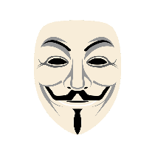
The Bonfire Night Worksheet Who Was Guy Fawkes? - Anglophenia Ep 18: o-rozewicz.pl/GuyFawkes-Anglophenia
a.k.a. the Guy Fawkes Worksheet
Before the video:
- What British celebrations do you know?
Fill in the mind map alone or with your deskmate. Add more lines if necessary. -

- Listen to the recording and fill in the gaps in the poem.
Do you know to what event it is referring to?

Audio 1: o-rozewicz.pl/GFpoem
Copyright info:
Poem read by Oskar Rożewicz
Music: “Dispute” by Hayden Folker | https://soundcloud.com/hayden-folker
Music promoted by https://www.free-stock-music.com
Creative Commons Attribution 3.0 Unported License
https://creativecommons.org/licenses/by/3.0/deed.en_US

Remember, remember, the _________________ of November,
The Gunpowder _________________ and Plot,
I know of no _________________,
Why the Gunpowder _________________,
Should ever be forgot.
_________________ Fawkes, _________________ Fawkes,
t'was his intent,
To blow up the _________________ and _________________,
Three-score barrels of _________________ below,
To prove old England's _________________;
By God's _________________ he was catch'd,
With a dark _________________ and burning _________________.
Holla boys, Holla boys, let the bells _________________,
Holla boys, Holla boys, God save the _________________!

- Translate these words and phrases into your own language. Ask your friends or use a dictionary to help you.
-
significance – ………………………………………………….…………………..………………………………………..………………..……………………..
an oppression – …………………………………………………….………………………………………………………………………….…………………..
a rebellion –…………………………………………………………………………………………..…………………………………………….…………………
to bring down – ……………………………………………………………………………………………………………………………………..………………
to ignite – ……………………………………….…………………………………………………………..………………………………………………………..
a blast – ……………………………………………………………………………………….…………………......…………………..……………..……………
cellars – ………………………………………………………………..…………………………………..…………………………………………………..……..
gunpowder – ……………………………………….………………..………………………………………………………………..…………………………….
a conspiracy – ….…………………………………………………………………………………………………………………………………………………….
to crack down – ..…………………………………………………………….……………………………………………………………………………………..
an effigy –.………………..……...........................................................................................................................................
a bonfire – …………………………………………………….…………………………………………………………….…………………………………………
to emulate – …….……………………….…………………………………………………………………………………………………………………………..

If you need English definitions you can look them up in OALD 😊 www.oxfordlearnersdictionaries.com
Don’t forget to mark the words you didn’t know before with a star

During the video:
- When was Guy Fawkes born?
- During the reign of Queen Elisabeth II
- During the reign of Queen Elisabeth I
- During the reign of Philip III
- During the reign of James I

- How many conspirators were there - including Guy Fawkes?
Mark the appropriate number of people on the ‘electronic screen’.
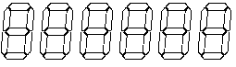

- What fake name did Guy Fawkes use when he was found in the cellars of the House of Lords?
………………………………………………………………………………

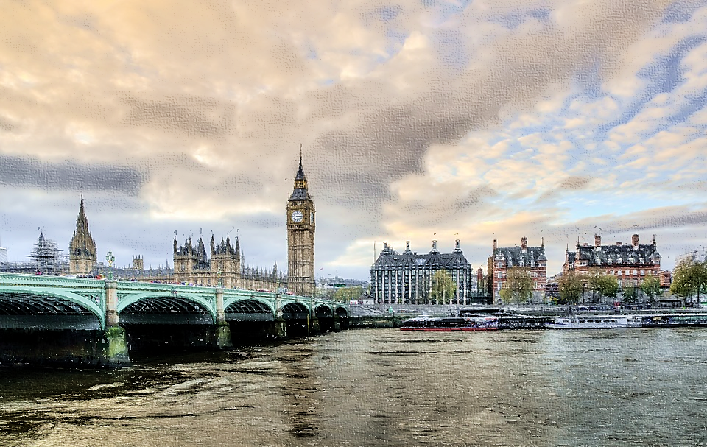
- Where is the current-day House of Lords? Find it on the provided sketch.
Source: https://pixabay.com/pl/photos/londyn-victoria-big-ben-1335477 (modified)

- What was the punishment imposed upon Guy Fawkes for his crime? Draw it… if you dare!

- What organisation adopted the masks you see on the right?
………………………………………………………………………………
- In what movie were the masks used for the first time?
………………………………………………………………………………

- Why did this organisation choose these masks for their protests?
- They appeared in an interesting film.
- They were difficult to buy.
- They were widely available.

After the video:
- Work in pairs. Describe the picture and answer the questions.

  - Why may the person in the photo try
to hide his / her identity?
  - Why some people may decide that 5th November is the perfect day for a protest?
  - Tell your partner about a situation, when you (or someone you know) has seen a protest or has participated in one.

Source: https://pixabay.com/pl/photos/miejskich-anonimowe-czarny-1658436
- Listen to the news report about a protest.
Decide if the provided sentences are true or false.
Audio 2: o-rozewicz.pl/A-News
Copyright info:
Text: “The Anonymous News Report” by Oskar Rożewicz
Music: “News” by Free Music | https://soundcloud.com/fm_freemusic
Music promoted by https://www.free-stock-music.com
Creative Commons Attribution 3.0 Unported License
https://creativecommons.org/licenses/by/3.0/deed.en_US

  - The Anonymous are responsible for physical attacks in the world. TRUE / FALSE
  - People protest against censorship during the Million Mask March. TRUE / FALSE
  - According to the Anonymous, police crulety happened in Africa. TRUE / FALSE
  - The group uses social networking sites to organise attacks. TRUE / FALSE
  - The Anonymous consider themselves to be a legion. TRUE / FALSE
- Work individually or in pairs. Using the Internet, find 5 facts about the Anonymous. -
  - ………………………………………………………………………………………………………………………………………………………………………………
  - ………………………………………………………………………………………………………………………………………………………………………………
  - ………………………………………………………………………………………………………………………………………………………………………………
  - ………………………………………………………………………………………………………………………………………………………………………………
  - ………………………………………………………………………………………………………………………………………………………………………………

