Speaking:
- Work in pairs. In turns, answer the questions. 
- Where is Thanksgiving celebrated?
- What is the traditional food eaten at a Thanksgiving dinner?
- Why do you think people celebrate Thanksgiving?
- Do you think Thanksgiving should be celebrated by everyone around the world? (Why? / Why not?)

Vocabulary:
- Translate these words and phrases into your language. Ask your friends or use a dictionary to help you.
-
annual – coroczny
a harvest – żniwa, plony
venison – sarnina
cranberries – żurawiny
subsequent – kolejny, dalszy
a nursery rhyme – rymowanka dla dzieci
to wage (a campaign) – przeprowadzać (kampanię) – aby coś osiągnąć
a (government) bill – propozycja ustawy
quirky – dziwaczny, zabawny, nietypowy
a reprieve – ulga
to deteriorate – podupadać, pogarszać się
to tempt – kusić
to soar – wzrastać, wznosić się
inflation – inflacja
If you need English definitions you can look them up in OALD 😊 www.oxfordlearnersdictionaries.com 
Don’t forget to mark the words you didn’t know before with a star

- Complete the text with the correct form of some of the words from the previous task.
Thanksgiving, an American and Canadian holiday, is celebrated A. annually on the fourth Thursday in November. Traditionally, people on this day eat turkey, sweet B. cranberries , bread stuffing, and pumpkin pie, with C. venison not being on the menu.
While the celebration is supposed to be a family meeting, there are people who may feel that it is
D. deteriorating recently, with family members being E. tempted
to discuss controversial political issues with their relatives. Due to that fact, even though it was supposed to be a
F. reprieve from the everyday burdens of life, it may become a tradition dreaded by a lot of people.

Listening: https://youtu.be/H9NDuxL4WA4 
- Watch the video. Mark the events on the timeline. Provide the dates.
- First national Thanksgiving holiday in the USA (Nov 26, 1789)
- The first Thanksgiving. (1621)
- First official pardon to a turkey. (1989)
- Thanksgiving rescheduled to one week earlier than before. (1939)
- Thanksgiving rescheduled back to the fourth Thursday in November. (1941)
- The announcement that Thanksgiving will be celebrated annually on the final Thursday in November. (1863)

E
1941
|

- The beginning of a campaign to make Thanksgiving a national holiday. (1827)

|
G
1827

|
F
1863

|
B
1621

|
A
1789

|
D
1939

|
C
1989

1600
2000

Speaking:
- Work in pairs. In turns, answer the questions.
- What do people do during Black Friday? (Why?)
- Are you saving money to buy anything this year? (Why? / Why not?)
- Do you agree with the saying “money makes the world go round”? (Why? / Why not?)
- Have you ever bought something that was a complete waste of money? (Why? What was it? / Why not?)

Reading:
https://www.theguardian.com/business/2022/nov/20/black-friday-may-lose-its-sparkle-as-football-and-inflation-hit-online-sales 
- Read the article. Decide if the sentences are TRUE or FALSE.

  - The annual Black Friday shopping spree in 2022 will be even bigger than usual.
TRUE / FALSE
  - Black Friday shopping is a one-day event.
TRUE / FALSE
  - The people in the UK and the US may watch a football match instead of going shopping on Black Friday evening.
TRUE / FALSE
  - People are becoming increasingly sceptical about Black Friday deals.
TRUE / FALSE
  - People during Black Friday will buy as many consumer electronics as before.
TRUE / FALSE
  - There’s a belief that delivery problems & the need to cut spending may provoke people to switch back to physical shopping.
TRUE / FALSE
  - Some retailers are struggling due to the soaring costs of gas and the wages of employees.
TRUE / FALSE

Speaking:
- Work in pairs. Describe the picture and answer the questions.

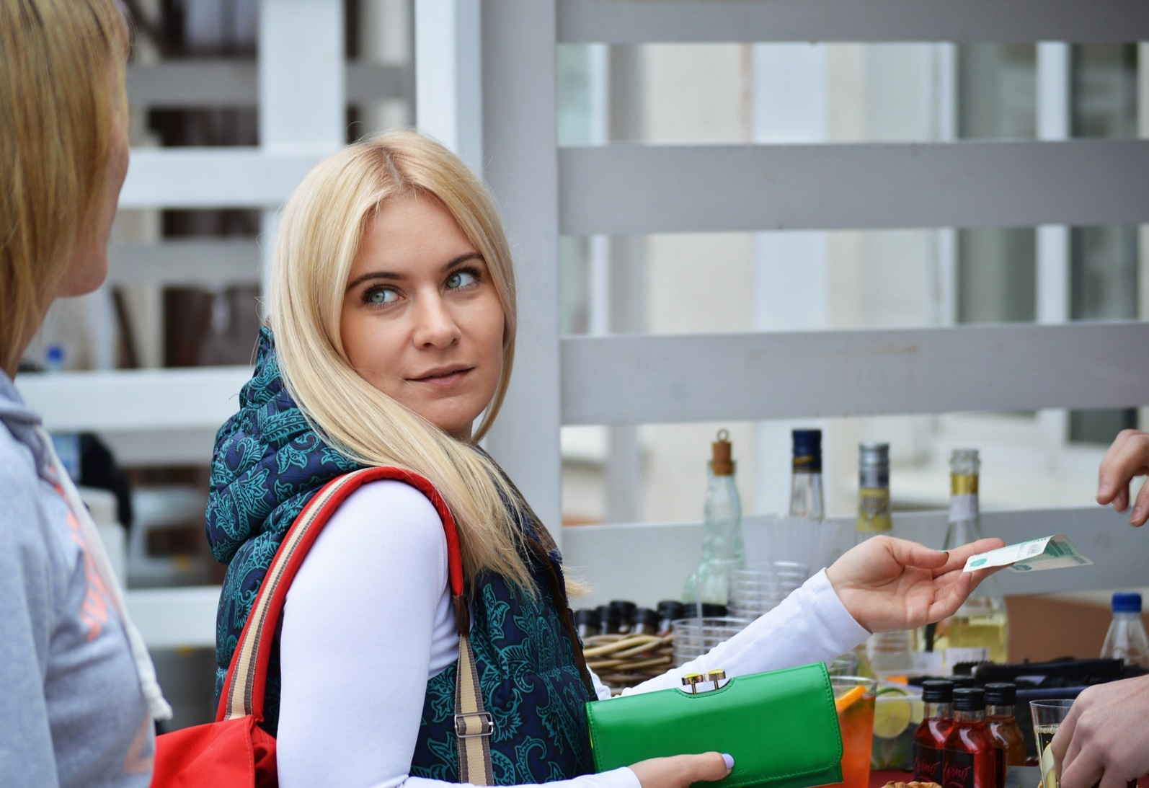
Source: https://pixabay.com/images/id-1438142/

  - What do you think is going to happen next? (Why?)
  - What are the pros and cons of cash payments?
  - Describe the time when you (or somebody you know) went on a shopping spree.

- Work in pairs. Discuss.
You are talking with your American schoolmate the week before Thanksgiving.
He’s invited you to a Thanksgiving dinner. In your dialogue discuss:
[time & date] [food] [guests] [clothing]

