St. Patrick’s Day Worksheet A Brief History of St. Patrick's Day: https://youtu.be/40BlVzjxu-I
Before the movie:
- What do you know about St. Patrick’s Day?
Fill in the mind map alone or with your deskmate. Add more lines if necessary. -

- Translate these words and phrases into your own language. Ask your friends or use a dictionary to help you.
-
to enslave – …………………………………………………………………………………………………….………..………………………………………..…
a raider – ………………………………………………………………………………………………………………………………………………………………
to return –.……………………………………………………………………………………………………………..……………………………………………..
to convert – …………………………………………………………………………………………………………………………………………………………..
to drive out – ………………………………………………………………..…………………………………………………………………………………….…
festivities – ………………………….…………………………………………………………………..………………………………………………………..….
to ban – ………………………………………………………….…………………………………………………………………………….……………………….
to consume – …………………..………………………………………………………………………………………………………………………..………….
to claim – ……………………………………………………………………………………………………………………………………….…………………..…
to pretend – ………………………………….………………………………………………………………………………………………………….…………...
forced – …..………………………..……………………………………………………………………………………………………….............................
labour – ……………………………………………………………………………………………………………………..……………………………………….
to join – ………………………………………………………………………………………………………………………..……………………….………………
a saint – ………………………………………………………………………………………………………………………………………………………………...

During the movie:
- Was St. Patrick Irish?
- Yes. b) No. c) I don’t know.
- Who enslaved St. Patrick?
- English raiders. b) Irish raiders. c) Roman Empire.
- When did he change his name to Patrick?
- When he was young. b) When he was enslaved. c) When he escaped.
- How many years did he devote to converting the Irish?
- 1 year. b) 3 years. c) 30 years.
- In which century did St. Patrick die? Mark it on the provided timeline.
- When is St. Patrick’s Day celebrated? Mark the date on the calendar.
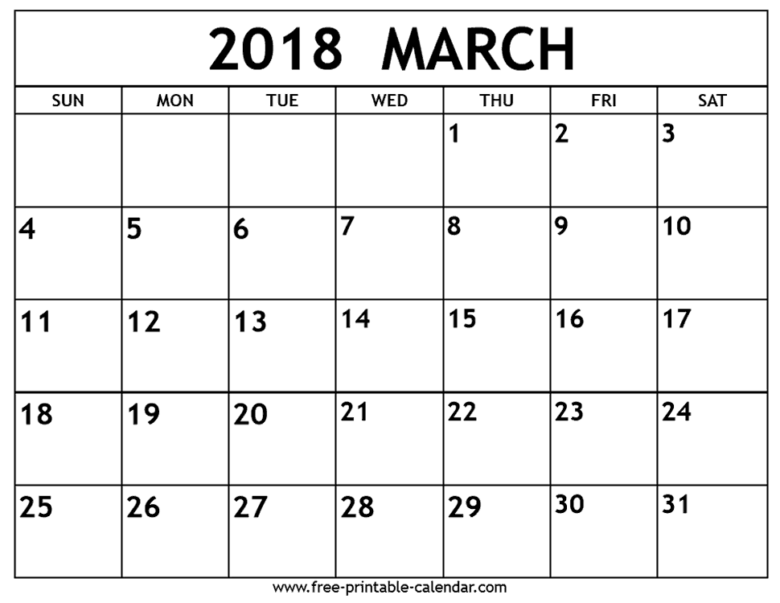

- Drinking in Ireland on St. Patrick’s Day was banned until…
a) 1970s. b) 1700s. c) 19th century.
- How many pints of Guinness are consumed worldwide?
Colour the appropriate number of pints, remembering, that each represents 1 million.
- Where was the first ever St. Patrick’s Parade held?
- in Belfast (Ireland) b) in Boston (USA) c) in New York (USA)
- How much green dye is used to turn the river in Chicago green?
- 4 lbs. b) 40 lbs. c) 45 lbs.
- Is New York’s St. Patrick’s Day parade the largest in the world?
a) Yes. b) No. c) I don’t know.
- How many Americans claim Irish ancestry? Fill in the ‘digital screen’. Add commas where necessary.
- Do you think that people in your country should celebrate St. Patrick’s Day?
- Yes. b) No.
Why?
………………………………………………………………………………………………………………………………………………………………………………………………………………………………………………………………………………………………………………………………………………………………………………………………………………………………………………………………………………………………………………………………………………
After the movie:
- Work in groups. Invent a parade that could be organized in your country.
- Describe its historical background, i.e. how it could be connected to the history of your country.
- Talk about the activities that people could perform during this parade.
- Describe the costumes, colours etc. that people could wear during this parade.
-
………………………………………………………………………………………………………………………………………………………………………………………………………………………………………………………………………………………………………………………………………………………………………………………………………………………………………………………………………………………………………………………………………………………………………………………………………………………………………………………………………………………………………………………………………………………………………………………………………………………………………………………………………………………………………………………………………………………………………………………………………………………………………………………………………………………………………………………………………………………………………………………………………………………………………………………………………………………………………………………………………………………………………………………………………………………………………………………………………………………………………………………………………………………………………………………………………………………………………………………………………………………………………………………………………………………………………………………………………………………………………………………………………………………………………………………………………………………………………………………………………………………………………………………………………………………………………………………………………………………………………………………………
………………………………………………………………………………………………………………………………………………………………………………………………………………………………………………………………………………………………………………………………………………………………………………………………………………………………………………………………………………………………………………………………………………………………………………………………………………………………………………………………………………………………………………………………………………………………………………………………………………………………………………………………………………………………………………………………………………………………………………………………………………………………………………………………………………………………

St. Patrick’s Day song: The Dubliners - Whiskey in the Jar: https://youtu.be/hlWTASnnft4
- Fill in the gaps in the song by The Dubliners: Whisky in the Jar, using the words provided below.
swore / army / bowling / prisoner / footmen / slaughter / jewels / money / chamber / stole / pretty / devil / captain / travel / delight / better / water / deceiver / juice / pistol
As I was a goin' over the far famed Kerry mountains
There's whiskey in the jar
And 't was early in the morning, just before I rose to ¹¹ __________
Up comes a band of ¹² __________ and likewise captain Farrell
I first produced me pistol for she ¹³ __________ away me rapier
I couldn't shoot the water, so a ¹⁴ __________
I was taken
Mush-a ring dumb-a do dumb-a da
Wack fall the daddy-o, wack fall the daddy-o
There's whiskey in the jar
There's some take ¹⁵ __________ in the carriages a rolling
and others take delight in the hurling and the
¹⁶ __________
but I take delight in the ¹⁷ __________ of the barley
and courting ¹⁸ __________ fair maids in the morning bright and early
Mush-a ring dumb-a do dumb-a da
Wack fall the daddy-o, wack fall the daddy-o
There's whiskey in the jar
And if anyone can aid me 't is my brother in the
¹⁹ __________
If I can find his station in Cork or in Killarney
And if he'll go with me, we'll go rovin' through Killkenney
And I'm sure he'll treat me ²⁰ __________ than my own a-sporting Jenny
Mush-a ring dumb-a do dumb-a da
Wack fall the daddy-o, wack fall the daddy-o
There's whiskey in the jar

I met with ¹ __________ Farrell and his money he was counting
I first produced my ² __________ and I then produced my rapier
Saying "Stand and deliver" for he were a bold
³ __________
Mush-a ring dumb-a do dumb-a da
Wack fall the daddy-o, wack fall the daddy-o
There's whiskey in the jar
I counted out his ⁴ _______ and it made a pretty penny
I put it in me pocket and I took it home to Jenny
She sighed and she ⁵ __________ that she never would deceive me
But the ⁶ __________ take the women for they never can be easy
Mush-a ring dumb-a do dumb-a da
Wack fall the daddy-o, wack fall the daddy-o
There's whiskey in the jar
I went up to my ⁷ __________, all for to take a slumber
I dreamt of gold and ⁸ __________and for sure 't was no wonder
But Jenny blew me charges and she filled them up with ⁹ __________
Then sent for captain Farrell to be ready for the
¹⁰ __________
Mush-a ring dumb-a do dumb-a da
Wack fall the daddy-o, wack fall the daddy-o

