Worksheet: Sex in Space (17-10-2018)
Before the movie:
- Planet Earth will be hit by an asteroid during the next 10 days. People have evacuated to the International Space Station “Hope 6”.
Bearing in mind the conditions available on the Space Station (e.g. microgravity) assess whether it will be possible for people to have sex in space.
- Will it be possible?
- What problems will we face?
Present your ideas on a mind map. Be creative
Attention: Remember that, even though sci-fi & fantasy films show that it is possible to create gravity, it’s not true. -

(YES / NO cliparts adapted from https://openclipart.org)
- What organisations work on the issue of space exploration: -
- In Poland?
- In other countries?
What are their tasks?
Use the internet and/or your knowledge on the topic. Present your findings in a table.
Name of the organization | Country | Tasks
POLSA  Polska Agencja Kosmiczna | Poland | Supporting the promotion and development of Polish space research instututes,  Coordinating the activity of the Polish space sector (nationally and internationally),  Ensuring more wide-spread use of the satellites in the Polish governmental institutions,  Participating in the military projects,  Representing Polish government abroad during contacts with other international space organisations  (Wikipedia)
NASA | USA | Civilian space program,  Aeronautics and aerospace research,  Space flight programs,  Non-military research,  Commercial programs,  Researching climate change  (Wikipedia)
ESA  The European Space Agency | Several European countries | providing for and promoting, for exclusively peaceful purposes, cooperation among the European States in space research and technology and their space applications, with a view to their being used for scientific purposes and for operational space applications systems,  setting a unified space and related industrial policy, recommending space objectives to the member states,  integrating national programs like satellite development, into the European program as much as possible  (Wikipedia)
CNSA  The China National Space Administration | China | governing the national space program,  planning and developing Chinese space activities, signing governmental agreements in the space area on behalf of organizations,  inter-governmental scientific and technical exchanges,  being in charge of the enforcement of national space policies,  managing the national space science, technology and industry  (Wikipedia)

- Think about the future.
Imagine that you are responsible for making plans at NASA about the space exploration.
On the provided timeline mark the milestones – when will we achieve certain successes in terms of space exploration – and provide their description.
2000
2200

When you finish designing the timeline work in pairs - tell your partner about it.

During the movie: The Universe S03E04: https://dai.ly/x1p92yg
While watching the video answer the questions provided below.
- Which law of motion is “the number one enemy of performing sex in space”?
- The First Law of Motion.
- The Second Law of Motion.
- The Third Law of Motion.

- Choose the correct words to create the Law mentioned in the previous task.
For every relationship / action there is an equal / unequal and opposite reaction / action.
If you push against something it doesn’t push / pushes against you.
- Who is Vanna Bonta?
- A journalist and an author of newspaper articles.
- A novelist and an author of sci-fi books.
- A scientist and an astronaut.
- What’s the “Two Suit”? Draw it…

or describe it.
The 2suit is a flight suit designed to facilitate intimacy in weightless environments. It features a large front flap that can be opened and attached to another 2suit via Velcro strips (Wikipedia)

- What’s a G Force One?
- A modified plane producing the effect of weightlessness.
- A device built into a plane which stops the gravity from affecting people.
- A spaceship entering the space for a few seconds and then coming back to the Earth.

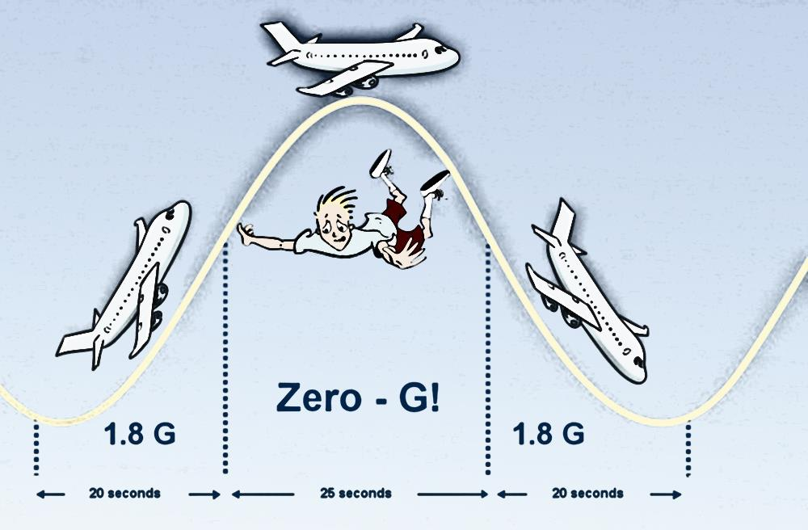
- How does the G Force one fly to produce the zero-gravity effect? Draw it.
(image taken from: https://www.scienceabc.com/innovation/how-does-nasa-create-zero-gravity.html)
- How much time does Vonna and her husband have to test out the Two Suit? Draw the number of time on the ‘digital screen’ and choose whether it’s hours, minutes or seconds.

hours / minutes / seconds.

- When does Vonna and her husband achieve success in testing the Two Suit?
- During the first attempt.
- During the eighth attempt.
- They don’t achieve success.
- Is living in space and in the micro-G setting risky for our health?
- Yes.
- No.
Why?
in the micro-G setting bones are loosing calcium, heart is loosing mass, skeleton is loosing mass etc.

- What animals have successfully replicated/reproduced in space? Tick all the correct answers.
- Rats
- Gorillas
- Fish
- Dogs
- Bees
- What is the Viagra effect?
- Persistent and painful erection in space.
- The pills replicating themselves in space.
- People changing skin colour after taking certain pills in space.
- What’s the time of a standard human pregnancy on Earth?
- 30 weeks.
- 36 weeks.
- 6 months.
- How will the delivery chamber look like in space? Draw it…
oxygen mask
pillow
lights
this is a VERY simplified version of what you see in the movie (18:15)
tubes
water
or describe it.
the delivery chamber will involve a fairly rapid flow of water to keep the chamber clean. It is inspired by water birthing.

- How will the proposed “Earth Suit” look like? Draw it…
this is a VERY simplified version of what you see in the movie (19:42)
or describe it.
it will be a support for the muscles and bones of the extra-terrestial human species

- How many years will it take the NASA mission to reach Mars?
- 30 years.
- 33 years.
- 3 years.
- What plans have scientists made to approach the problem of sex in space? Tick all the correct answers.
- Sending single-sex crews.
- Sending married couples.
- Sending people and robots together.
- Training people to deal with the problem and to do a good job.
- Sending the crew for 9 months to a remote location in Antarctica to let them learn dealing with the problems.
- Taking only sick people onboard of a spaceship.
- Allowing people to have sex without any bans and obligations.

- Has anyone tried sex on a spaceship?
- Yes, although it’s not confirmed.
- Yes and it’s confirmed.
- No.
- Who is seen as more open-minded in terms of living in space?
- Americans.
- Russians.
- What’s the three dolphin technique?
- The presence of a dolphin in space.
- The possibility for using dolphins to create intimate relationship between humans in space.
- The presence of a third person while two people have sex.
- What’s the “best thing” to connect two people in space in an intimate moment?
- A chain. b) A duct tape. c) A rope.

- What’s the snuggle tunnel? Draw it…
or describe it.
it’s the ‘tunnel’ allowing people to have sex and intimacy in space

- Do you agree that “wherever humans go, sex will follow”? Why / Why not?
Yes / No,
because…
…………………………………………………………………………………………………………………………………………………………………………………………………………………………………………………………………………………………………………………………………………………………………………………………………………………………………………………………………………………………………………………………………………………………………………………………………………………………………………………………………………………………………………………………………………………………………………………………………………………………………………………………………………………………………………………………………………

After the movie:
- Work in pairs. Ask and answer the following questions.
- Did you like the movie? Why / Why not?
- What was the most surprising thing you’ve learnt from the movie?
- Would you like to be an astronaut? Why / Why not?

If you want to make notes for the discussion, put them below
…………………………………………………………………………………………………………………………………………………………………………………………………………………………………………………………………………………………………………………………………………………………………………………………………………………………………………………………………………………………………………………………………………………………………………………………………………………………………………………………………………………………………………………………………………………………………………………………………………………………………………………………………………………………………………………………………………

- Imagine that you are writing an e-mail to NASA to ask about the problem of sex in space.
In your e-mail: -
- Ask about the current research done on the problem of sex in space,
- Ask for information about the future plans on researching the topic,
- Present your opinion on the topic,
- Invite NASA representative to Poland to a conference on the topic.
Your e-mail should be at least 100 words long – it can be longer
…………………………………………………………………………………………………………………………………………………………………………………………………………………………………………………………………………………………………………………………………………………………………………………………………………………………………………………………………………………………………………………………………………………………………………………………………………………………………………………………………………………………………………………………………………………………………………………………………………………………………………………………………………………………………………………………………………………………………………………………………………………………………………………………………………………………………………………………………………………………………………………………………………………………………………………………………………………………………………………………………………………………………………………………………………………………………………………………………………………………………………………………………………………………………………………………………………………………………………………………………………………………………………………………………………………………………………………………………………………………………………………………………………………………………………………………………………………………………………………………………………………………………………………………………………………………………………………………………………………………………………………………………………………………………………………………………………………………………………………………………………………………………………………………………………………………………………………………………………………………………………………………………………………………………………………………………………………………………………………………………………………………………………………………………………………………………………………………………………………………………………………………………………………………………………………………………………………………………………………………………………………………………………………………………………………………………………………………………………………………………………………………………………………………………………………………………………………………………………………………………………………………………………………………………………………………………………………………………………………………………………………………………………………………………………………………………………………………………………………………………………………………………………………………………………………………………………………………………………………………………………………………………………………………………………………………………………………………………………………………………………………………………………………………………………………………………………………………………………………………………………………………………………………………………………………………………………………………………………………………………………

