Warm-up:
- Work in pairs. In turns, answer the questions.
- Where (from what continent) do pumpkins come from? Central America.
- What is the name of the Halloween decoration made with pumpkins? A jack-o’-lantern.
- How do we call (informally) the insides of a pumpkin? Tip: think of animals. Flesh / Meat / Guts
- Have you ever carved a pumpkin for Halloween? Why? / Why not?
Pumpkin trivia
Try to guess:
- According to Guinness World Records, how much does the heaviest pumpkin weigh? Is it between:
a) 250 - 500 kg, b) 500 – 750 kg, c) 750 - 1,000 kg, d) 1,000 kg – 1500 kg or e) 1,500 kg - 2,000 kg?
- Which US state produces the most pumpkins? Is it:
a) Texas, b) Arizona, c) Indiana, d) Illinois, or e) California?
- How long does it take for pumpkins to mature? Is it:
a) 1-15 days, b) 15-30 days, c) 30-60 days, d) 60-90 days or e) 90-120 days?
- How much water is there in a pumpkin? Is it:
a) 15%, b) 25%, c) 65%, d) 80% or e) 90%? Trivia questions inspired by https://www.quiztriviagames.com/pumpkin-quiz/
Vocabulary:
- Translate these words and phrases into your language. Ask your friends or use a dictionary to help you.
-
a pound – funt (jednostka wagi) 1 pound = 0.45 kg
a vine – pnącze
ripe – dojrzały
to sow – siać
to breed – rodzić, hodować
annually – rocznie
to cultivate – uprawiać, kultywować
boundaries – granice
to facilitate – ułatwiać, umożliwiać
remarkable – niezwykły
staggering – szokujący, piorunujący
If you need English definitions you can look them up in OALD 😊 www.oxfordlearnersdictionaries.com
Don’t forget to mark the words you didn’t know before with a star
- Complete the text with the correct form of some of the words from the previous task.
It’s this season of the year again! Halloween is almost upon us. It is celebrated A. annually on the 31st of October, right after the pumpkins are ready for harvest and around 75-115 days after they were
B. sown / sowed . It’s a tradition C. cultivated all around the world, especially in the US. On this occasion you can see D. remarkable (not only) pumpkin decorations around the buildings, interesting & scary costumes, as well as plenty of kids going trick or treating.
Listening: https://www.youtube.com/watch?v=I3cc2QeSfWw
- Watch the video. Answer the questions.
  - How many pounds of pumpkins do US farmers harvest every year for Halloween?
500 mln lb
  - What proportion of pumpkins is made for decorations, and what for puree? Mark it on the pie chart.
  - 50:50
  - What’s the botanical family of pumpkin?
Cucurbita family
  - When did American Indians teach pilgrims how to grow pumpkins? Mark the time on the timeline.
1600s = 17th century
  - What is the worst enemy of farmers growing pumpkins?
A fungus called powdery mildew
  - Do farmers walk around the pumpkin farms before it’s time to harvest pumpkins?
Yes / No
  - Is the canned pumpkin the same as the pumpkin used for decorations?
Yes / No
Reading: https://www.theguardian.com/food/2022/oct/11/maverick-champion-pumpkin-travis-gienger
- Read the article. Decide if the sentences are TRUE or FALSE.

  - The annual weigh-off happens on the grounds of the Half Moon Bay festival.
TRUE / FALSE It happens on the California coast.
  - Travis Gienger won the weigh-off.
TRUE / FALSE He was even awarded $23,040 in prize money.
  - The pumpkin described in the article sprouted from the common seeds one can buy at a local shop.
TRUE / FALSE Giant pumpkins are grown from special, selected, seeds.
  - Minnesota is a perfect place to grow pumpkins.
TRUE / FALSE It’s got harsh springs, so it is difficult to grow pumpkins there.
- Read the article once again (if need be) and answer the questions.
  - What’s the size of the biggest pumpkin in the world?
2,702lb = 1,225.61 kg
  - What do you need to grow giant pumpkins?
The right amount of space, protection (=refuge) from pests, and nurturing soil.
  - Where will Maverick, the pumpkin described in the article, be on display?
It will be on display at the 50th Half Moon Bay (San Francisco) art and pumpkin festival, held on 15th and 16th October.
Speaking:
- Work in pairs. Describe the picture and answer the questions.

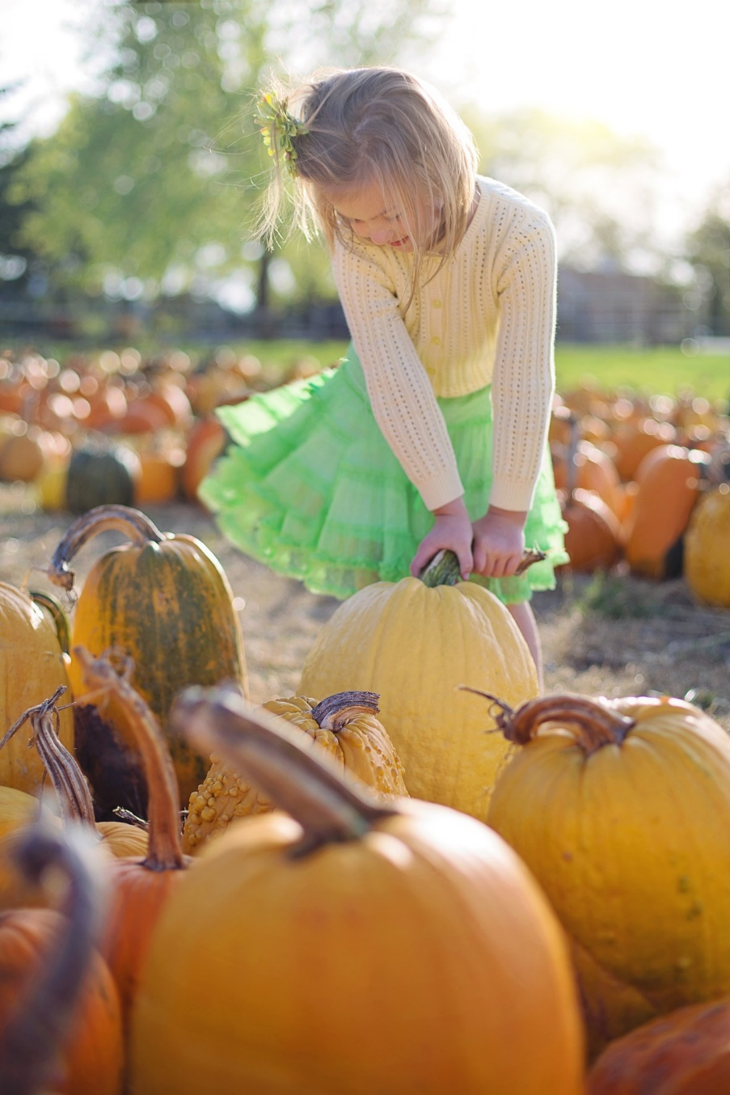
Source: https://pixabay.com/images/id-2878159/

  - Why do you think the girl is on the pumpkin farm?
  - What are the pros and cons of farming pumpkins?
  - Describe the time when you (or somebody you know) celebrated Halloween.

- Work in pairs. Discuss.
You and your schoolmates are at a student exchange in the US. Your American host is organising a Halloween party and has asked you to call one of your friends to invite them. In the phone call discuss the following aspects:

[time & date] [food] [music] [clothing]

