Before the video: top clipart adapted from https://openclipart.org/detail/2944/the-charm-of-oxford
- Work in pairs. In turns, answer the questions.
- Have you ever been to the UK?
If your answer is “yes”, then what places have you visited?
If “no”, then would you like to go there in the future? Why / Why not?
- What famous place is located in Oxford? Why is it famous?
- Translate these words and phrases into your own language. Ask your friends or use a dictionary to help you.
-
idyllic –
to depart –
spacious –
to recline –
produce (n.) –
to redevelop –
mind-boggling –
bustling –
captivating –
a meadow –
If you need English definitions you can look them up in OALD 😊 www.oxfordlearnersdictionaries.com
Don’t forget to mark the words you didn’t know before with a star

- Look at the map of the UK. Where exactly is Oxford?
Try to find the dot which represents Oxford. Work alone or with your deskmate. -

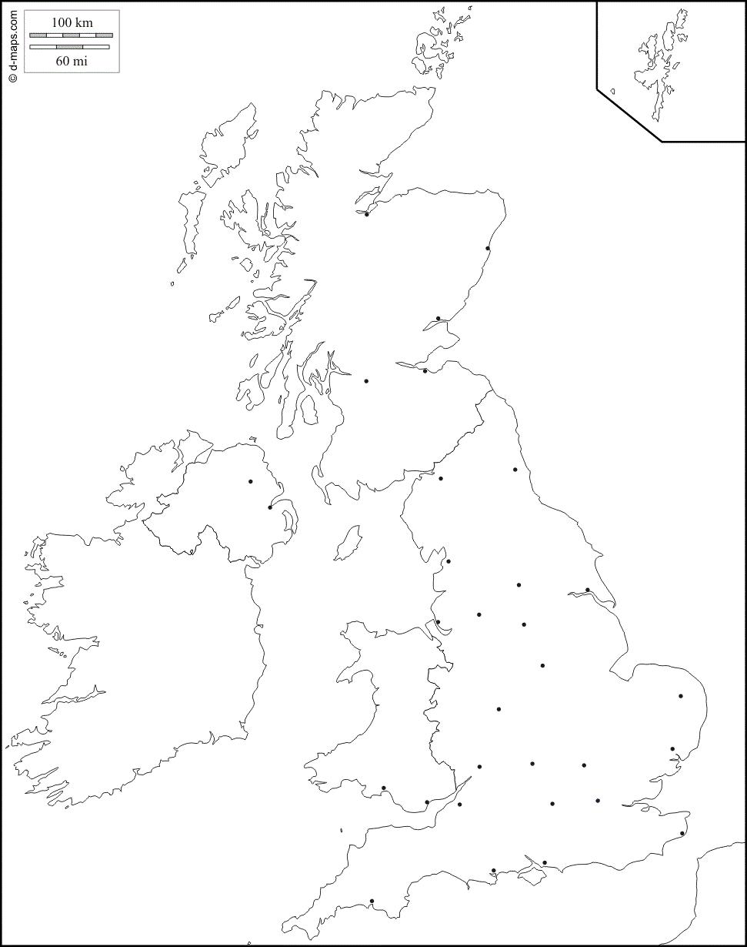 (map adapted from https://d-maps.com)

During the video:
- Watch the video and answer the questions.
Oxford Travel Guide - Day Trip from LONDON | Josh Goes Slow: https://youtu.be/AadPkKxc4ok

  - Where did the speaker start his journey?

  - How often does the Oxford Tube depart?
  - What’s the price of the open return ticket to Oxford from London?

  - If you departed from London at 13:00 when would you be arriving at Oxford? Mark the time on the clock.
clipart adapted from https://openclipart.org/detail/217092/blank-clock
  - What can you find at the Gloucester Green Market?

  - By the eighteenth century the remains of Oxford Castle were used as a…
- prison
- church
- hotel
  - The door and lamppost of the gothic university church were an inspiration for
by C.S. Lewis.
  - How many items can you find in the Radcliffe Camera?
  - Oxford lays claim to the largest system in the UK.
- tube
- library
- college
  - When did the Oxford Covered Market open to the public? Mark the date on the timeline.
1800
1500

  - Why is the Turf Pub so famous?

  - What can you do at the river Cherwell?

After the video: -
- Work in groups. Imagine that you are travelling to Oxford for 3 days.
Prepare a sightseeing plan, describing what attractions you would like to see (and why), where you would eat, as well as providing information about the accommodation (e.g. hotels) you would choose.
Don’t forget to talk about the costs!

To help you with the task you can use the internet, especially:
https://www.expedia.com/Oxford.dx9272
https://www.tripadvisor.co.uk/Tourism-g186361-Oxford_Oxfordshire_England-Vacations.html

You can use the blank space for your notes ;)

