The English-speaking world: Michigan
Before the videos:
- When you think about Michigan, what comes to your mind first?
Fill in the mind map alone or with your deskmate. Add more lines if necessary. -

Michigan
(clipart adapted from https://openclipart.org)
- Look at the map of the USA. Where is the state of Michigan?
Try to find & mark it on the map. Work alone or with your deskmate. -

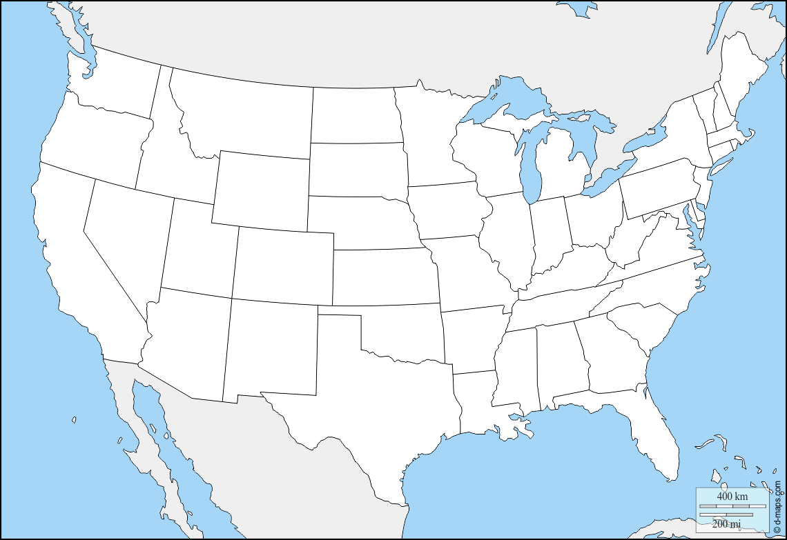
(map adapted from https://d-maps.com)
- Translate these words and phrases into your own language. Ask your friends or use a dictionary to help you.
-
quintessential –
an endeavor –
an aviation –
connoisseur –
pristine –
delightful –
wetlands –
thriving –
abundant –
thrilling –
exhibits –
galore –
an acquisition –
charm –
diversity –
entertainment –

If you need English definitions you can look them up in OALD 😊
www.oxfordlearnersdictionaries.com
- Which of the words presented in exercise 3 were new to you?
Mark the new words with a star

To do the next part you’ll need to watch 3 videos:
- Visit Michigan USA - Discover all the Best Things to do on a Michigan Holiday (Visit the USA)
https://youtu.be/1NtB7K3X8JU
- Detroit, Michigan: Holiday With Cars, Music, History, and Urban Family Fun (Visit the USA)
https://youtu.be/HSPJIfiamiQ
- Lansing, Michigan: Activities in the Capital City (Visit the USA)
https://youtu.be/YnMAs4myJA8
During the first video:
- What’s in the Henry Ford?

- How many galleries are there in the Detroit Institute of Arts?

- Where can you find 13 mile river trail?

- What things can you find in R. E. Olds Transportation Museum?

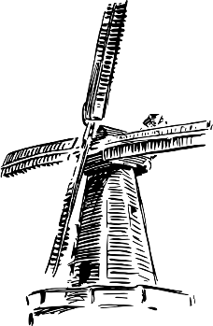
- Where can you find the construction shown in the picture?
Adapted from https://openclipart.org/detail/278824/windmill-2

- How many cities make up the Great Lakes Bay region?

- What’s the area size of Sleeping Bear Dunes?

- What’s surprising about the Mackinac Island?

During the second video:
- What century Campus Martius dates back to? Mark it below.
- How did Rosa Park’s name record in the US history?

- When did Berry Gordy start Motown Records? Mark it on the provided timeline.
2000
1900

During the third video:
- What University can you find in Lansing?

- How many students are studying at the University mentioned above?
Mark the number on the ‘digital screen’.

- What can you do at the Eastwood Towne Center?

- How many golf courses are there around Lansing?

- What’s the name of one of the city’s first breweries mentioned in the video?

After the videos: -
- Work in groups. Imagine that you are travelling to Michigan for 7 days.
Prepare a sightseeing plan, describing what attractions you would like to see (and why), where you would eat, as well as providing information about the accommodation (e.g. hotels) you would choose.
Don’t forget to talk about the costs!

To help you with the task you can use the internet, especially:
https://www.expedia.com/Michigan.dx224
https://www.tripadvisor.com/Tourism-g28943-Michigan-Vacations.html

You can use the blank space for your notes ;)

