Halloween Worksheet The Surprising History of Halloween (youtube): https://youtu.be/tBusTdK1kp4
Before the video:
- What do you and (your friend) know about Halloween?
Fill in the mind map alone or with your deskmate. Add more lines if necessary. -

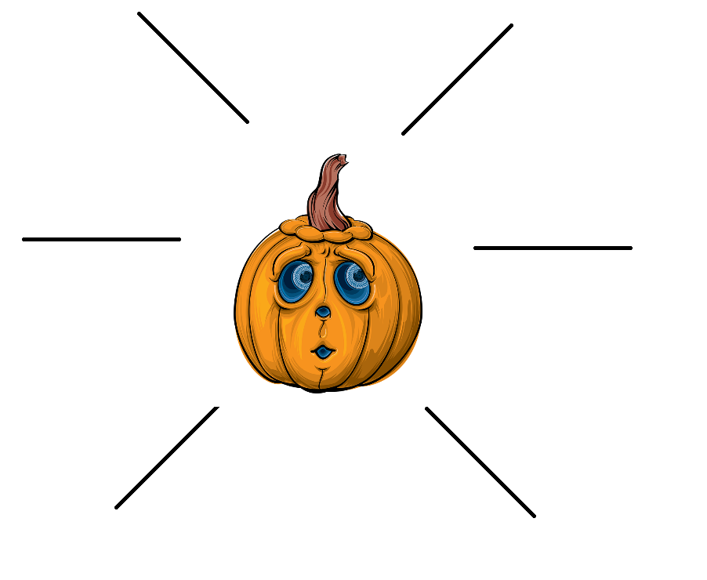

- Translate these words into your own language. Ask your friends or use the dictionary to help you.
-
devilish - diabelski
a veil – zasłona, przesłona
a fairy – wróżka, duszek
a spirit – duch, dusza
to keep someone / something at bay – trzymać na dystans
a guise - przebranie
rigid – sztywny, ścisły, rygorystyczny
to flood - zalać
to carve – wyrzeźbić, wydrążyć
a coinage – tu: tworzenie nowych wyrażeń
If you need English definitions you can look them up in OALD 😊 www.oxfordlearnersdictionaries.com
Don’t forget to mark the words you didn’t know before with a star

During the video:
- Did many of the Halloween traditions originate with the Christian religion?
- Yes, they did. b) No, they didn’t. c) I don’t know.
- When did summer come to an end, according to Celts?
31st October
- What is the date of the Halloween?
31st October
- Why did the Celts:
- leave food & wine at the doorstep?
to keep ghosts at bay
- dress up in costumes?
to blend in with the spirits
- In which century did the Pope establish All Hallow’s Day?
8th century AD
- Which pope established All Hallow’s Day?
- John Paul II b) Gregory IV c) Gregory III

- What is the origin of trick or treating?
Souling – a custom where poor children went door-to-door collecting baked cakes in exchange fortheir families’ souls in purgatory;
guising – a tradition where masked individuals would go door-to-door dancing and singing in exchange for food and wine
- When did the Potato Famine force Irish to “flood” the US? Mark it on the timeline provided below.
mid 19th century
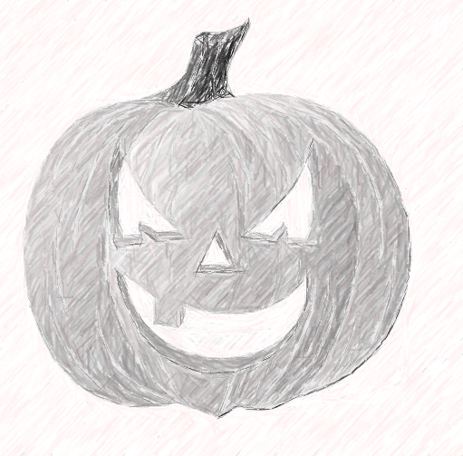
- What is a jack-o’-lantern? Draw it.

- When did Halloween become more “family-friendly”?
- In the 1850s b) In the 1950s c) In the 1970s

- Is Halloween profitable nowadays? a) Yes, it is. b) No, it isn’t. c) I don’t know.

After the video:
- How do some people celebrate Halloween now? -
………………………………………………………………………………………………………………………………………………………………………………………………………………………………………………………………………………………………………………………………………………………………………………………………………………………………………………………………………………………………………………………………………………………………………………………………………………………………………………………………………………………………………………………………………………………………………………………………………………………………………………………………………………………………………………………………………………………………………………………………………………………………………………………………………………………………………………………………………………………………………………………………………………………………………………………………………………
- Work in pairs or in groups. Write a spooky story you could tell someone else to scare them. -
………………………………………………………………………………………………………………………………………………………………………………………………………………………………………………………………………………………………………………………………………………………………………………………………………………………………………………………………………………………………………………………………………………………………………………………………………………………………………………………………………………………………………………………………………………………………………………………………………………………………………………………………………………………………………………………………………………………………………………………………………………………………………………………………………………………………………………………………………………………………………………………………………………………………………………………………………………………………………………………………………………………………………………………………………………………………………………………………………………………………………………………………………………………………………………………………………………………………………………………………………………………………………………………………………………………………………………………………………………………………………………………………………………………………………………………………………………………………………………………………………………………………………………………………………………………………………………………………………………………………………………………………………………………………………………………………………………………………………………………………………………………………………………………………………………………………………………………………………………………………………………………………………………………………
………………………………………………………………………………………………………………………………………………………………………………………………………………………………………………………………………………………………………………………………………………………………………………………………………………………………………………………………………………………………………………………………………………

