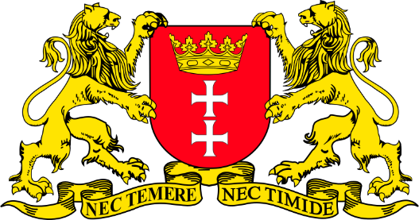
Gdańsk: the City of Freedom and Solidarity
Before the movie:
- When you think about Gdańsk, what comes to your mind first?
Fill in the mind map alone or with your deskmate. Add more lines if necessary. -

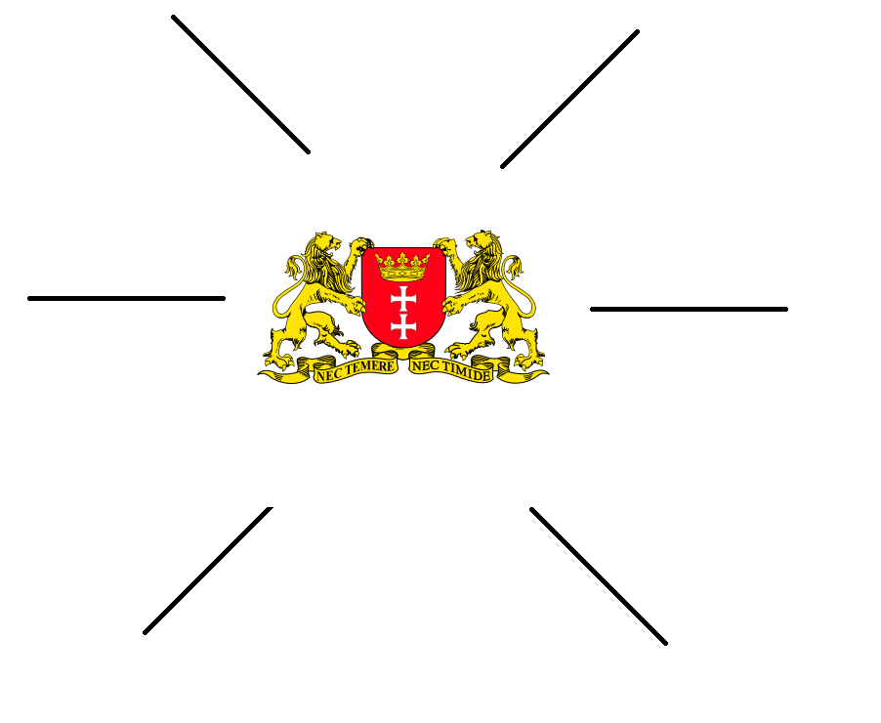
(clipart adapted from https://openclipart.org)
- Look at the map of Poland. Where exactly is Gdańsk?
Try to find the dot which represents Gdańsk. Work alone or with your deskmate. -

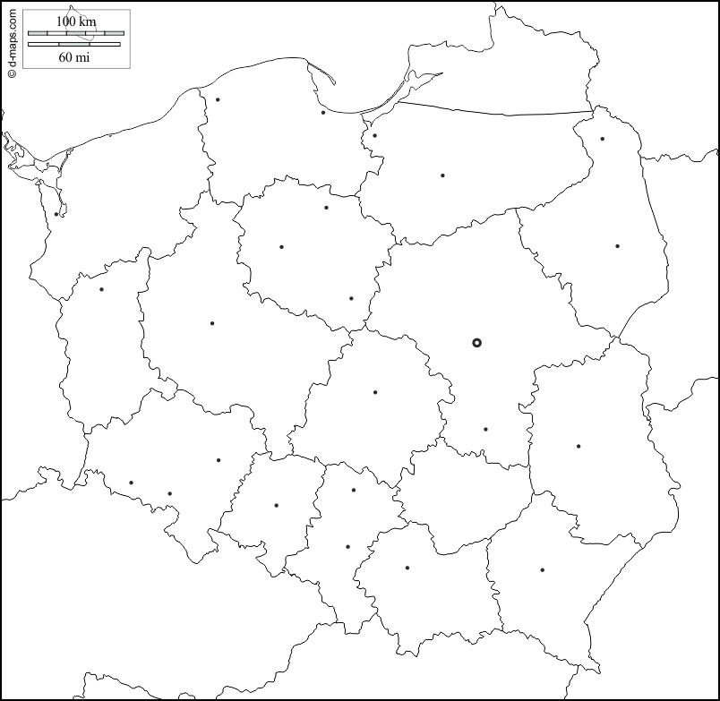
(map adapted from https://d-maps.com/carte.php?num_car=18745&lang=en)
- Translate these words and phrases into your own language.
Ask your friends or use a dictionary to help you.
-

scenic – malowniczy
an adventure – przygoda
urban – miejski
to combine – łączyć
harmonious – harmonijny
turbulent – niespokojny, burzliwy
modernity – nowoczesność
a pier – molo, pirs, filar
a bay – zatoka, zalew
vibrant – żywy, intensywny, tętniący życiem
vantage point – punkt obserwacyjny, punkt widokowy
a cutlet – kotlet, sznycel
a dill – koper
to toll – dzwonić, bić
meringue – pianka, beza
to drizzle – mżyć

If you need English definitions you can look them up in OALD 😊
www.oxfordlearnersdictionaries.com

- Which of the words presented in exercise 3 were new to you?
Mark the new words with a star

During the movie:
Watch the first movie and answer the questions (5-7).
Gdańsk, Sopot, Gdynia [EN]: https://youtu.be/UP1MXel6HXk
- How many flights daily arrive at Gdańsk? Mark the appropriate number on the “digital screen”.
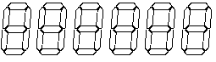
- What’s TriCity?
It’s an agglomeration of three cities – Gdańsk, Sopot, Gdynia.

- Describe each city in detail. Fill in the table.
GDAŃSK | SOPOT | GDYNIA
the capital of the region  1000 years of history  turbulent past  city of freedom, Solidarity, culture  tradition meets modernity  art goes out on the streets | calm city  fashionable resort  rich spa & wellness offer  trendy clubs, restaurants, cafes  the longest wooden pier in Europe | the youngest part of the agglomeration  the city of innovation & business  the maritime capital of Poland – the port of destination of the largest sail boats  the capital of European modernity  the arena of international sports and music events

Watch the second movie and answer the questions.
10 Things to do in Gdańsk, Poland Travel Guide: https://youtu.be/8d0ioLYPj6Q
- What attractions have they seen & visited? Make a list.
  - Basilica of Saint Mary (Bazylika Mariacka)
  - Main pedestrian street in Gdańsk: Długa
  - Amber Museum
  - Historical Museum of the City of Gdańsk (Muzeum Historyczne Miasta Gdańska)
  - The Medieval Crane (Żuraw)
  - SS Sołdek
  - Restaurant on a boat
  - Neptune Milk Bar
  - European Solidarity Centre (Europejskie Centrum Solidarności)
- How many steps is it to the top of the Basilica?
Mark the appropriate number on the “digital screen” .
- In the past Amber Museum was…
- a tourist attraction
- a prison and a torture chamber
- a factory

- When was the Medieval Crane first mentioned in texts? Mark the date on the timeline.
1367
1500
1000

- What’s the purpose of the European Solidarity Centre?
It tells the story of Solidarity, a Polish trade union and civil resistance movement founded in 1980.

After the movie: -
- Choose two attractions from the list you’ve made in task 8 and describe them thoroughly.
Use the internet if necessary.
- Work in groups. Imagine that you are travelling to Gdańsk for 5 days.
Prepare a sightseeing plan, describing what attractions you would like to see (and why), where you would eat, as well as providing information about the accommodation (e.g. hotels) you would choose.
Don’t forget to talk about the costs!

To help you with the task you can use the internet, especially:
https://wikitravel.org/en/Gdańsk
https://pl.tripadvisor.com/Tourism-g274725-Gdańsk_Pomerania_Province_Northern_Poland-Vacations.html

………………………………………………………………………………………………………………………………………………………………………………………………………………………………………………………………………………………………………………………………………………………………
………………………………………………………………………………………………………………………………………………………………………………………………………………………………………………………………………………………………………………………………………………………………
………………………………………………………………………………………………………………………………………………………………………………………………………………………………………………………………………………………………………………………………………………………………
………………………………………………………………………………………………………………………………………………………………………………………………………………………………………………………………………………………………………………………………………………………………
………………………………………………………………………………………………………………………………………………………………………………………………………………………………………………………………………………………………………………………………………………………………
………………………………………………………………………………………………………………………………………………………………………………………………………………………………………………………………………………………………………………………………………………………………
………………………………………………………………………………………………………………………………………………………………………………………………………………………………………………………………………………………………………………………………………………………………
………………………………………………………………………………………………………………………………………………………………………………………………………………………………………………………………………………………………………………………………………………………………
………………………………………………………………………………………………………………………………………………………………………………………………………………………………………………………………………………………………………………………………………………………………
………………………………………………………………………………………………………………………………………………………………………………………………………………………………………………………………………………………………………………………………………………………………
………………………………………………………………………………………………………………………………………………………………………………………………………………………………………………………………………………………………………………………………………………………………
………………………………………………………………………………………………………………………………………………………………………………………………………………………………………………………………………………………………………………………………………………………………
………………………………………………………………………………………………………………………………………………………………………………………………………………………………………………………………………………………………………………………………………………………………
………………………………………………………………………………………………………………………………………………………………………………………………………………………………………………………………………………………………………………………………………………………………………………………………………………………………………………………………………………………………………………………………………………………………………………………………………………………………………………………………………………………………………………………………

