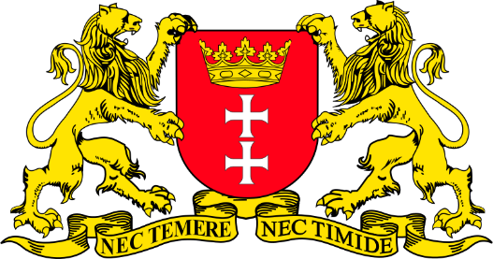
Gdańsk: the City of Freedom and Solidarity
Before the movie:
- When you think about Gdańsk, what comes to your mind first?
Fill in the mind map alone or with your deskmate. Add more lines if necessary. -

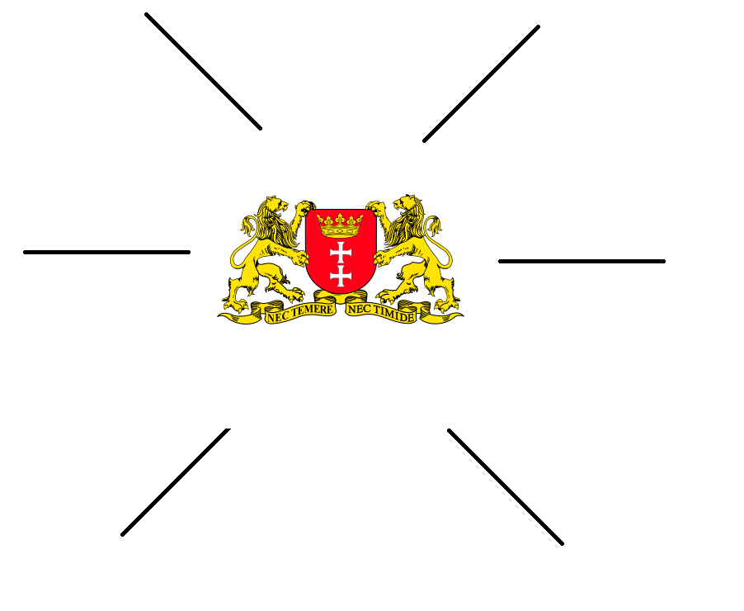
(clipart adapted from https://openclipart.org)
- Look at the map of Poland. Where exactly is Gdańsk?
Try to find the dot which represents Gdańsk. Work alone or with your deskmate. -

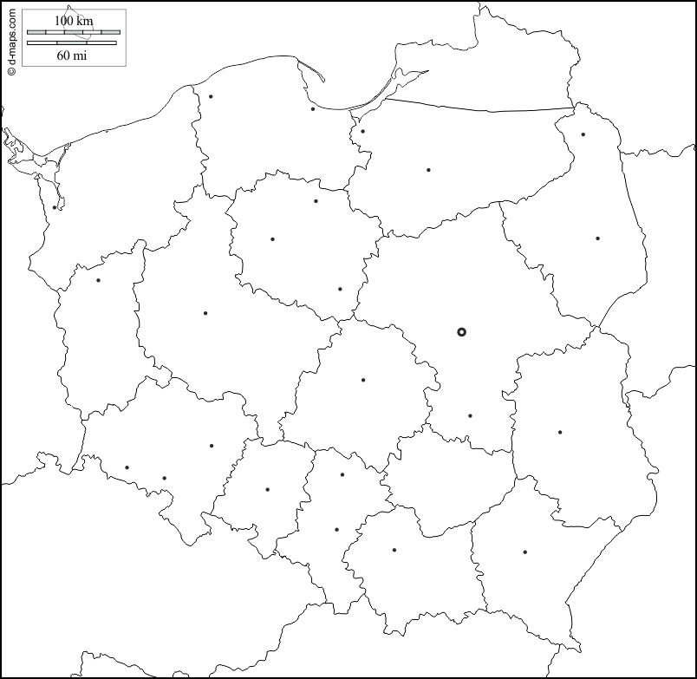
(map adapted from https://d-maps.com/carte.php?num_car=18745&lang=en)
- Translate these words and phrases into your own language.
Ask your friends or use a dictionary to help you.
-

scenic – ………………………………………………………………………………………………………………………………………………………………….
an adventure – ………………………………………………………………………………………………………………………………………………………
urban – ………………………………………………………………………………………………………………………………………………………………….
to combine – ………………………………………………………………………………………………………………………………………………………….
harmonious – …………………………………………………………………………………………………………………………………………………………
turbulent – …………………………………………………………………………………………………………………………………………………………….
modernity – ……………………………………………………………………………………………………………………………………………………………
a pier – …………………………………………………………………………………………………………………………………………………………………..
a bay – ……………………………………………………………………………………………………………………………………………………………………
vibrant – ………………………………………………………………………………………………………………………………………………………………..
vantage point – ………………………………………………………………………………………………………………………………………………………
a cutlet – ………………………………………………………………………………………………………………………………………………………………..
a dill – …………………………………………………………………………………………………………………………………………………………………….
to toll – ………………………………………………………………………………………………………………………………………………………………….
meringue – …………………………………………………………………………………………………………………………………………………………….
to drizzle – ……………………………………………………………………………………………………………………………………………………………..

If you need English definitions you can look them up in OALD 😊
www.oxfordlearnersdictionaries.com

- Which of the words presented in exercise 3 were new to you?
Mark the new words with a star

During the movie:
Watch the first movie and answer the questions (5-7).

Gdańsk, Sopot, Gdynia [EN]: https://youtu.be/UP1MXel6HXk
- How many flights daily arrive at Gdańsk? Mark the appropriate number on the “digital screen”.
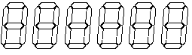
- What’s TriCity?
……………………………………………………………………………………………………………………………………………………………………………….……………………………………………………………………………………………………………………………………………………………………………….
- Describe each city in detail. Fill in the table.
GDAŃSK | SOPOT | GDYNIA

Watch the second movie and answer the questions.
10 Things to do in Gdańsk, Poland Travel Guide: https://youtu.be/8d0ioLYPj6Q
- What attractions have they seen & visited? Make a list.
  - …………………………………………………………………………………………………………
  - …………………………………………………………………………………………………………
  - …………………………………………………………………………………………………………
  - …………………………………………………………………………………………………………
  - …………………………………………………………………………………………………………
  - …………………………………………………………………………………………………………
  - …………………………………………………………………………………………………………
  - …………………………………………………………………………………………………………
  - …………………………………………………………………………………………………………
- How many steps is it to the top of the Basilica?
Mark the appropriate number on the “digital screen” .
- In the past Amber Museum was…
- a tourist attraction
- a prison and a torture chamber
- a factory

- When was the Medieval Crane first mentioned in texts? Mark the date on the timeline.
1500
1000

- What’s the purpose of the European Solidarity Centre?
……………………………………………………………………………………………………………………………………………………………………………….……………………………………………………………………………………………………………………………………………………………………………….
……………………………………………………………………………………………………………………………………………………………………………….……………………………………………………………………………………………………………………………………………………………………………….
After the movie: -
- Choose two attractions from the list you’ve made in task 8 and describe them thoroughly.
Use the internet if necessary.
- Work in groups. Imagine that you are travelling to Gdańsk for 5 days.
Prepare a sightseeing plan, describing what attractions you would like to see (and why), where you would eat, as well as providing information about the accommodation (e.g. hotels) you would choose.
Don’t forget to talk about the costs!

To help you with the task you can use the internet, especially:
https://wikitravel.org/en/Gdańsk
https://pl.tripadvisor.com/Tourism-g274725-Gdansk_Pomerania_Province_Northern_Poland-Vacations.html

………………………………………………………………………………………………………………………………………………………………………………………………………………………………………………………………………………………………………………………………………………………………
………………………………………………………………………………………………………………………………………………………………………………………………………………………………………………………………………………………………………………………………………………………………
………………………………………………………………………………………………………………………………………………………………………………………………………………………………………………………………………………………………………………………………………………………………
………………………………………………………………………………………………………………………………………………………………………………………………………………………………………………………………………………………………………………………………………………………………
………………………………………………………………………………………………………………………………………………………………………………………………………………………………………………………………………………………………………………………………………………………………
………………………………………………………………………………………………………………………………………………………………………………………………………………………………………………………………………………………………………………………………………………………………
………………………………………………………………………………………………………………………………………………………………………………………………………………………………………………………………………………………………………………………………………………………………
………………………………………………………………………………………………………………………………………………………………………………………………………………………………………………………………………………………………………………………………………………………………
………………………………………………………………………………………………………………………………………………………………………………………………………………………………………………………………………………………………………………………………………………………………
………………………………………………………………………………………………………………………………………………………………………………………………………………………………………………………………………………………………………………………………………………………………
………………………………………………………………………………………………………………………………………………………………………………………………………………………………………………………………………………………………………………………………………………………………
………………………………………………………………………………………………………………………………………………………………………………………………………………………………………………………………………………………………………………………………………………………………
………………………………………………………………………………………………………………………………………………………………………………………………………………………………………………………………………………………………………………………………………………………………
………………………………………………………………………………………………………………………………………………………………………………………………………………………………………………………………………………………………………………………………………………………………………………………………………………………………………………………………………………………………………………………………………………………………………………………………………………………………………………………………………………………………………………………………

