Democracy Worksheet Democracy - A short introduction: https://youtu.be/u6jgWxkbR7A
Before the movie:
- What comes to your mind when you hear the word democracy?
Fill in the mind map alone or with your deskmate. Add more lines if necessary. -

Democracy
- Translate these words and phrases into your own language. Ask your friends or use a dictionary to help you.
-
concerns – obawy
a birthplace – miejsce urodzenia
rulers – władcy, włodarze, rządzący
slaves – niewolnicy
flawed – zaburzone, ze skazą
to fade away – zanikać
to prevent – zapobiegać
to vote – głosować
a lawmaker – ustawodawca, prawodawca
legislative – ustawodawcza
executive – wykonawcza
judiciary – sądownictwo
to exceed one’s authority – wykraczać poza swoją władzę / kompetencje
to expel – wydalić
If you need English definitions you can look them up in OALD 😊 www.oxfordlearnersdictionaries.com
Don’t forget to mark the words you didn’t know before with a star
During the movie:
- Where did the first democracy start? Mark the appropriate region on the provided world map.
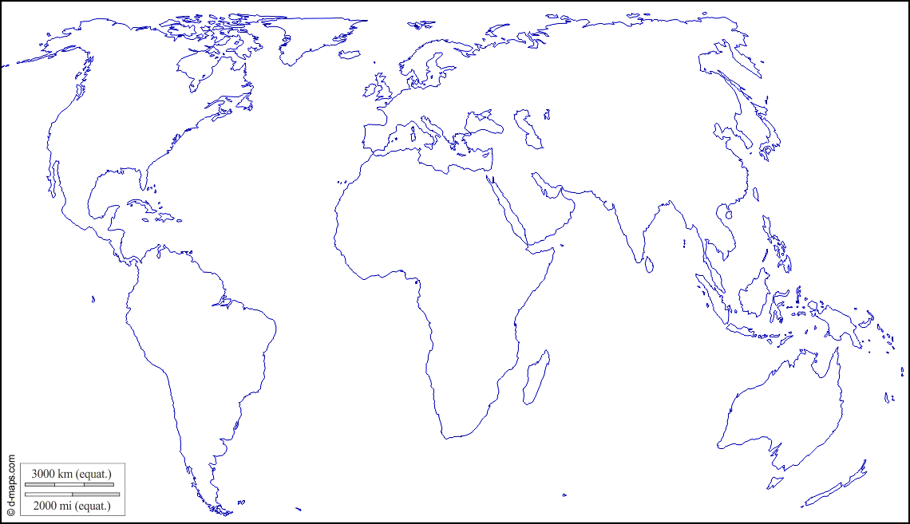 (map adapted from https://d-maps.com)

- Were all people equal in the first democracy?
Yes, they were. / No, they weren’t.
Why?
Slaves and women didn’t have the same rights as the rest of the society.
How is this system called today?
A flawed democracy.
- What was Magna Carta?
A set of laws preventing the king of England to do whatever he wanted.
Surprisingly enough, the video mentions a constitution, where in fact in the UK there is no such document in the written form and there wasn’t anything resembling one at the time of Magna Carta.

When did it happen? Mark the appropriate date on the timeline.
1215 AD
1500 AD
1 AD

- What is an indirect democracy?
A democracy in which people don’t make laws directly, but choose their representatives to do so.
Is this the current trend in most of the modern democracies?
Yes, it is. / No, it isn’t.
- Modern democracies are divided into 3 branches. Create a mind map in which you explain them.
Democracy
Democracy
przykładowa mapka myśli:
the judiciary
the people who judge you if you commit a crime
the legislative
the people who make the law
the executive
the people who make sure you obey the law

- Explain the concept of general will – an idea developed by Jean-Jacques Rousseau.
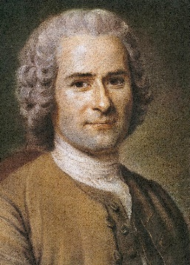
A democratic government must work in a way that reflects the wish, feelings, desires and values of the society.
photo:
public domain

After the movie:
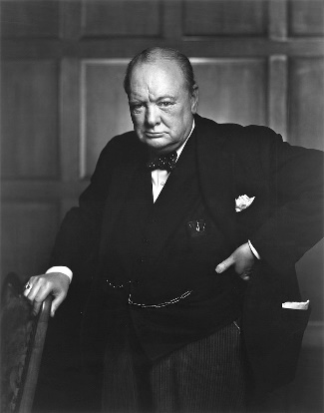
- Discuss in pairs:
photo:
public domain under
CC BY 2.0 license.
A Do you agree with the following statement? Why?
“Democracy is the worst form of government, except for all the others.”
Winston S. Churchill
B Do you feel that you are living in a democratic country? Why / Why not?
C What changes could be introduced to improve the state of modern democracies?

