Democracy Worksheet Democracy - A short introduction: https://youtu.be/u6jgWxkbR7A
Before the movie:
- What comes to your mind when you hear the word democracy?
Fill in the mind map alone or with your deskmate. Add more lines if necessary. -

Democracy
- Translate these words and phrases into your own language. Ask your friends or use a dictionary to help you.
-
concerns – ………………………………………………………….…………………..…..……………………………………..………………………………..
a birthplace – …………………………….……………….………………………………………………………………………………………………………..
rulers – ……………………………….………………………………………………………..………………………………………………………………………
slaves – ……………………………………………………………………………………….…………………………………………………………………………
flawed – ……………………………………….……………………………………………………………..………………………………………………………..
to fade away – ……………………………………………………………………………….…………………......…………………..…………………………
to prevent – ………………………………………………………………..…………………………………..……….…………………………………………..
to vote – …………………………………………….………………..……………………………………..……………………………..………………………….
a lawmaker – ….………………………………………………………………………………………………………….………………………………………….
legislative – ..……………………………………………………………….………………………………………….……………………………………………..
executive – .………………..……........................................................................................................................................
judiciary – …………………………………………………….………………………………………………………………….….………………………………..
to exceed one’s authority – …….……………………………………………………………………………………………………………………………..
to expel – …..…..………………………………………………………………………………………………………….………………………………………….
If you need English definitions you can look them up in OALD 😊 www.oxfordlearnersdictionaries.com
Don’t forget to mark the words you didn’t know before with a star
During the movie:
- Where did the first democracy start? Mark the appropriate region on the provided world map.
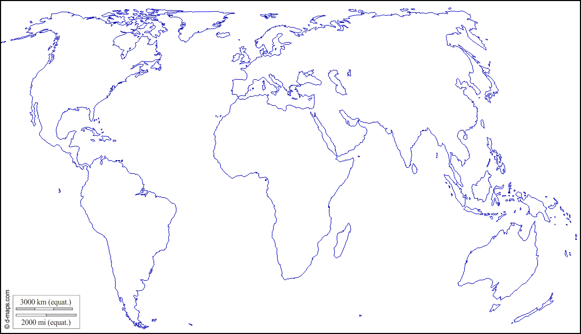 (map adapted from https://d-maps.com)

- Were all people equal in the first democracy?
Yes, they were. / No, they weren’t.
Why?
………………………………………………………………………………………………………………………………………………………………………………………………………………………………………………………………………………………………………………………………………………………………………………………………………………………………………………………………………………………………………………………………………………
How is this system called today?
………………………………………………………………………………………………………………………………………………………………………………
- What was Magna Carta?
………………………………………………………………………………………………………………………………………………………………………………
………………………………………………………………………………………………………………………………………………………………………………

When did it happen? Mark the appropriate date on the timeline.
1500 AD
1 AD

- What is an indirect democracy?
………………………………………………………………………………………………………………………………………………………………………………
………………………………………………………………………………………………………………………………………………………………………………
Is this the current trend in most of the modern democracies?
Yes, it is. / No, it isn’t.
- Modern democracies are divided into 3 branches. Create a mind map in which you explain them.

- Explain the concept of general will – an idea developed by Jean-Jacques Rousseau.
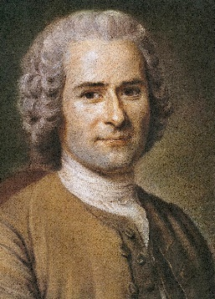
………………………………………………………………………………………………………………………………………………………………………………………………………………………………………………………………………………………………………………………………………………………………………………………………………………………………………………………………………………………………………………………………………………………………………………………………………………………………………………………………………………………………………
photo:
public domain

After the movie:
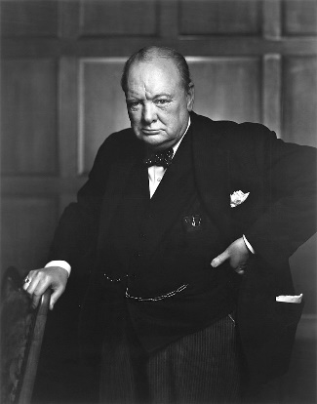
- Discuss in pairs:
photo:
public domain under
CC BY 2.0 license.
A Do you agree with the following statement? Why?
“Democracy is the worst form of government, except for all the others.”
Winston S. Churchill
B Do you feel that you are living in a democratic country? Why / Why not?
C What changes could be introduced to improve the state of modern democracies?

