Christmas Worksheet How to Have a British Christmas - Anglophenia Ep 20: https://youtu.be/v2W3QR9WXdA
Before the movie:
- When you think about Christmas, what comes to your mind first?
Fill in the mind map alone or with your deskmate. Add more lines if necessary. -

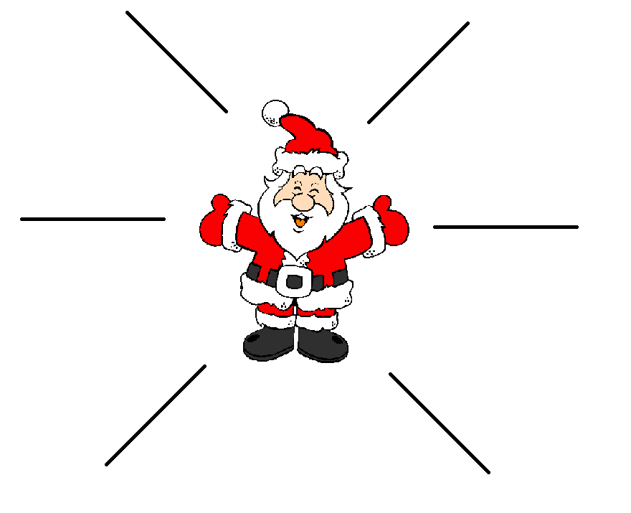

- Translate these words into your own language. Ask your friends or use the dictionary to help you.
-
a Christmas stocking - …skarpeta świąteczna…………………………………………………………….………………..………………….
a stranger - …osoba obca, nieznajoma……………………………………………………………………………..………………………………….
mandatory -..obowiązkowy………………………………………………………………………………………………………………………………….
a feast - …uczta…………………………………………………………………………………………………………………………………………………….
a veggie - …vegetable = warzywo……………..…………………………………………………..……………………………………………………..
gravy - …sos pieczeniowy (z tłuszczu) ………………………………………………..………………………………………………………………..
a telly - …TV = telewizja…………………………….………………………………………………………………………………………………………….
to flavour - …przyprawiać………………………………………………..…………………………………………………………………………………..
the poor - …biedni…………………………………………………………………………….……………………………………………………………………
to trample (to death) - …zadeptać (na śmierć).…………………………………………………………………………………………………….
major (difference) - …główna (różnica)…..…………………………………………………………………………………………………………...

During the movie:
- What do we call Christmas in the UK?
- Crimbo. b) Santa. c) Christmas Eve.
- How do the British people send letters to Father Christmas?
- They put them in a mailbox. b) They send e-mails. c) They burn the letters.
- Where do Brits hang stockings?

- 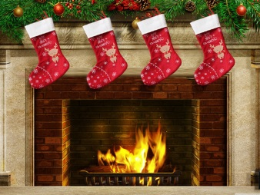 b)
- Why do they leave Father Christmas a brandy and a mince pie instead of milk and cookies?
………Because he’s a grown-up …………………………………………………………………………………………………………………
- What’s a Christmas cracker? Draw it.
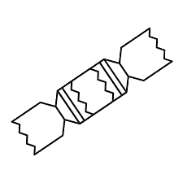
- What’s inside a Christmas cracker?
cheesy plastic prize, a paper crown, a terrible joke
………………………………………………………………………………………………………………………………………………………………………………………………………………………………………………………………………………………………………………………………………………………………………………………………………………………………………………………………………………………………………………………………………………………………………………

- Is it mandatory to wear a paper crown?
- Yes. b) No. c) I have no idea.

- What’s the main Christmas dish in the UK?
a) A roasted turkey. b) Bacon wraps . c) A carp.

- Which vegetables are traditionally served during the Christmas dinner?
- 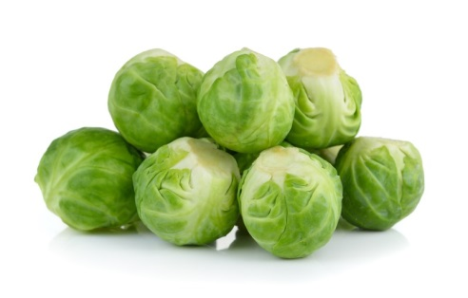 b) 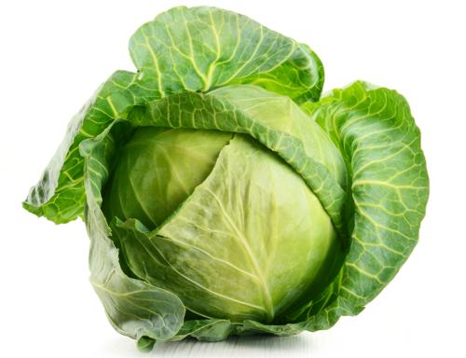

- What’s Christmas pudding? How is it made?
very dense, boiled cake flavoured with dried fruit and spices
…….……………………………………………………………………………………………………………………………………………………………………………….……………………………………………………………………………………………………………………………………………………………………………….……………………………………………………………………………………………………………………………………………………………………………….…………………………………………………………………………………………………………………………………………………………………………
- What do Brits typically do during the Royal Christmas Message?
- They listen carefully to what the monarch is saying.
- They sleep.
- They do the usual chores, pretending to listen to the Message.
- What do British people do on a Boxing Day nowadays? What American day it reminds you of?
Shopping. It reminds me of Black Friday in the USA.
…….……………………………………………………………………………………………………………………………………………………………………………….……………………………………………………………………………………………………………………………………………………………………………….……………………………………………………………………………………………………………………………………………………………………………….…………………………………………………………………………………………………………………………………………………………………………
- What are pantomimes based on?
- True stories b) Fairy tales. c) Movies and TV series.

- When should Brits take down the Christmas tree?
- Before the 4th July. b) Within 12 days from Christmas. c) At the end of the year.

After the movie:
- Work in pairs or in groups. Choose 1 Christmas tradition celebrated in your country and describe it. -
………………………………………………………………………………………………………………………………………………………………………………………………………………………………………………………………………………………………………………………………………………………………………………………………………………………………………………………………………………………………………………………………………………………………………………………………………………………………………………………………………………………………………………………………………………………………………………………………………………………………………………………………………………………………………………………………………………………………………………………………………………………………………………………………………………………………………………………………………………………………………………………………………………………………………………………………………………………………………………………………………………………………………………………………………………………………………………………………………………………………………………………………………………………………………………………………………………………………………………………………………………………………………………………………………………………………………………………………………………………………………………………………………………………………………………………………………………………………………………………………………………………………………………………………………………………………………………………………………………………………………………………………
Christmas carol – Teacher’s Answer Key:
Silent Night (with lyrics): https://youtu.be/9T4WB2zfmps
- Listen to the Christmas carol and try to fill in the gaps in it, using the words provided below.

child / heavenly / Saviour / holy / holy / bright / birth / heavenly / heaven / Saviour / God / birth / holy / grace

Silent night, ¹ holy night,
All is calm, all is ² bright
Round yon virgin mother and ³ child
Holy infant so tender and mild,
Sleep in ⁴ heavenly peace.
Sleep in ⁵ heavenly peace.

Silent night, ⁶ holy night,
Son of ⁷ God, love's pure light
Radiant beams from thy holy face,
With the dawn of redeeming ⁸ grace,
Jesus, Lord, at thy ⁹ birth.
Jesus, Lord, at thy ¹⁰ birth.

silent night, ¹¹ holy night,
Shepherds quake at the sight,
Glories stream from ¹² heaven afar,
Heavenly hosts sing Alleluia!
Christ the ¹³ Saviour, is born!
Christ the ¹⁴ Savour, is born!

- Sing the Christmas carol together with your groupmates! +

