The Beginning of May in Poland & The Constitution of May 3 - Worksheet
- When you think about the 1st, 2nd and 3rd May, what comes to your mind first?
Fill in the mind map alone or with your deskmate. Add more lines if necessary. -
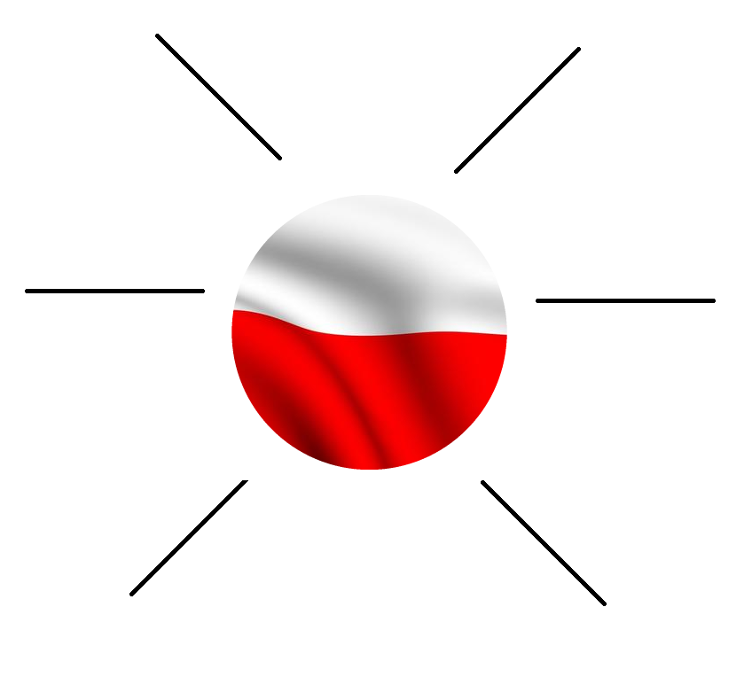
- Translate these words and phrases into your own language. Ask your friends or use a dictionary to help you.
-
labor / labour – …praca…………………………………..………………………………………..…..………………………….………………………….
an anniversary – …rocznica…….………………………………….………………………….………………………….………………………………….
an illumination –…iluminacja………..………….…….………………………….………………………….………………………………………………
a resident – …mieszkaniec………………………………………………..…….…….………………………….………………………….………………..
spectacular – …widowiskowy, efektowny……………………………………………………………………………..………………………………
accession – …akcesja, wstąpienie……………………….……………………………………..…………………...……………………………………..
membership – …członkostwo………………….……….………………..………………………….………………………….…………………………..
outweigh – …przeważać, mieć większe znaczenie…………………..…………..………………………….…………………………………….
to settle – …osiedlić się……..…………………...…………………..…………………………….………………………….……………………………….
substantial – .…znaczny, pokaźny……………………………………………………………………………….…………………………………………
to instate – …wprowadzić (na stanowisko)......................... ………………………….………………………….…………………………….
to awake – …obudzić (się)……. …………………………………..……………………………………..………………………….……………………….
a defect – …defekt, usterka, wada………………..……………………….……………..………………………….…………………………………….
independently – …niezależnie, niepodlegle…………………….…………………………………………….……………………………………….
to accompany – …towarzyszyć………………………..……………………………………………………………..…………………………………….
tremendous – …olbrzymi, ogromny……………………………..………………………………….…………………………………………………….
to preserve – …chronić, zachowywać..…………………………..………………………….…….. ………………………….……………………….
to amass – …gromadzić (dużą ilość czegoś)….….……………………………….. ………………………….……………………………………….
to consign – …odsyłać, powierzać…….………………….………………………………….………………………….………………………………….
legislative (power) – …(władza) ustawodawcza.………………..………… ………………………….……………………………………………
executive (power) – …(władza) wykonawcza….……………………..………………………….………………………….……………………….
judicial (power) – …(władza) sądownicza…………….………..…………………………….………………………….……………………………..
constitutional monarchy – …monarchia konstytucyjna……..………………………………………….……………………………………….
national holiday – …święto narodowe…………………………………..…………………………….………………………………………………..
public holiday / bank holiday –…dzień ustawowo wolny od pracy………………………….……………………………………………..
Text A:

https://www.huffingtonpost.com/entry/its-a-long-triple-holiday_b_9820556

Text B:

https://pamiecpolski.archiwa.gov.pl/en/the-constitution-of-3rd-may-1791/
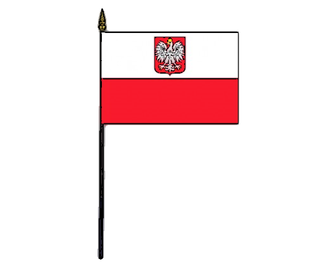
- What is displayed on the streets of Gdańsk between 1.05 and 3.05? Draw it.
- How many years have passed:
- since Poland became a member country of the EU? …[current year] - 2004…………………………………………………
- since the adoption of the Government Act of 3rd of May? …[current year] - 1791…………………………………………
Put your answers in the correct places in the Text A – the ones marked by a grey background.

- Fill in the timeline with the information and dates from Text A. -
2018
1700
2004
1989
1945
1791
1787

Poland’s accession to
the European Community; the reinstation of A Day of Polish Flag
the socialist period in Poland
Polish Constitution is adopted (2nd in the world, 1st in Europe).
American Constitution is adopted (1st in the world).

- What was the purpose of creating the Polish Constitution of 3rd May 1791? -
Find the answers in Text A and Text B, then present them on a mind map. Add more lines if necessary.
the attempt to preserve the independence of the state and to ensure the potential for the country’s economic and political development.
the elimination of the long-standing defects based on free elections and nobility-based political system of the Republic of Two Nations (Poland and Lithuania); the abolishment of various aspects of the former system (e.g. liberum veto)

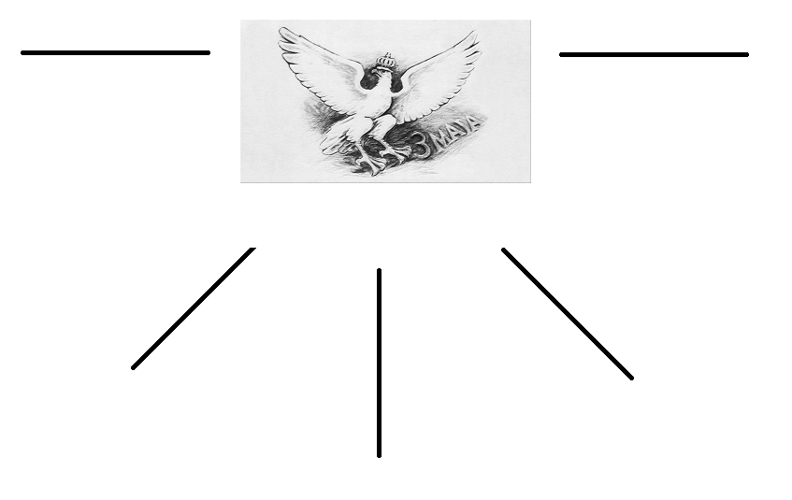
the change of
the country’s political system to a constitutional monarchy
the adoption of Montesquieu’s division of power into the legislative, the executive and the judicial one
the creation of the possibility for the further transformation of the state system

- On the provided map of current-day Poland mark the route which took the original manuscript
of the Constitution. Write down the dates.
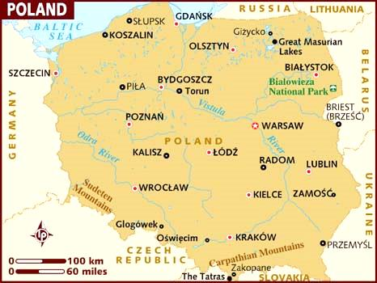
1870s
after 1945

- Read Text A and B again and decide if the provided sentences are TRUE, FALSE,
or if there is NO INFORMATION.
- Between May 1 and May 3 Gdańsk is illuminated in red colour only.
TRUE / FALSE / NO INFORMATION
- Polish Flag Day is a national holiday.
TRUE / FALSE / NO INFORMATION
- The Constitution from 1791 changed Poland into a democratic country.
TRUE / FALSE / NO INFORMATION
- Talking about the 1791 Constitution was forbidden between 1945 and 1999.
TRUE / FALSE / NO INFORMATION
!
- Today’s Poland is a paradise.
TRUE / FALSE / NO INFORMATION
- The Polish Constitution of 1791 was the first constitution in Europe.
TRUE / FALSE / NO INFORMATION
- 1791 Constitution has never been abolished and is still being used in Poland.
TRUE / FALSE / NO INFORMATION
- The Constitution is now held in the Central Archives of Historical Records.
TRUE / FALSE / NO INFORMATION

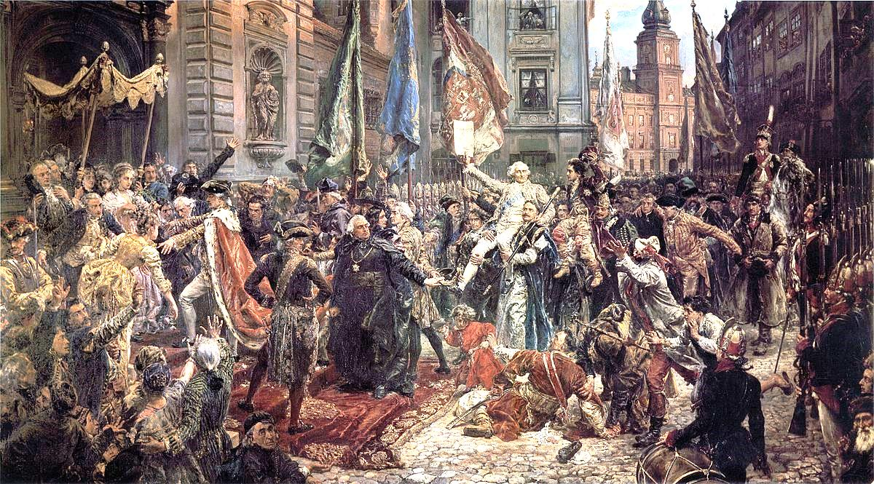
- Describe the picture to your friend.
- Do you know the name of this painting and its author? Try to guess it and then check the answer by flipping the page upside down.
Jan Matejko, Constitution of May 3, 1791
- Work in groups. How do Polish people celebrate the beginning of May nowadays?
Describe the activities they perform. Use the Internet if necessary. -
………………………………………………………………………………………………………………………………………………………………………………………………………………………………………………………………………………………………………………………………………………………………………………………………………………………………………………………………………………………………………………………………………………………………………………………………………………………………………………………………………………………………………………………………………………………………………………………………………………………………………………………………………………………………………………………………………………………………………………………………………………………………………………………………………………………………………………………………………………………………………………………………………………………………………………………………………………………………………………………………………………………………………………………………………………………………………………………………………………………………………………………………………………………………………………………………………………………………………………………………………………………………………………………………………………………………………………………………………………………………………………………………………………………………………………………………………………………………………………………………………………………………………………………………………………………………………………………………………………………………………………………………
………………………………………………………………………………………………………………………………………………………………………………………………………………………………………………………………………………………………………………………………………………………………………………………………………………………………………………………………………………………………………………………………………………………………………………………………………………………………………………………………………………………………………………………………………………………………………………………………………………………………………………………………………………………………………………

