Worksheet - THE ENGLISH MIX 2
Clothes, Household chores, Past Simple & Past Continuous, Writing an informal e-mail
Clothes
- Look at the pictures. Label them with the names provided below.
/ socks / a blouse / a coat / an earring / a dress / a jacket / jeans / patterned / striped / a shirt / shorts / a skirt /
/ a suit / a sweater (a jumper) / sweatpants / a sweatshirt / a tie / a bow tie / a tracksuit / trousers /
/ a t-shirt / boots / shoes / sandals / trainers / glasses / baggy / checked / a ring / a belt /
1. a suit 2. a bow tie 3. a tie

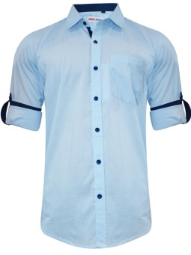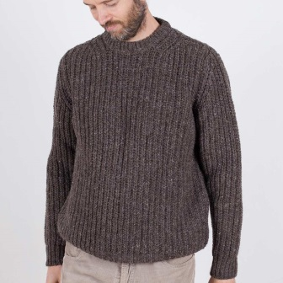
4. a t-shirt 5. a shirt 6. a sweater (a jumper)

7. sweatpants 8. trousers 9. jeans

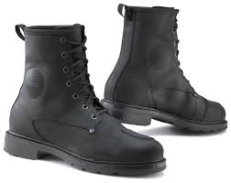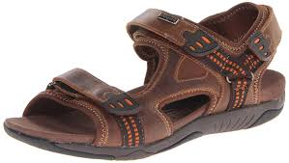
10. boots 11. trainers 12. sandals

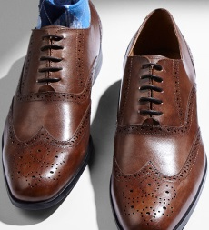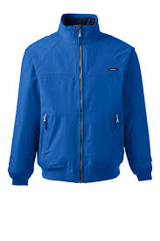
13. shoes 14. a sweatshirt 15. a jacket
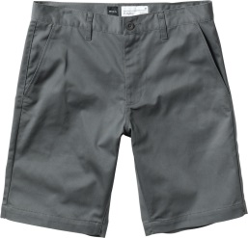
16. shorts 17. checked 18. striped

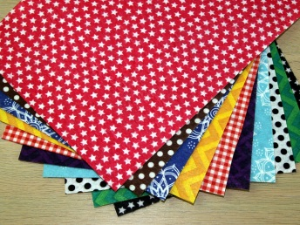
19. patterned 20. baggy 21. a skirt

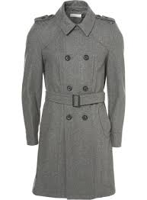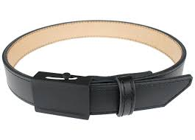
22. a blouse 23. a coat 24. a belt

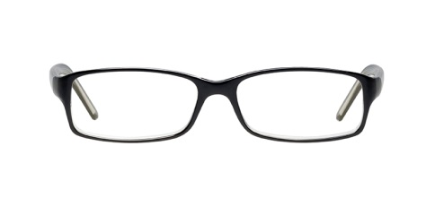
25. a tracksuit 26. glasses 27. a dress
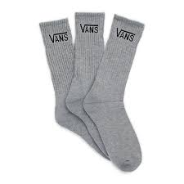
28. socks 29. a ring 30. an earring
- How do you look when you are at work / at home / at a party? Describe to your partner.
When I’m at home, I wear………………………………………………………………………………………………………………………………………
When I’m at work, I wear……………………………………………………………………………………………………………………………………….
When I’m at a party, I wear…………………………………………………………………………………………………………………………………….

- What are these people wearing? Describe to your partner.
Benedict
Lucas
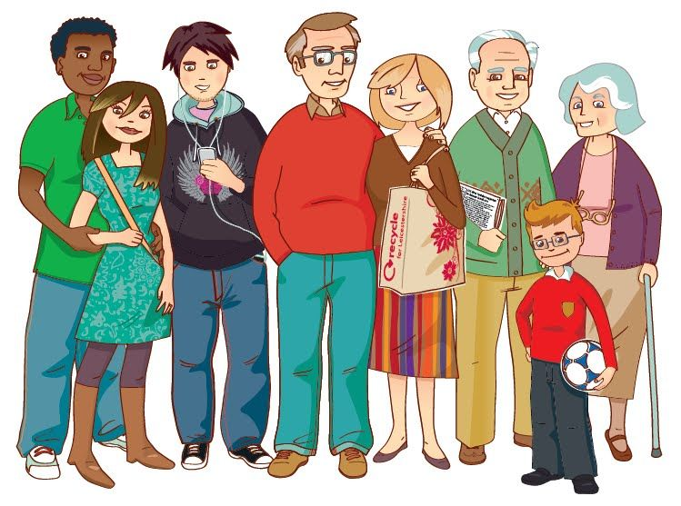
Oscar
Catherine
Helen
Christopher
Anna
Tom

(the image is taken from: https://pl.pinterest.com/pin/185140234658957368)

- Choose one person from the group and describe him or her to your partner, who has to guess which person you are describing.

Example: This person wears a blue shirt, a red tie, blue trousers, black shoes and black socks.
It’s Christian!
Yes, that’s him!
No, that’s not him, try again!

It’s Samantha!
Yes, that’s her!
No, that’s not her, try again!

- Look at the list of household chores. Divide them into categories.
Some phrases can be used more than once.
Household duties (Chores)

/ to make your bed / to go shopping / to sweep the floor / to lay the table / to iron clothes / to mow the lawn /
/ to work in the garden / to wash the car / to walk the dog / to mop the floor / to take out the rubbish /
/ to clean windows / to hang out the washing / to hoover the carpet (to vacuum the carpet) /
/ to wash up the dishes (to do the washing-up) / to cook a meal / to run the washing machine /
/ to clear the table / to load the dishwasher / to dust

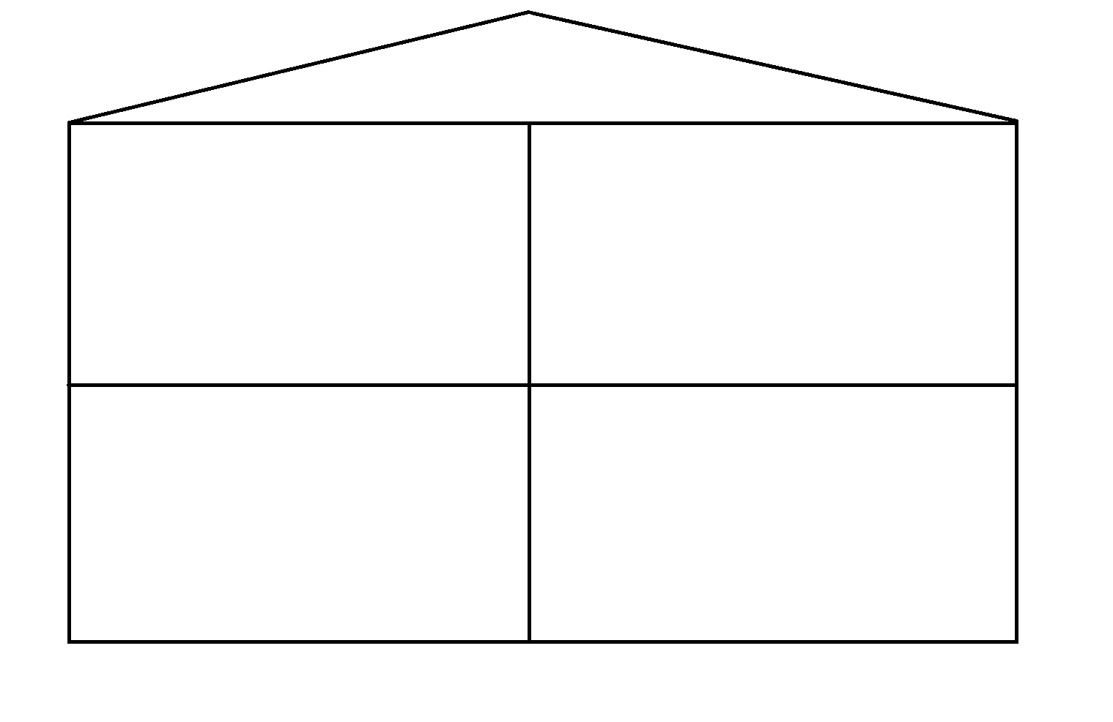
to sweep the floor, to lay the table, to mop the floor, to take out the rubbish, to clean windows, to hoover the carpet (to vacuum the carpet), to wash up the dishes (to do the washing-up), to cook a meal, to clear the table, to load the dishwasher , to dust
1. in a kitchen,
in a dining room
(Icons made by Freepik from www.flaticon.com)

to make your bed, to sweep the floor, to iron clothes, to mop the floor, to clean windows, to hoover the carpet (to vacuum the carpet), to dust
2. in a bedroom
Things we do…
to go shopping, to wash the car, to walk the dog
to sweep the floor , to mop the floor, to run the washing machine, to dust
to mow the lawn, to work in the garden, to wash the car, to hang out the washing
5. outside (e.g. in a city)
4. around the house (e.g. in a garden)
3. in a bathroom

- Whan things do you do at your home? How often? Discuss with your partner.
What chores do you do?
How often do you…………………………?

The simple past tense (…) is used to talk about a completed action in a time before now.
The simple past is the basic form of past tense in English. The time of the action can be in the recent past or the distant past and action duration is not important.
Past Simple
(theory)
EXAMPLES
John Cabot sailed to America in 1498.
My father died last year.
He lived in Fiji in 1976.
We crossed the Channel yesterday.

You always use the simple past when you say when something happened, so it is associated with certain past time expressions:
frequency: often, sometimes, always
I sometimes walked home at lunchtime.
I often brought my lunch to school.
a definite point in time: last week, when I was a child, yesterday, six weeks ago
We saw a good film last week.
Yesterday, I arrived in Geneva.
She finished her work atseven o'clock
I went to the theatre last night
an indefinite point in time: the other day, ages ago, a long time ago
People lived in caves a long time ago.
She played the piano when she was a child.
Note: the word ago is a useful way of expressing the distance into the past. It is placed after the period of time: a week ago, three years ago, a minute ago.

(…)
FORMING THE SIMPLE PAST TENSE
PATTERNS OF SIMPLE PAST TENSE FOR REGULAR VERBS
Affirmative
+ verb + ed
I skipped.
Negative
+ did not + infinitive without to
They didn't go.
Interrogative
Did + + infinitive without to
Did she arrive?
(…)

EXAMPLE:
TO WALK
Affirmative Negative Interrogative
I walked I didn't walk Did I walk?
You walked You didn't walk Did you walk?
He walked He didn't walk Did he walk?
We walked We didn't walk Did we walk?
They walked They didn't walk Did they walk?

SIMPLE PAST TENSE OF TO BE, TO HAVE, TO DO
Be Have Do
I was had did
You were had did
He/She/It was had did
We were had did
You were had did
They were had did
(adapted from: www.ef.com)

For further info (in Polish) you can visit: https://www.ang.pl/gramatyka/czas/past-simple

- Play the interactive games. Play the games from the list provided below -
https://learningapps.org/2074366
Past Simple
(practice)
Game list:
  - Was or were?
  - Past Simple 1
  - Past Simple – matching 1
  - Past Simple – matching 2
  - Did / Didn’t
  - Czasowniki regularne i nieregularne
  - Czasowniki nieregularne 1
- Fill in the blanks with the correct form of the verb in brackets. Use the Past Simple tense.
a) Yesterday evening I worked (work) hard till late because I had (have) a difficult task to do.
b) They climbed (climb) a very high mountain during their last holidays.
c) My mother gave (give) me a new CD and my sister and I listened (listen) to it immediately.
d) My aunt played (play) the violin when she was (be) young.
e) My mother didn’t / did not mind (not mind) and gave (give) them all her support.

The past continuous describes actions or events in a time before now, which began in the past and is still going on at the time of speaking. In other words, it expresses an unfinished or incomplete action in the past.

It is used:

Often, to describe the background in a story written in the past tense, e.g.
"The sun was shining and the birds were singing as the elephant came out of the jungle. The other animals were relaxing in the shade of the trees, but the elephant moved very quickly. She was looking for her baby, and she didn't notice the hunter who was watching her through his binoculars. When the shot rang out, she was running towards the river..."
to describe an unfinished action that was interrupted by another event or action, e.g.
"I was having a beautiful dream when the alarm clock rang."
to express a change of mind: e.g.
"I was going to spend the day at the beach but I've decided to get my homework done instead."
with 'wonder', to make a very polite request: e.g. "I was wondering if you could baby-sit for me tonight."
Past Continuous
(theory)

EXAMPLES
They were waiting for the bus when the accident happened.
Caroline was skiing when she broke her leg.
When we arrived he was having a bath.
When the fire started I was watching television.
Note: with verbs not normally used in the continuous form, the simple past is used.

FORMING THE PAST CONTINUOUS
The past continuous of any verb is composed of two parts : the past tense of the verb "to be" (was/were), and the base of the main verb +ing.

Affirmative:
+ was/were + verbing
They were watching

Negative:
+ was/were + verbing
They were not watching.
(weren’t)
Interrogative:
Was/were + + verbing
Were they watching?

EXAMPLE:
TO PLAY, PAST CONTINUOUS
Affirmative Negative Interrogative
I was playing I was not playing Was I playing?
You were playing You were not playing Were you playing?
He was playing He wasn't playing Was he playing?
We were playing We weren't playing Were we playing?
They were playing They weren't playing Were they playing?
(adapted from: www.ef.com)

For further info (in Polish) you can visit: https://www.ang.pl/gramatyka/czas/present-continuous
- Play the interactive games from the list provided below -
https://learningapps.org/view2074401
Past Continuous
(practice)
Game list:
  - Past Continuous 1
  - Past Continuous 2
- Fill in the gaps with the proper form of a verb, using the Past Continuous tense.
a) The teacher wasn’t / was not talking (not talk) when Mary arrived.
b) The pupils were playing (play) when the bell rang.
c) Lucy was not / wasn’t doing (do) her homework when someone knocked the door.
d) Mark´s parents were writing (write) him a letter when they heard a crash.
e) Ann wasn’t / was not sleeping (not sleep) when the alarm clock rang.

1. The most common use of the past continuous tense is to talk about something that was happening around a particular time in the past.
Past Simple
&
Past Continuous
(theory)
What were you doing at 8 o’clock last night? I was watching television.
I started watching television before 8 o’clock and I continued watching it after 8 o’clock.
In 1994 he was working in a small town in Poland.
At 6 o’clock on Saturday morning we were travelling to the airport.
2. We often use the past continuous and the past simple tense together. When this happens, the past continuous describes a longer, ‘background’ action or situation and the past simple describes the [shorter] action or events.
When I woke up this morning it was raining and my father was singing in the kitchen.
I was walking home, whistling happily, when I saw two masked men run out of the bank.
Often, the ‘action’ described by the past simple tense interrupts the ‘situation’ described by the past continuous tense.
I broke my leg when/while I was skiing.
I was playing a computer game when the doorbell rang.
Notice that the past continuous describes ‘situations’ that go on for some time – ‘skiing’ and ‘playing’ but the past simple describes ‘actions’ that happen quickly – ‘broke’ and ‘rang’.
Notice too the important difference between these two sentences:
When they arrived, Jeff was cooking dinner. Jeff started cooking before they arrived.
When they arrived, Jeff cooked dinner. Jeff started cooking dinner after they arrived.
(adapted from: https://learnenglish.britishcouncil.org/es/quick-grammar/past-continuous-and-past-simple)
- Play the interactive games from the list provided below -
https://learningapps.org/view2074401
Past Simple
&
Past Continuous
(practice)
Game list:
  - Past Simple and Past Continuous 1
  - Past Simple and Past Continuous 2
- Fill in the gaps with the proper form of a verb, using the Past Simple or Past Continuous tense.
a) We were going (go) down the road at 100 Km/h when the wheel fell (fall) off.
b) She nearly had (have) a heart attack when she saw (see) the lion.
c) My mother was getting (get) dressed when she felt (feel) a pain in her chest.
d) She was filling (fill) in a questionnaire when the pen ran (run) out of wink.
e) Susan didn’t / did not see (not/see) her friend because she was facing (face) the other way.
f) Mike fell (fall) off the ladder while he was painting (paint) the ceiling.
g) While Ann was cooking (cook) dinner, the phone rang (ring)
h) Susan was waiting (wait) for me at home when I arrived (arrive) yesterday.
i) What were you doing (you /do) at this time yesterday?
j) I saw (see) carol at the party. She was wearing (wear) a beautiful dress.
k) I broke (break) a plate last night. I was doing (do) the washing up.
l) Were you watching (you/watch) TV when I arrived (arrive)?
- Describe what you did / what you were doing on a given day.
- yesterday
- today, before the lesson
- on Monday
- on Saturday

- You’ve received an e-mail. Write a reply.
Hi!
My name is Oscar and I’m 27 years old. I read an article about your city and I decided that I want to get to know some people from this city better. I found your e-mail adress on the Meet New Friends site
My birthday is on 22nd December. I live in London with my wife and two children. My wife’s name is Joanna and she is very beautiful! My children’s names are Tom and Elise – Tom is 4, and Elise is 2. I am an IT technician here in London – I think I’m quite good at my work! I’m responsible for updating the software and hardware for companies working with us. I also provide them with assistance if they have problems with their computers.
During weekends, I usually spend time with my family. We often go to the zoo together, or watch some movies at the cinema. We sometimes travel to the countryside and have a picnic there. It’s relaxing and very healthy
I like playing video games and cooking. On Friday I bought a new game called the Witcher 3, which as far as I know was produced in Poland! It’s fantastic! I would love to try your Polish food – I tried to cook bigos once, but I think I did something wrong – it wasn’t tasty. I love cooking English food – I think
I prepare a fantastic English breakfast, which includes beans, sausages, eggs… I think you should try it!
Yesterday I was dancing in one of the London’s top night club called Fabric. It was awesome! I drank a couple of shots and met a lot of interesting people. While dancing, I decided to ask you a question - do you have any famous night clubs in your town?
Tell me something about you and your city! I would love to hear from you!
Cheers
Oscar

………………………………………………………………………………………………………………………………………………………………………………………………………………………………………………………………………………………………………………………………………………………………
………………………………………………………………………………………………………………………………………………………………………………………………………………………………………………………………………………………………………………………………………………………………
………………………………………………………………………………………………………………………………………………………………………………………………………………………………………………………………………………………………………………………………………………………………
………………………………………………………………………………………………………………………………………………………………………………………………………………………………………………………………………………………………………………………………………………………………
………………………………………………………………………………………………………………………………………………………………………………………………………………………………………………………………………………………………………………………………………………………………
………………………………………………………………………………………………………………………………………………………………………………………………………………………………………………………………………………………………………………………………………………………………………………………………………………………………………………………………………………………………………………………………………………………………………………………………………………………………………………………………………………………………………………………………
………………………………………………………………………………………………………………………………………………………………………………………………………………………………………………………………………………………………………………………………………………………………
………………………………………………………………………………………………………………………………………………………………………………………………………………………………………………………………………………………………………………………………………………………………
………………………………………………………………………………………………………………………………………………………………………………………………………………………………………………………………………………………………………………………………………………………………
- What have you learnt during this lesson? Fill in the mind map alone or in pairs. -

What have I learnt?

