Worksheet - The Basic Pronunciation Practice
- Look at the words. Practice their pronunciation with a teacher.
Consonants - spółgłoski
/f/ fate /feɪt/ /t/ tie /taɪ/ /s/ sigh /saɪ/
/h/ high /haɪ/ /k/ kite /kaɪt/ /ʃ/ shy /ʃaɪ/, dish /dɪʃ/, brush /brʌʃ/
/j/ you /juː/ /b/ bite /baɪt/ /v/ vote /vəʊt/
/w/ wait /weɪt/ /d/ date /deɪt/ /p/ pie /paɪ/
/r/ right /raɪt/ /g/ guy /ɡaɪ/ /z/ zoo /zuː/
/m/ meet /miːt/ /l/ lie /laɪ/ /n/ neat /niːt/
/ʧ/ cheese /tʃiːz/, chips /tʃɪps/, March /mɑː(r)tʃ/
/ʒ/ leisure /ˈleʒə(r)/, usually /ˈjuːʒʊəli/, television /ˈtelɪˌvɪʒ(ə)n/ /ŋ/ king /kɪŋ/, beginning /bɪˈɡɪnɪŋ/,
/ʤ/ judge /dʒʌdʒ/, giraffe /dʒəˈrɑːf/, sponge /spʌndʒ/ thanks /θæŋks/, long /lɒŋ/
/θ/ thought /θɔːt/, throat /θrəʊt/, tooth /tuːθ/, bath /bɑːθ/
/ð/ that /ðæt/, although /ɔːlˈðəʊ/, themselves /ðəmˈselvz/, either /ˈaɪðə(r)/
Vowels - samogłoski
/e/ dress /dres/, mess /mes/ /æ/ trap /træp/, accent /ˈæks(ə)nt/, tap /tæp/
/uː/ boot /buːt/, choose /tʃuːz/, too /tuː/ /ɜː/ bird /bɜː(r)d/, dessert /dɪˈzɜː(r)t/, turn /tɜː(r)n/
/ʊ/ foot /fʊt/, wood /wʊd/, cooker /ˈkʊkə(r)/ /ʌ/ but /bʌt/, brush /brʌʃ/, sponge /spʌndʒ/
/ɔː/ more /mɔː(r)/, bore /bɔː(r)/, sore /sɔː(r)/ /ɑː/ far /fɑː(r)/ , apart /əˈpɑː(r)t/, bath /bɑːθ/
/ɒ/ lot /lɒt/, forgot /fə(r)ˈɡɒt/, drop /drɒp/ /ɪ/ kit /kɪt/, skin /skɪn/, political /pəˈlɪtɪk(ə)l/
/iː/ meet, speed, dream
/eɪ/ face /feɪs/, make /meɪk/ /aʊ/ mouth /maʊθ/, brown /braʊn/
/ɪə/ beer /bɪə(r)/, deer /dɪə(r)/ /aɪ/ price /praɪs/, mice /maɪs
/ʊə/ poor /pʊə(r)/ /ɔɪ/ choice /tʃɔɪs/, coin /kɔɪn/
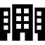
/eə/ square /skweə(r)/ /əʊ/ goat /ɡəʊt/, boat /bəʊt/
5. outside (e.g. in a city)
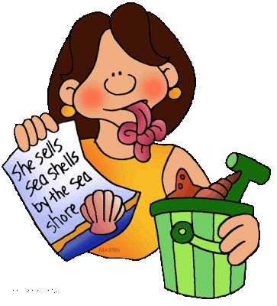
- Match the words with the sound you can hear. More than one sound is possible. -
/ blue / now / put / day / my /
/ boy / near / corn / pass / sure /
/ nurse / jeans / chair / through / six /
/ sheep / vision / song / lie / gym /
/ lot / wheel / vocabulary / voice / shampoo

Use the online dictionary if need be - https://www.macmillandictionary.com
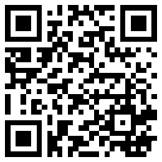

- Practise reading these tongue-twisters aloud. -
- Six silly sheep still asleep.
- She sells seashells by the seashore.
- The big fat cat sat on the rat.
- Double bubble gum bubbles double.
- The three trees.
- Three thieves thank you.
- How much wood would a woodchuck chuck if a woodchuck could chuck wood?
- Fuzzy Wuzzy was a bear, Fuzzy Wuzzy had no hair, Fuzzy Wuzzy wasn't very fuzzy, Was he?
- If two witches were watching two watches: which witch would watch which watch?

