St. Patrick’s Day Worksheet A Brief History of St. Patrick's Day: https://youtu.be/40BlVzjxu-I
Before the movie:
- What do you know about St. Patrick’s Day?
Fill in the mind map alone or with your deskmate. Add more lines if necessary. -

- Translate these words and phrases into your own language. Ask your friends or use a dictionary to help you.
-
to enslave – ……zniewalać, czynić kogoś niewolnikiem……………………………………………..………………………………………..…
a raider – …napastnik, pirat……………………………………………………………………………………..……………………………………………
to return –.…powrócić…………………………………………………………………………………………………………………………………………...
to convert – ……nawracać………………………………………………………………………………………………………………….…………………..
to drive out – ……wygnać……………………………………..………………………………………………………………………………………………..
festivities – ……uroczystości………………………………………………………………..………………………………………………………………….
to ban – ……zakazać……………………….…………………………………………………………………………….………………………………………..
to consume – ……konsumować, spożywać………………………………………………………………………………………………..………….
to claim – …zgłaszać, twierdzić, utrzymywać…………………………………………………………………….…………………………………..
to pretend – ………udawać……….………………………………………………………………………………………………………….………………….
forced – …..…wymuszony…..……………………………………………………………………………………………………….............................
labour – ……praca……………………………………………………………………………………………………………..……………………………………
to join – ……dołączyć……………………………………………………………………………………………………..……………………….………………
a saint – ……święty………………………………………………………………………………………………………………………………………………….

During the movie:
- Was St. Patrick Irish?
- Yes. b) No. c) I don’t know.
- Who enslaved St. Patrick?
- English raiders. b) Irish raiders. c) Roman Empire.
- When did he change his name to Patrick?
- When he was young. b) When he was enslaved. c) When he escaped.
- How many years did he devote to converting the Irish?
- 1 year b) 3 years c) 30 years
- In which century did St. Patrick die? Mark it on the provided timeline.
- When is St. Patrick’s Day celebrated? Mark the date on the calendar.
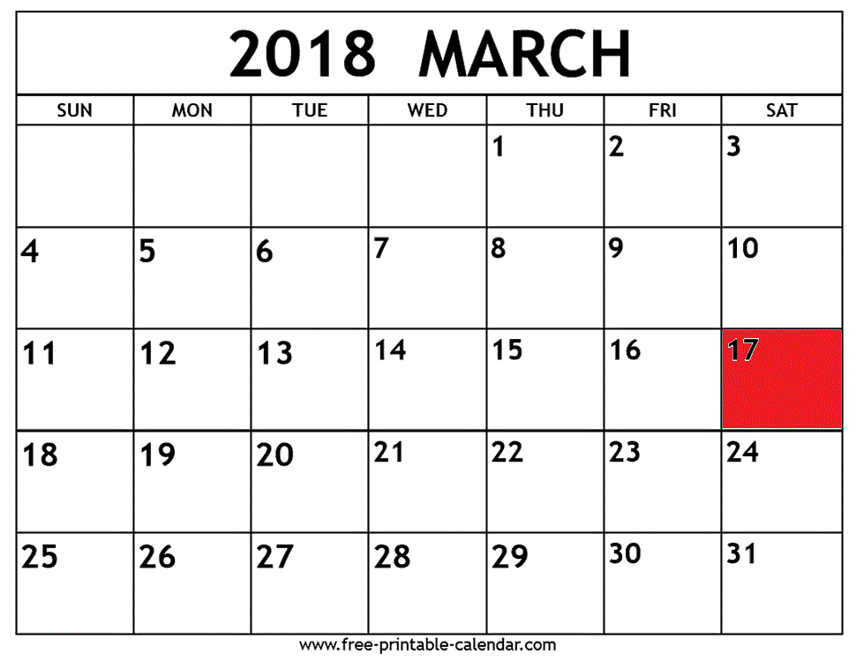

- Drinking in Ireland on St. Patrick’s Day was banned until…
a) 1970s. b) 1700s. c) 19th century.
- How many pints of Guinness are consumed worldwide?
Colour the appropriate number of pints, remembering, that each represents 1 million.
- Where was the first ever St. Patrick’s Parade held?
- in Belfast (Ireland) b) in Boston (USA) c) in New York (USA)
- How much green dye is used to turn the river in Chicago green?
- 4 lbs. b) 40 lbs. c) 45 lbs.
- Is New York’s St. Patrick’s Day parade the largest in the world?
a) Yes. b) No. c) I don’t know.
- How many Americans claim Irish ancestry? Fill in the ‘digital screen’. Add commas where necessary.
34,000,000
- Do you think that people in your country should celebrate St. Patrick’s Day?
- Yes. b) No.
Why?
………………………………………………………………………………………………………………………………………………………………………………………………………………………………………………………………………………………………………………………………………………………………………………………………………………………………………………………………………………………………………………………………………………
After the movie:
- Work in groups. Invent a parade that could be organized in your country.
- Describe its historical background, i.e. how it could be connected to the history of your country.
- Talk about the activities that people could perform during this parade.
- Describe the costumes, colours etc. that people could wear during this parade.
-
………………………………………………………………………………………………………………………………………………………………………………………………………………………………………………………………………………………………………………………………………………………………………………………………………………………………………………………………………………………………………………………………………………………………………………………………………………………………………………………………………………………………………………………………………………………………………………………………………………………………………………………………………………………………………………………………………………………………………………………………………………………………………………………………………………………………………………………………………………………………………………………………………………………………………………………………………………………………………………………………………………………………………………………………………………………………………………………………………………………………………………………………………………………………………………………………………………………………………………………………………………………………………………………………………………………………………………………………………………………………………………………………………………………………………………………………………………………………………………………………………………………………………………………………………………………………………………………………………………………………………………………………
………………………………………………………………………………………………………………………………………………………………………………………………………………………………………………………………………………………………………………………………………………………………………………………………………………………………………………………………………………………………………………………………………………………………………………………………………………………………………………………………………………………………………………………………………………………………………………………………………………………………………………………………………………………………………………………………………………………………………………………………………………………………………………………………………………………………

St. Patrick’s Day song: The Dubliners - Whiskey in the Jar: https://youtu.be/hlWTASnnft4
- Fill in the gaps in the song by The Dubliners: Whisky in the Jar, using the words provided below.
swore / army / bowling / prisoner / footmen / slaughter / jewels / money / chamber / stole / pretty / devil / captain / travel / delight / better / water / deceiver / juice / pistol
As I was a goin' over the far famed Kerry mountains
There's whiskey in the jar
And 't was early in the morning, just before I rose to ¹¹ travel
Up comes a band of ¹² footmen and likewise captain Farrell
I first produced me pistol for she ¹³ stole away me rapier
I couldn't shoot the water, so a ¹⁴ prisoner I was taken
Mush-a ring dumb-a do dumb-a da
Wack fall the daddy-o, wack fall the daddy-o
There's whiskey in the jar
There's some take ¹⁵ delight in the carriages a rolling
and others take delight in the hurling and the
¹⁶ bowling
but I take delight in the ¹⁷ juice of the barley
and courting ¹⁸ pretty fair maids in the morning bright and early
Mush-a ring dumb-a do dumb-a da
Wack fall the daddy-o, wack fall the daddy-o
There's whiskey in the jar
And if anyone can aid me 't is my brother in the
¹⁹ army
If I can find his station in Cork or in Killarney
And if he'll go with me, we'll go rovin' through Killkenney
And I'm sure he'll treat me ²⁰ better than my own a-sporting Jenny
Mush-a ring dumb-a do dumb-a da
Wack fall the daddy-o, wack fall the daddy-o
There's whiskey in the jar

I met with ¹ captain Farrell and his money he was counting
I first produced my ² pistol and I then produced my rapier
Saying "Stand and deliver" for he were a bold
³ deceiver
Mush-a ring dumb-a do dumb-a da
Wack fall the daddy-o, wack fall the daddy-o
There's whiskey in the jar
I counted out his ⁴ money and it made a pretty penny
I put it in me pocket and I took it home to Jenny
She sighed and she ⁵ swore that she never would deceive me
But the ⁶ devil take the women for they never can be easy
Mush-a ring dumb-a do dumb-a da
Wack fall the daddy-o, wack fall the daddy-o
There's whiskey in the jar
I went up to my ⁷ chamber, all for to take a slumber
I dreamt of gold and ⁸ jewels and for sure 't was no wonder
But Jenny blew me charges and she filled them up with ⁹ water
Then sent for captain Farrell to be ready for the
¹⁰ slaughter
Mush-a ring dumb-a do dumb-a da
Wack fall the daddy-o, wack fall the daddy-o

