Valentine’s Day Worksheet History of the Holidays: History of Valentine’s Day | History : https://youtu.be/D8QRXkrWUjM
Before the movie:
- When you think about Valentine’s Day, what comes to your mind first?
Fill in the mind map alone or with your deskmate. Add more lines if necessary. -

- Translate these words and phrases into your own language. Ask your friends or use a dictionary to help you.
-
a guarantee - ………………………………………………………………………………………………………………………..……………………………….
origins - ………………………………………………………………………………………………………………………………………………………………….
a vestige -..……………………………………………………………………………………………………………………………………………………………..
a church - ……………………………………………………………………………………………………………………………………………………………….
an association - ………………………………………………………………..……………………………………………………………………………………
fertility - ………………………….……………………………………………………………………………………………………………………………………..
to declare - ………………………………………………………….………………………………………………………………………………………………..
to canonize - …………………..……………………………………………………………………………………………………………………………………..
an emperor - ………………………………………………………………………………………………………………………………………………………….
half-hearted - ………………………………….……………………………………………………………………………………………………………………..
to ban - ……..………………………..……………………………………………………………………………………………………………......................
to catch on - ………………………………………………………………………………………………………………………..………………………………..
to condemn – ………………………………………………………………………………………………………………………..………………………………
to shower someone with something – …………………………………………………………………………………………………………………..
annually - ………………………………………………………………………………………………………………………..…………………………………….
During the movie:
- Are we certain about the origins of St. Valentine’s Day?
- Yes. b) No. c) I don’t know.
- What pagan festival is believed to have started the association between mid-February and romance?
- Valentinalia b) Luperkaulia c) Samhain
- Faunus was the god of…
- love. b) death. c) fertility.
- In which century did Pope Gelasius declare 14th February as St. Valentine’s Day?
Why did he do it?
………………………………………………………………………………………………………………………………………………………………………………………………………………………………………………………………………………………………………………………………………………………………
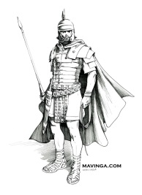
- What did the armies of the Emperor Claudius II have to do?
- They had to abandon their friends.
- They had to abandon their families.
- They had to take their families with them.
- What happened to Father Valentine during the Emperor’s reign? Draw it.

- What’s the English name of this god?
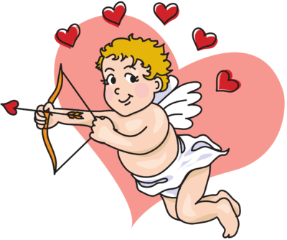
- Amor b) Valentine c) Cupid
- Is our modern Valentine’s day still connected to its pagan and Christian past?
a) Yes. b) No. c) I don’t know.

- Americans shower their loved ones with…
- 180 roses b) 180,000 roses c) 180,000,000 roses
- Is love really all you need, according to the video?
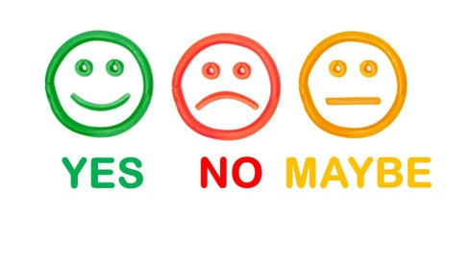
After the movie:
- Work in pairs or in groups. Write a (short) romantic story. -
………………………………………………………………………………………………………………………………………………………………………………………………………………………………………………………………………………………………………………………………………………………………………………………………………………………………………………………………………………………………………………………………………………………………………………………………………………………………………………………………………………………………………………………………………………………………………………………………………………………………………………………………………………………………………………………………………………………………………………………………………………………………………………………………………………………………………………………………………………………………………………………………………………………………………………………………………………………………………………………………………………………………………………………………………………………………………………………………………………………………………………………………………………………………………………………………………………………………………………………………………………………………………………………………………………………………………………………………………………………………………………………………………………………………………………………………………………………………………………………………………………………………………………………………………………………………………………………………………………………………………………………………
………………………………………………………………………………………………………………………………………………………………………………………………………………………………………………………………………………………………………………………………………………………………………………………………………………………………………………………………………………………………………………………………………………………………………………………………………………………………………………………………………………………………………………………………………………………………………………………………………………………………………………………………………………………………………………………………………………………………………………………………………………………………………………………………………………………………………………………………………………………………………………………………………………………………………………………………………………………………………………………………………………………………………………………………………………………………………………………………………………………………………………………………………………………………………………………………………………………………………………………………………………………………………………………………………………………………………………………………………………………………………………………………………………………………………………………………………………………………………………………………………………
Valentine’s song: Demi Lovato - Tell Me You Love Me (Lyrics Video): https://youtu.be/j0z45UdhoWc
- Fill in the gaps in the song by Demi Lovato: Tell Me You Love Me.
If the same gap appears more than once then it has a / * / symbol near the gap number.
Oh no, here we go again
On days like this
Oh, tell me you ^{6*} ____________________ me
I need ^{7*} ____________________
On days like this, I do
On days like this
Oh, can you hear my ^{8*} ____________________ say
You ain’t nobody 'til you got somebody
You ain't nobody 'til you got somebody
My heart's like
No, you ain't nobody 'til you got somebody
You ain't nobody 'til you got somebody
^{12*} ____________________ I need
Is standing in front of me
I know that we will be alright, alright, yeah
Through the ups and ¹³ ____________________
Baby, I'ma stick around
I ¹⁴ ____________________ we will be alright, alright
Oh, tell me you ^{6*} ____________________ me
I need ^{7*} ____________________
On days like this, I do
On days like this
Oh, tell me you love me
I need ^{7*} ____________________
On days like this, I do
On days like this
Oh, can you hear my ^{8*} ____________________ say
You ain't nobody 'til you got somebody
You ain't nobody 'til you got somebody
^{12*} ____________________ I need
Is standing right in front of me
I know that we will be alright, alright, yeah

¹ ____________________ over what I said
I'm ² ____________________, yeah I’m sorry
Bad at ³ _____________, no, I'm not good at this
But I can't say I’m innocent
Not hardly, but I'm ⁴____________________
And all my friends, they know and it's true
I don't know who I am ⁵ _________________ you
I got it bad, baby
Got it bad
Oh, tell me you ^{6*} ____________________ me
I need ^{7*} _______________ on days like this, I do
On days like this
Oh, tell me you ^{6*} ____________________ me
I need ^{7*} ____________________
On days like this, I do
On days like this
Oh, can you hear my ^{8*} _________________ say
No, you ain't nobody 'til you got somebody
You ain't nobody 'til you got somebody
And I hope I never see the day
That you move on and be ⁹ __________ without me
Without me
What’s my hand without your ¹⁰__________ to hold?
I don’t know what I'm living for
If I’m living ¹¹____________________you
All my friends, they know and it's true
I don't know who I am without you
I've got it bad, baby
I got it bad
Oh, tell me you ^{6*} ____________________ me
I need ^{7*} ___________________ on days like this, I do

