Christmas Worksheet How to Have a British Christmas - Anglophenia Ep 20: https://youtu.be/v2W3QR9WXdA
Before the movie:
- When you think about Christmas, what comes to your mind first?
Fill in the mind map alone or with your deskmate. Add more lines if necessary. -

- Translate these words into your own language. Ask your friends or use the dictionary to help you.
-
a Christmas stocking - ………………………………………………………………………………………………………………………..………………….
a stranger - …………………………………………………………………………………………………………………………………………………………….
mandatory -..………………………………………………………………………………………………………………………………………………………….
a feast - ………………………………………………………………………………………………………………………………………………………………….
a veggie - ……………………………………………………………………..………………………………………………………………………………………..
gravy - ………………………….……………………………………………………………………………………………………………………………………..
a telly - ………………………………………………………….……………………………………………………………………………………………………….
to flavour - …………………..………………………………………………………………………………………………………………………………………..
the poor - ………………………………………………………………………………………………………………………………………………………………
to trample (to death) - ………………………………….……………………………………………………………………………………………………….
major (difference) - ……..………………………..……………………………………………………………………………………………………………...

During the movie:
- What do we call Christmas in the UK?
- Crimbo. b) Santa. c) Christmas Eve.
- How do the British people send letters to Father Christmas?
- They put them in a mailbox. b) They send e-mails. c) They burn the letters.
- Where do Brits hang stockings?
- 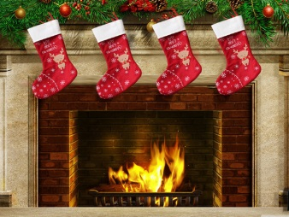 b) 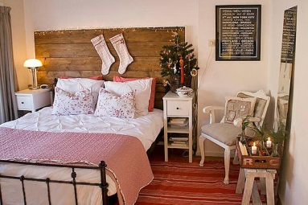
- Why do they leave Father Christmas a brandy and a mince pie instead of milk and cookies?
………………………………………………………………………………………………………………………………………………………………………………
- What’s a Christmas cracker? Draw it.
- What’s inside a Christmas cracker?
………………………………………………………………………………………………………………………………………………………………………………………………………………………………………………………………………………………………………………………………………………………………………………………………………………………………………………………………………………………………………………………………………………………………………………
- Is it mandatory to wear a paper crown?
- Yes. b) No. c) I have no idea.

- What’s the main Christmas dish in the UK?
a) A roasted turkey. b) Bacon wraps . c) A carp.

- Which vegetables are traditionally served during the Christmas dinner?
- 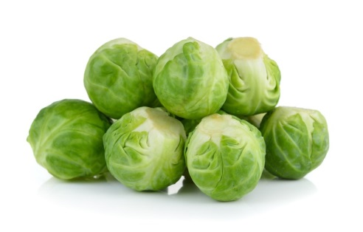 b) 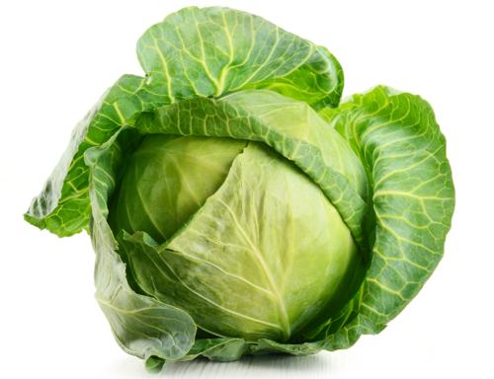

- What’s Christmas pudding? How is it made?
…….……………………………………………………………………………………………………………………………………………………………………………….……………………………………………………………………………………………………………………………………………………………………………….……………………………………………………………………………………………………………………………………………………………………………….……………………………………………………………………………………………………………………………………………………………………………….…………………………………………………………………………………………………………………………………………………………………………
- What do Brits typically do during the Royal Christmas Message?
- They listen carefully to what the monarch is saying.
- They sleep.
- They do the usual chores, pretending to listen to the Message.
- What do British people do on a Boxing Day nowadays? What American day it reminds you of?
…….……………………………………………………………………………………………………………………………………………………………………………….……………………………………………………………………………………………………………………………………………………………………………….……………………………………………………………………………………………………………………………………………………………………………….……………………………………………………………………………………………………………………………………………………………………………….…………………………………………………………………………………………………………………………………………………………………………
- What are pantomimes based on?
- True stories b) Fairy tales. c) Movies and TV series.

- When should Brits take down the Christmas tree?
- Before the 4th July. b) Within 12 days from Christmas. c) At the end of the year.

After the movie:
- Work in pairs or in groups. Choose 1 Christmas tradition celebrated in your country and describe it. -
………………………………………………………………………………………………………………………………………………………………………………………………………………………………………………………………………………………………………………………………………………………………………………………………………………………………………………………………………………………………………………………………………………………………………………………………………………………………………………………………………………………………………………………………………………………………………………………………………………………………………………………………………………………………………………………………………………………………………………………………………………………………………………………………………………………………………………………………………………………………………………………………………………………………………………………………………………………………………………………………………………………………………………………………………………………………………………………………………………………………………………………………………………………………………………………………………………………………………………………………………………………………………………………………………………………………………………………………………………………………………………………………………………………………………………………………………………………………………………………………………………………………………………………………………………………………………………………………………………………………………………………………
Christmas carol: Silent Night (with lyrics): https://youtu.be/9T4WB2zfmps
- Listen to the Christmas carol and try to fill in the gaps in it, using the words provided below.

child / heavenly / Saviour / holy / holy / bright / birth / heavenly / heaven / Saviour / God / birth / holy / grace

Silent night, ¹ ____________________ night,
All is calm, all is ² ____________________
Round yon virgin mother and ³ ____________________.
Holy infant so tender and mild,
Sleep in ⁴ ____________________ peace.
Sleep in ⁵ ____________________ peace.

Silent night, ⁶ ____________________ night,
Son of ⁷ ____________________, love's pure light
Radiant beams from thy holy face,
With the dawn of redeeming ⁸ ____________________,
Jesus, Lord, at thy ⁹ ____________________.
Jesus, Lord, at thy ¹⁰ ____________________.

silent night, ¹¹ ____________________ night,
Shepherds quake at the sight,
Glories stream from ¹² ____________________ afar,
Heavenly hosts sing Alleluia!
Christ the ¹³ ____________________, is born!
Christ the ¹⁴ ____________________, is born!

- Sing the Christmas carol together with your groupmates! +

Christmas Song: Mariah Carey – All I Want for Christmas Is You: https://youtu.be/yXQViqx6GMY
- Fill in the gaps in the song by Mariah Carey: All I Want For Christmas Is You.
I won't make a ¹² ................... and send it
To the North Pole for Saint Nick
I won't even stay ¹³ ................... to
Hear those magic reindeer's click

'Cause I just want you here ¹⁴ ...................
Holding on to me so tight
What more ¹⁵ .................... I do
Baby all I ¹⁶ .................... for Christmas is you
Ooh baby

All the lights are shining
So brightly everywhere
And the sound of children's
Laughter fills the ¹⁷ ...................

And everyone is singing
I ¹⁸ ................... those sleigh bells ringing
Santa won't you bring me the one I really need
Won't you please ¹⁹ ................... my baby to me quickly

Oh I don't want a lot for Christmas
This is ²⁰ ................... I'm asking for
I just want to see my ²¹ ...................
Standing right outside my door

Oh I just want you for my own
More than you could ever know
Make my ²² ................... come true
Baby all I ²³ .................... for Christmas is... You
All I ²⁴ ................... for Christmas is you, baby

I don't want a lot for Christmas
There's just one thing I ¹ ...................
I don't care about the presents
Underneath the Christmas ² ...................
I just want you for my own
More than you could ever know
Make my ³ ................... come true
All I ⁴ ................... for Christmas is... You

I don't want a lot for Christmas
There's just one thing I ⁵ ...................
I don't care about the presents
Underneath the Christmas ⁶ ...................
I don't need to hang my stocking
There upon the fireplace
Santa Claus won't ⁷ ................... me happy
With a toy on Christmas day

I just want you for my own
More than you could ever know
Make my ⁸ .................... come true
All I ⁹ ................... for Christmas is you
You baby

I won't ¹⁰ ................... for much this Christmas
I don't even wish for snow
I'm just gonna ¹¹ ................... on waiting
Underneath the mistletoe

- Sing the song together with your groupmates! +

